

Table of Contents

GCP Handson Document (20+ Services) 1

Cloud Services we are going to learn: 1

Project & IAM setup: 1

**What is the gcloud CLI?** 6

# GCP Handson Document (20+ Services)

## Cloud Services we are going to learn:

1. **Security (IAM, ACL, Firewall rules)**
2. **Cloud SDK (Linux/Windows/Cloud shell)**
3. **Cloud Storage – GCS**
4. **Networking (Region, Zones, VPC, Subnet)**
5. **Compute – Compute Engine**
6. **DB – Cloud SQL, Cloud Spanner, BigTable**
7. **Analytics – Big Query, Dataproc, Dataprep, Dataplex, Dataflow, PubSub, Looker/Data Studio**
8. **Integration Services – Cloud Scheduler, Workflow**
9. **Operation – Cloud Logging**

### Project & IAM setup:

#### Create a Project in the Console.

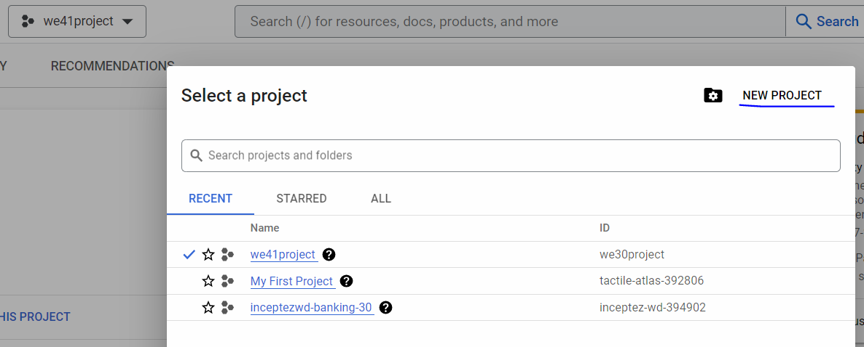

1. **Create a Principal and assign roles/permissions**

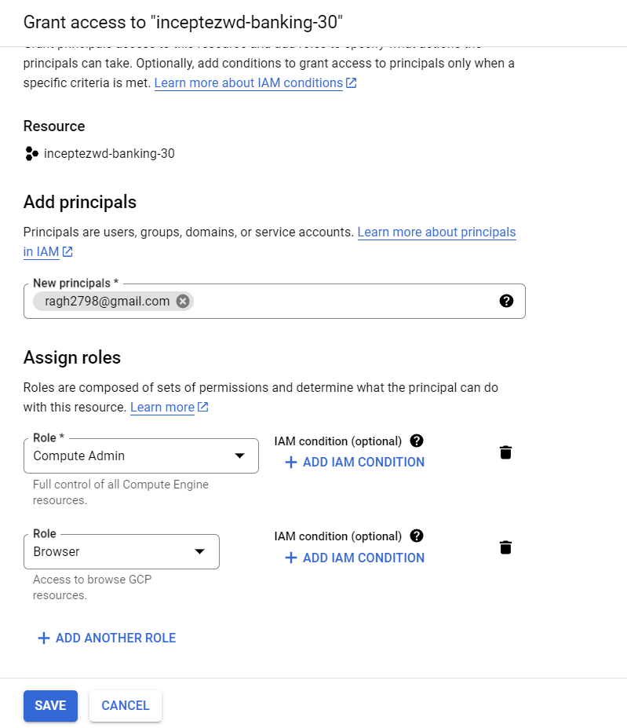

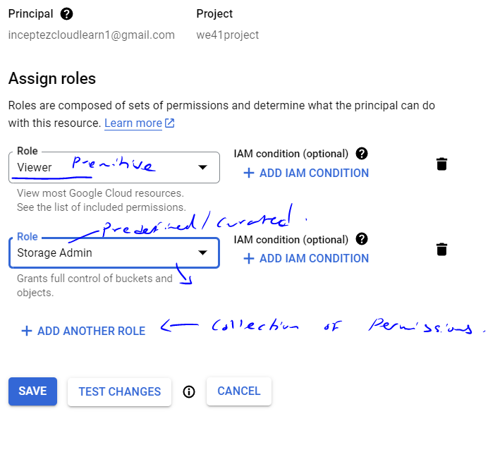

The Principal (individual user) have access to GCP Project (Authentication) with the (Authorization) for access of Compute Engine (VM) Admin – Predefined/Curated Role and access for browsing the cloud resources across the project – Primitive role

1. **Setting up of the service account in IAM for accessing the services:**
2. In the Google console create a service account
3. Give storage admin role to the above account
4. Download the json credential file

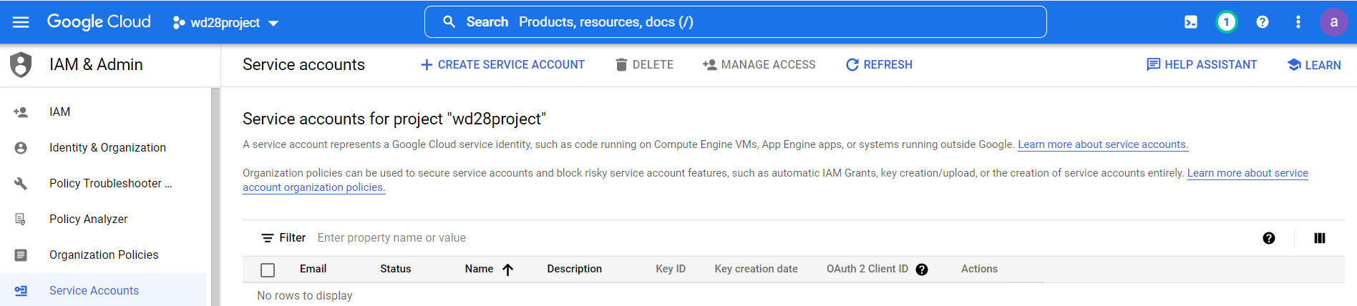

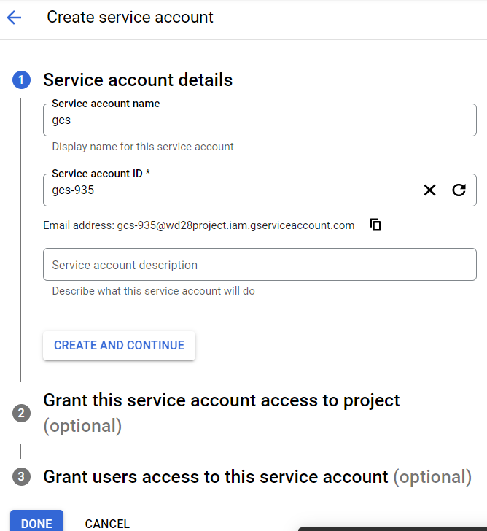

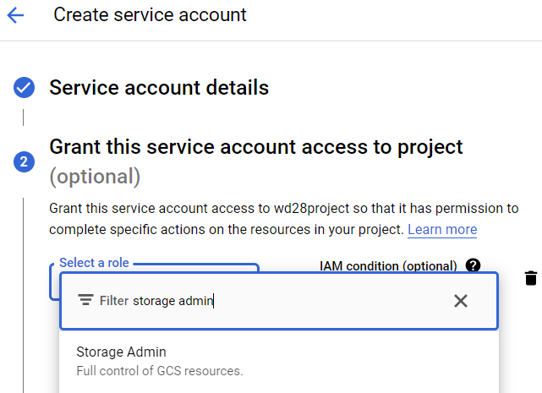

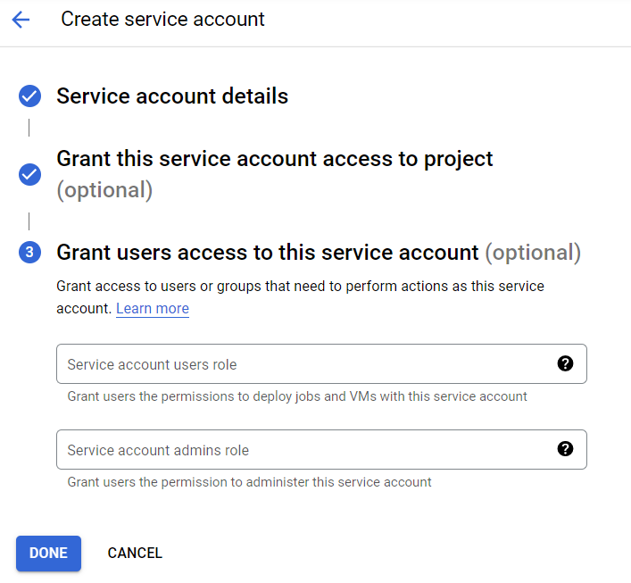

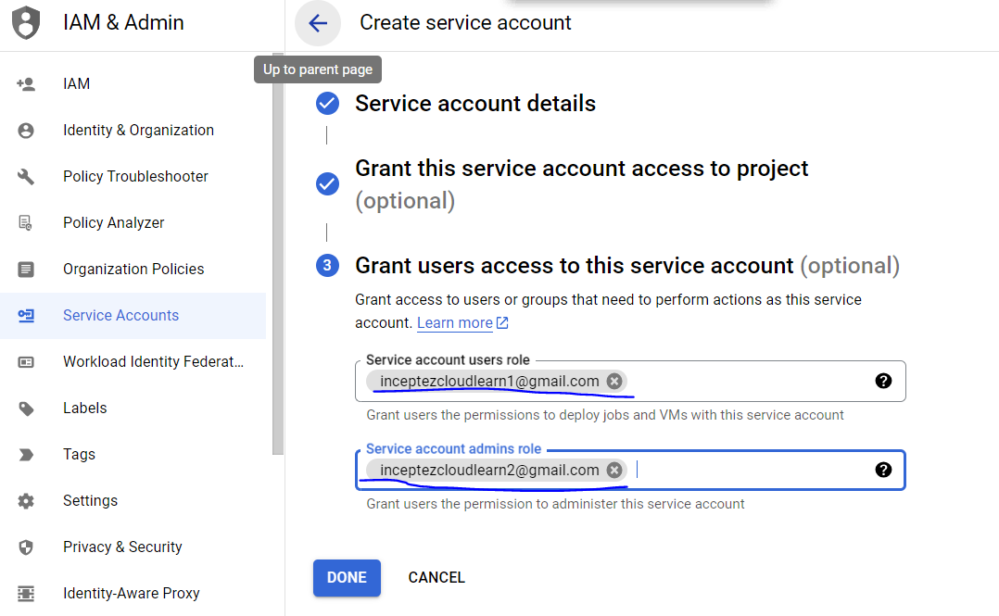

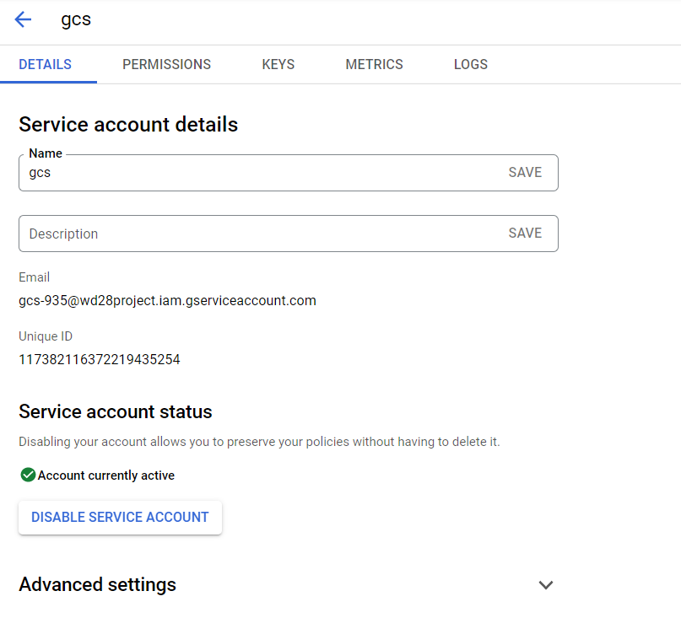

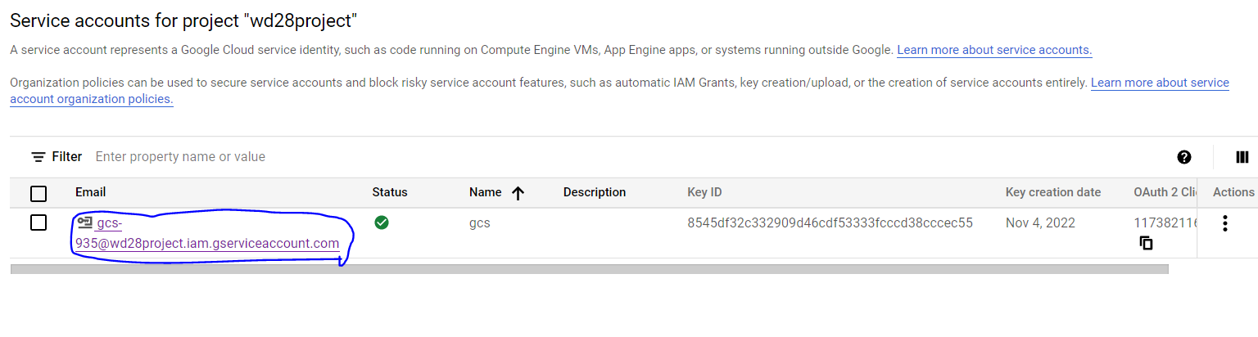

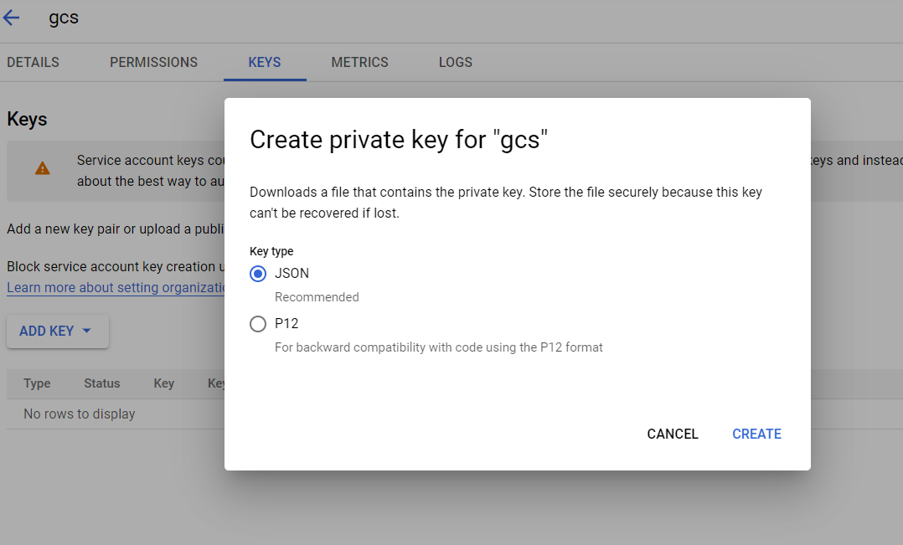

**Cloud SDK (Software Dev Kit) setup in EdgeNode (will be done by the cluster admin):**

1. **Setting up of the Cloud SDK to use gcloud, gsutil & bq utils tools in Windows/Linux:**

**Google Cloud SDK:**

* **Google Cloud CLI** in the Windows/Edge node lets you manage resources and services from the command line.
* **Cloud Shell in the console** lets you code or use a terminal directly in the web-browser rather than using an onprem linux/windows box or cloud dataproc cluster cli.

**What is the gcloud CLI?**

The Google Cloud CLI is a set of tools to create and manage Google Cloud resources. You can use these tools to perform many common platform tasks from the command line or through scripts and other automation.

For example, you can use the gcloud CLI to create and manage the following:

* Cloud Storage (GCS)
* Compute Engine (EC2) virtual machine instances and other resources
* Cloud SQL instances (RDS)
* Google Kubernetes Engine clusters (EKS)
* Dataproc clusters and jobs (EMR)

**What is gsutil?**

gsutil is a Python application that lets you access Cloud Storage from the command line. You can use gsutil to do a wide range of ***bucket*** and ***object*** management tasks, including:

**Gcloud vs Gsutil**

The gsutil command is used only for Cloud Storage. With the gcloud command, you can interact with other Google Cloud products like the App Engine, Google Kubernetes Engine etc, ***but gsutil has more options than gcloud specifically for cloud storage.***

**Handson:**

**Installation and Configuration of GCloud SDK for leveraging the utilities it provides:**

<https://cloud.google.com/sdk/docs/install-sdk#linux>

cd /home/hduser/install

curl -O https://dl.google.com/dl/cloudsdk/channels/rapid/downloads/google-cloud-cli-408.0.1-linux-x86_64.tar.gz

tar -xvf google-cloud-cli-408.0.1-linux-x86_64.tar.gz

/home/hduser/install/google-cloud-sdk/install.sh

*Do you want to help improve the Google Cloud CLI (y/N)?*

N

*You must log in to continue. Would you like to log in (Y/n)?*

Y

*Enter a path to an rc file to update, or leave blank to use [/home/hduser/.bashrc]:*

*just type enter key*

echo "export PATH=$PATH:/home/hduser/install/google-cloud-sdk/bin" >> ~/.bashrc

source ~/.bashrc

**To Initialize and set Gcloud to connect with our project run the below command in the VM (Authenticate)**

Let’s play the below IAM Usecases with the principals created using the gcloud sdk with GCS storage service:

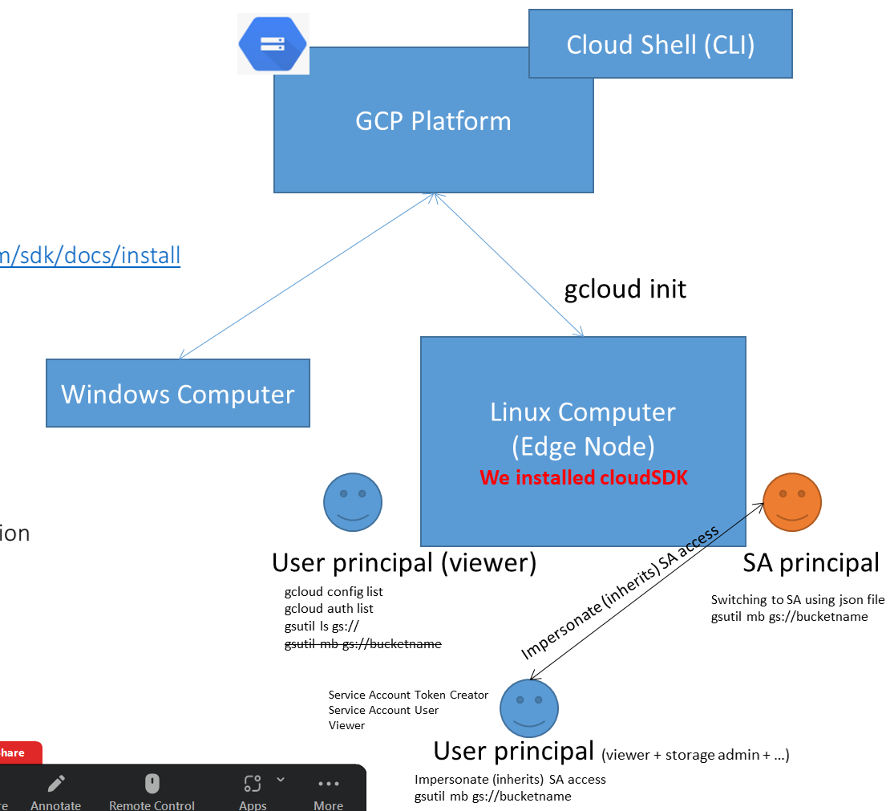

1. First we created the user principal and service account principal with the below roles defined…
2. As a individual user (principal) like [inceptezcloudlearn1@gmail.com](mailto:inceptezcloudlearn1@gmail.com) by adding roles like viewer ~~+ storage admin~~?
   1. **In the Console** – We viewed, created or deleted some GCS buckets using the user principal, (then removed the storage admin access later)
   2. **In the CLI/util/api…** - We have to install/configure tools/util provided by GCP (Gcloud) – gsutil, bq utils in our edgenode, then tried accessing the gsutil command to viewed, created or deleted some GCS buckets (only view was working because of access restriction) – all the commands are detailed below in this document

*(pseudo commands)*

gcloud config set project projectname

gcloud config set user username

gsutil ls gs://some-bucket-name

gsutil mb gs://some-bucket-name

1. As a service account (principal) like [cloudstorage-sa@tactile-atlas-392806.iam.gserviceaccount.com](mailto:cloudstorage-sa@inceptez-wd-394902.iam.gserviceaccount.com) by adding roles like compute admin + storage admin etc., (by exposing the SA json),
   1. What we can do using some (3rd party) tools like PYSPARK using online transfer methodology (code is given in this document itself)
   2. We interacted with the GSC in GCP from onprem using online transfer methodology by using the gcloud SDK or gsutil utility.

*(pseudo commands)*

Gcloud config set service-account file=jsonfile

1. As a user principal (project member account) added as a service account user and the service account (project account) token creator in the service account, this user principal can impersonate the service account’s role and he can do all the activities

**GCloud SDK/CLI Handson Starts here**

gcloud init #only for the ***first time*** to initialize gcloud access, define the user, project, configuration

**If Firefox is not opening with the below url then, Paste the below url to the Chrome in windows**

<https://accounts.google.com/o/oauth2/auth?response_type=code&client_id=32555940559.apps.googleusercontent.com&redirect_uri=http%3A%2F%2Flocalhost%3A8085%2F&scope=openid+https%3A%2F%2Fwww.googleapis.com%2Fauth%2Fuserinfo.email+https%3A%2F%2Fwww.googleapis.com%2Fauth%2Fcloud-platform+https%3A%2F%2Fwww.googleapis.com%2Fauth%2Fappengine.admin+https%3A%2F%2Fwww.googleapis.com%2Fauth%2Fsqlservice.login+https%3A%2F%2Fwww.googleapis.com%2Fauth%2Fcompute+https%3A%2F%2Fwww.googleapis.com%2Fauth%2Faccounts.reauth&state=j0lXQwMxIMbwkXvwpMyA0Xzf9iF1pU&access_type=offline&code_challenge=suvT_zZID2hJcEQBgmh0esSjiH1sSz_xWK0leU2FmJI&code_challenge_method=S256>

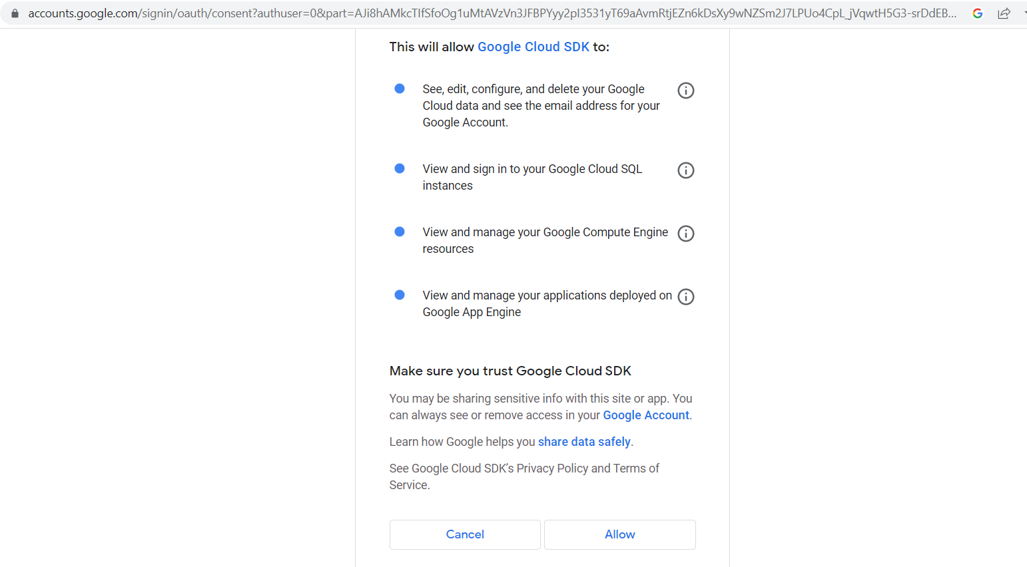

**Paste the below response url from Chrome in windows to the Firefox inside the VM**

<http://localhost:8085/?state=j0lXQwMxIMbwkXvwpMyA0Xzf9iF1pU&code=4/0ARtbsJrar-cWniFtEJ57Tz1tD-GycVgc9oZmqP2gLheJaoBDKRAM60iKEcUicc-Go9rNvA&scope=email%20openid%20https://www.googleapis.com/auth/userinfo.email%20https://www.googleapis.com/auth/cloud-platform%20https://www.googleapis.com/auth/appengine.admin%20https://www.googleapis.com/auth/sqlservice.login%20https://www.googleapis.com/auth/compute%20https://www.googleapis.com/auth/accounts.reauth&authuser=0&prompt=consent>

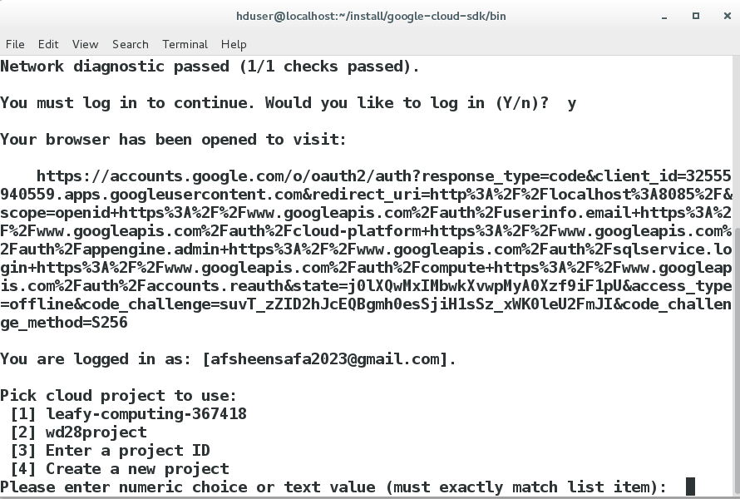

To know the list of all accounts and the current active account info

gcloud auth list

To know the list of active configs

gcloud config list

To interact with some of the google cloud services for eg. cloud storage using the given principal who has some roles attached like viewer/editor

*I logged in as a user who has only viewer role access*

gsutil ls gs://

*viewing of cloud storage is possible….*

*Lets try create a bucket with the viewer access..?*

gsutil mb gs://we41-sample-bucket-testing

Creating gs://wd30-sample-bucket-testing/...

AccessDeniedException: 403 inceptezcloudlearn1@gmail.com does not have storage.buckets.create access to the Google Cloud project. Permission 'storage.buckets.create' denied on resource (or it may not exist).

To activate the service account in the current vm (**authorization**)

gcloud auth activate-service-account **--key-file=/home/hduser/gcplearn/we30project-427ada2097c2.json**

gcloud auth activate-service-account **--key-file=/home/hduser/gcplearn/prasath-409302-d408fcf872f6.json**

gcloud config set auth/impersonate_service_account your account name

gcloud auth list

*Lets try create a bucket with the storage admin access using service account..? now able to create bucket and did “TRANSFER SERVICE”*

gsutil mb gs://wd30-sample-bucket-testing

gsutil cp cust.txt gs://wd30-sample-bucket-testing/

To set a gcloud account

gcloud config set account <mailid>

To Login to a gcloud user account (login is expired means, use the below command to login)

gcloud auth login

To set a gcloud project

gcloud config set project <projectid>

gcloud auth list #i am a SA principal

gcloud config set account inceptezcloudlearn1@gmail.com

gcloud auth list #i am a user principal

gsutil mb gs://wd30-sample-bucket-testing1

Creating gs://wd30-sample-bucket-testing1/...

AccessDeniedException: 403 inceptezcloudlearn1@gmail.com does not have storage.buckets.create access to the Google Cloud project. Permission 'storage.buckets.create' denied on resource (or it may not exist).

gsutil ls gs://wd30-sample-bucket-testing

gs://wd30-sample-bucket-testing/cust.txt

To Logout (revoke) to a gcloud account

gcloud auth revoke

Usecase: How To impersonate a service account by the gcloud user, first setup the Service account and add a principal with ‘Service Account Token Creator’ role

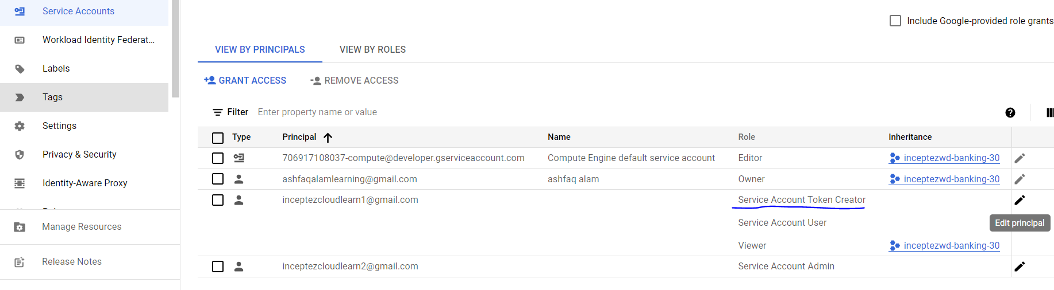

*Then perform the below operation to try impersonating the service account permissions* ***without*** *using the SA json key.*

Login to the above principal:

gcloud auth login

gcloud auth list

Try performing some action where this user doesn’t have permission

gsutil cp cust1.txt gs://inceptez-data-samples/

Copying file://cust1.txt [Content-Type=text/plain]...

AccessDeniedException: 403 inceptezcloudlearn1@gmail.com does not have storage.objects.create access to the Google Cloud Storage object. Permission 'storage.objects.create' denied on resource (or it may not exist).

Let’s impersonate and try the same above action again

gcloud config set auth/impersonate_service_account cloudstorage-sa@tactile-atlas-392806.iam.gserviceaccount.com

***#This impersonate is similar to running the pbrun pbrole proj-serviceid command in organisation ……***

**#pbrun cloudstorage-sa**

Updated property [auth/impersonate_service_account].

gcloud config list

gcloud auth list

gsutil cp cust1.txt gs://inceptez-data-samples/

Copying file://cust.txt [Content-Type=text/plain]...

WARNING: This command is using service account impersonation. All API calls will be executed as [cloudstorage-sa@tactile-atlas-392806.iam.gserviceaccount.com].

- [1 files][ 148.0 B/ 148.0 B]

Operation completed over 1 objects/148.0 B.

gsutil ls gs://wd30-sample-bucket-testing/

WARNING: This command is using service account impersonation. All API calls will be executed as [cloudstorage-sa@tactile-atlas-392806.iam.gserviceaccount.com].

gs://wd30-sample-bucket-testing/cust.txt

----------- Initial CLI setup to access the cloud resource using the Service account is completed --------

**Google Cloud Storage Service (Accessing of GCS):**

1. **Google Cloud Storage CLI Commands:**

Make Bucket Commands:

gsutil mb gs://com-inceptez-data-learn1-we41

Project Specific

gsutil mb -p tactile-atlas-392806 gs://com-inceptez-data-learn2-we41

Location Types (regional, dual, multi) – costing, usability(availability), performance

gsutil mb -l **us-east1** gs://com-inceptez-data-att-we41#regional (replicated across upto 3 zones-clusters) 99.999999999% availability

gsutil mb -l **asia-south1** gs://com-inceptez-data-jio-we41

gsutil mb -l **us** --placement **us-west1,us-west2** gs://com-inceptez-data-learn5-we41 #dual region(replicated across upto 3+3 zones-clusters) – better availability, reachability and fault tolerance

gsutil mb -l asia gs://com-inceptez-data-asia-we41 #DEFAULT MULTI region - accross the country all/any regions

Storage Classes – costing, usability(availability), performance

gsutil mb -c nearline gs://com-inceptez-data-learn6-we41

gsutil mb -c standard -l us-east1 gs://com-inceptez-data-learn6-we41

gsutil mb --autoclass gs://com-inceptez-data-learn8-we41 #depends upon the frequency of access and period of storage

gsutil autoclass set on gs://com-inceptez-data-learn8-we41

gsutil autoclass get gs://com-inceptez-data-learn8-we41

Retention Period (How long we are going to protect the data from deletion/overwriting)

gsutil mb --retention 60s -c nearline gs://com-inceptez-data-learn9-we41

gsutil cp samplefile.txt gs://com-inceptez-data-learn9-we41

gsutil cp samplefile.txt gs://com-inceptez-data-learn9-we41 #overwriting

gsutil rm gs://com-inceptez-data-learn9-we41/samplefile.txt #delete

#after 60 seconds

gsutil cp samplefile.txt gs://com-inceptez-data-learn9-we41 #overwriting

#after 60 seconds

gsutil rm gs://com-inceptez-data-learn9-we41/samplefile.txt #delete

Access Controls: IAM (uniform (preferred access control)) & ACLs (fine grained)

gsutil acl ch -r -u inceptezlearncloud@gmail.com:R gs://com-inceptez-data-learn1-we41/custs

gsutil acl ch -r -u inceptezlearncloud@gmail.com:O gs://com-inceptez-data-learn6-we41/streamdata2.txt

gsutil acl ch -u allAuthenticatedUsers:R gs://com-inceptez-data-learn6-we41 #make the bucket public

**#All about IAM**

gsutil iam ch user:inceptezlearncloud@gmail.com:objectCreator,objectViewer gs://com-inceptez-data-learn9-we41

gsutil iam ch allUsers:objectViewer gs://com-inceptez-data-learn8-we41

gsutil iam ch allAuthenticatedUsers:objectViewer gs://com-inceptez-data-learn7-we41 #only for buckets IAM access controls can be defined

gsutil iam ch -d user:inceptezlearncloud@gmail.com gs://com-inceptez-data-learn9-we41

gsutil pap set enforced gs://com-inceptez-data-learn6-we41 #enforce public access prevention

gsutil iam ch allUsers:objectViewer gs://com-inceptez-data-learn6-we41 #Can’t changed to public since PAP enforced

gsutil pap set inherited gs://com-inceptez-data-learn5-we41

gsutil iam ch allUsers:objectViewer gs://com-inceptez-data-learn5-we41 #Can be changed to public since PAP inherited

**Object Commands (Transfer Service):**

Copy Objects:

File/Files Copy: Local to GS

gsutil cp /home/hduser/hive/data/custs gs://com-inceptez-data-learn9-we41

File/Files List:

gsutil ls gs://inceptez-bucket-data2/

gsutil ls -l gs://inceptez-bucket-data2/

gsutil ls -L gs://inceptez-bucket-data2/

gsutil ls gs://inceptez-bucket-data2/

gsutil ls -l -r gs://inceptez-bucket-data2

Versioning: Must be used cautiously (mostly with lifecycle we have use).

gsutil versioning set on gs://com-inceptez-data-learn8-we41

gsutil cp -r datadir gs://inceptez-bucket-data2/datadir

gsutil ls -l -r -a gs://inceptez-bucket-data2 #long list, recursive, all versions

gsutil ls -la gs://com-inceptez-data-learn8-we41/ | grep -v TOTAL | tail -2 #last 2 versions

gsutil cp cust1.txt gs://com-inceptez-data-learn8-we41/

gsutil ls -a gs://com-inceptez-data-learn8-we41/

gsutil cat gs://com-inceptez-data-learn8-we41/cust1.txt#1692430336436311

gsutil versioning set off gs://com-inceptez-data-learn8-we41

File Copy & rename of current/given version from one bucket to another:

gsutil cp gs://com-inceptez-data-learn8-we41/custs gs://com-inceptez-data-learn8-we41/custs_recent

gsutil cp gs://com-inceptez-data-learn8-we41/custs#1692239294517457 gs://com-inceptez-data-learn8-we41/custs_old

Move entire Directory:

mkdir ~/sparkdatagcs

cp ~/sparkdata/*.txt sparkdatagcs

gsutil mv ~/sparkdatagcs gs://com-inceptez-data-learn8-we41/datadir

gsutil -m mv ~/sparkdatagcs gs://com-inceptez-data-learn8-we41/ #multi thread move (multi part upload)

Files Copy/Move: GS to GS

*#To create a directory and copy data into it in GCS*

*#Note: We can’ t create directory in gs directly using any gsutils commands*

1. *Create a directory in local and copy it to gs using –r option*
2. *Copy list of files using some pattern (*.csv) and mention the target directory (not exist/exist) in gcs.*

gsutil cp gs://com-inceptez-data-learn9-we41/samplefile.txt gs://com-inceptez-data-learn8-we41/custdata1 #file copied as a file

gsutil cp gs://com-inceptez-data-learn9-we41/* gs://com-inceptez-data-learn8-we41/alldatafolder #files copied inside the folder

gsutil -m cp -r gs://com-inceptez-data-learn8-we41/sparkdatagcs gs://com-inceptez-data-learn9-we41/

Copy Without overwriting: (by default the file with same name will be overwritterned, we can avoid overwriting by creating versions or by skipping the overwrite)

gsutil cp -n cust1.txt gs://com-inceptez-data-learn9-we41/

gsutil cp -n cust1.txt gs://com-inceptez-data-learn9-we41/

gsutil cp -n gs://com-inceptez-data-learn8-we41/custs gs://com-inceptez-data-learn6-we41/custs1

Copy entire Directory:

*#To create a directory and copy data into it in GCS*

*#Note: We can’ t create directory in gs directly using any gsutils commands*

1. *Create a directory in local/existing gs folder and copy it to gs using –r option*
2. *Copy list of files using some pattern (*.csv) and mention the target directory (not exist/exist) in gcs.*

gsutil cp /home/hduser/datadir2/custdata.txt gs://com-inceptez-data-learn6-we41/datadirnotexist1 #this directory name will be created as a file

gsutil cp /home/hduser/datadir2/*.txt gs://com-inceptez-data-learn6-we41/datadirnotexist

gsutil -m cp -r /home/hduser/datadir gs://com-inceptez-data-learn6-we41/

Multi threaded & recursive copy:

gsutil -m cp -r /home/hduser/hive/data gs://com-inceptez-data-learn6-we41/datadir

Streaming data copy – output of a GS command can be copied to LFS

gsutil cp gs://inceptez-bucket-data2/file22.txt - | head -2

gsutil cp gs://com-inceptez-data-learn6-we41/streamdata.txt - | grep Sports

Streaming data copy – output of a command can be copied to GS

tail -2 datadir/file2.txt | gsutil cp - gs://inceptez-bucket-data2/file22.txt

Compose - Concatenate a sequence of objects into a new composite object

gsutil compose gs://com-inceptez-data-learn9-we41/cust1.txt gs://com-inceptez-data-learn9-we41/cust2.txt gs://com-inceptez-data-learn9-we41/cust12.txt

Disk Usage commands

gsutil du -c -h gs://inceptez-bucket-data #totalsize in human readable format

Remove Command

gsutil rm gs://inceptez-bucket-data2/file2.txt #remove object

gsutil rm -r gs://inceptez-bucket-data2/datadir/

gsutil rm gs://inceptez-bucket-data2/file2.txt#1691769745297390 #remove a given version

gsutil rb gs://inceptez-bucket-data

gsutil rb -f gs://inceptez-bucket-data #Continue silently (without printing error messages)

rsync command (sync the contents of a destination bucket or directory match those of a source bucket or directory – comparing the object names and modification time of the objects)

Note: If we place new objects or modify the existing files, rsync will compare objectname and time and sync if varies else it won’t do anything

gsutil rsync -r gs://bucket1/dir1 gs://bucket2/dir2

gsutil -m rsync -r gs://com-inceptez-data-learn9-we41/sparkdatagcs gs://com-inceptez-data-learn7-we41/sparkdatatarget

#deleting all other objects in the destination that is not in the source

gsutil ls gs://com-inceptez-data-learn7-we41/sparkdatatarget | wc -l

gsutil rm gs://com-inceptez-data-learn9-we41/sparkdatagcs/cust1data.txt

gsutil -m rsync -r gs://com-inceptez-data-learn9-we41/sparkdatagcs gs://com-inceptez-data-learn7-we41/sparkdatatarget #nothing happens

gsutil ls gs://com-inceptez-data-learn7-we41/sparkdatatarget | wc -l

gsutil -m rsync -r **-d** gs://com-inceptez-data-learn9-we41/sparkdatagcs gs://com-inceptez-data-learn7-we41/sparkdatatarget #delete the cust1data.txt in the target bucket

gsutil ls gs://com-inceptez-data-learn7-we41/sparkdatatarget | wc -l

Statistics Command

gsutil stat gs://inceptez-bucket-data2/datadir/file2.txt #statistics of the object

1. **Usecase1 & Usecase 2 - Setup Spark Application to Pull/push data into GCS bucket from HDFS (OnPrem) (Online Transfer) – Very important for Cloud DEs**
2. ~~In the Google console create a service account~~
3. ~~Give storage admin role to the above account~~
4. ~~Download the json credential file or make use of the sa json file provided~~
5. Refer the SA json file in the spark app modifying the code
6. Download the necessary GCS connector jar inside the VM from the below gs location and add it in the spark.jars config or --jars or place it inside the /usr/local/spark/jars/**gcs-connector-hadoop2-2.2.7.jar**

**gsutil cp gs://hadoop-lib/gcs/gcs-connector-hadoop2-2.2.7.jar /home/hduser/install/**

or Download the jar from the below drive location

<https://drive.google.com/file/d/1i78ASkZ-GZi9bJCaUzOeQZBnnxgtDQNP/view?usp=drive_link>

1. *In pyspark, we are already leveraging the service account by using service account key, hence the program can speak with the Cloud Storage Service.*
2. Execute use case 1A, 1B, 2A & 2B given in our presentation

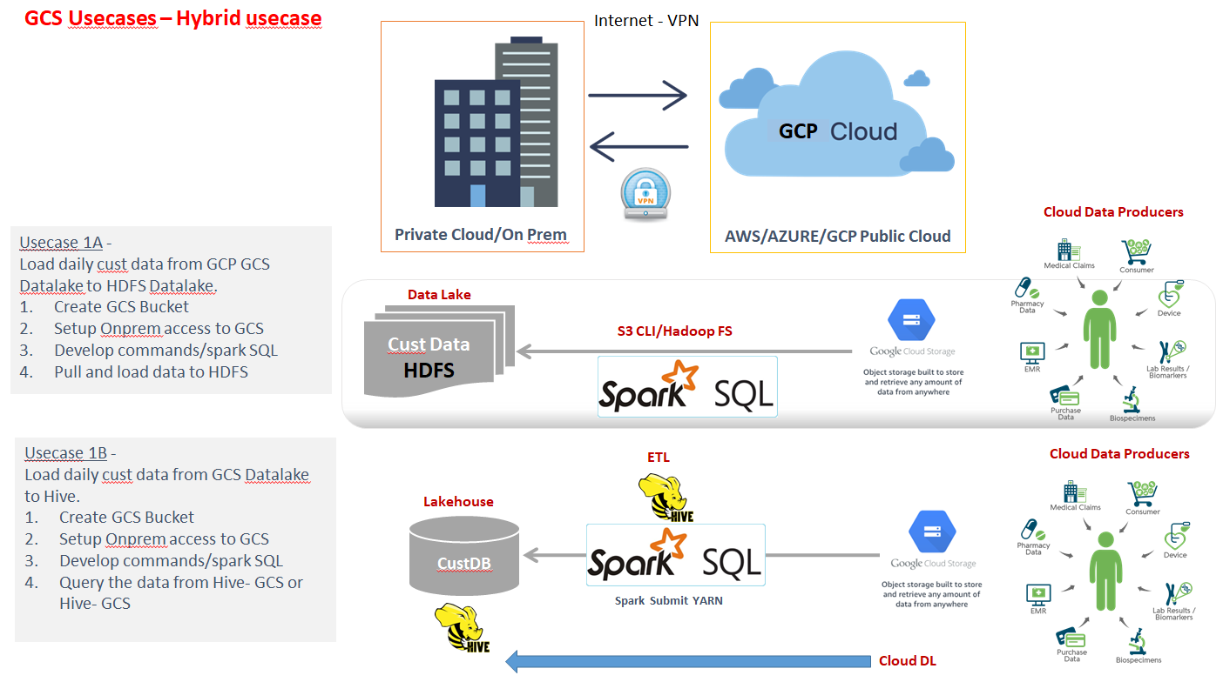

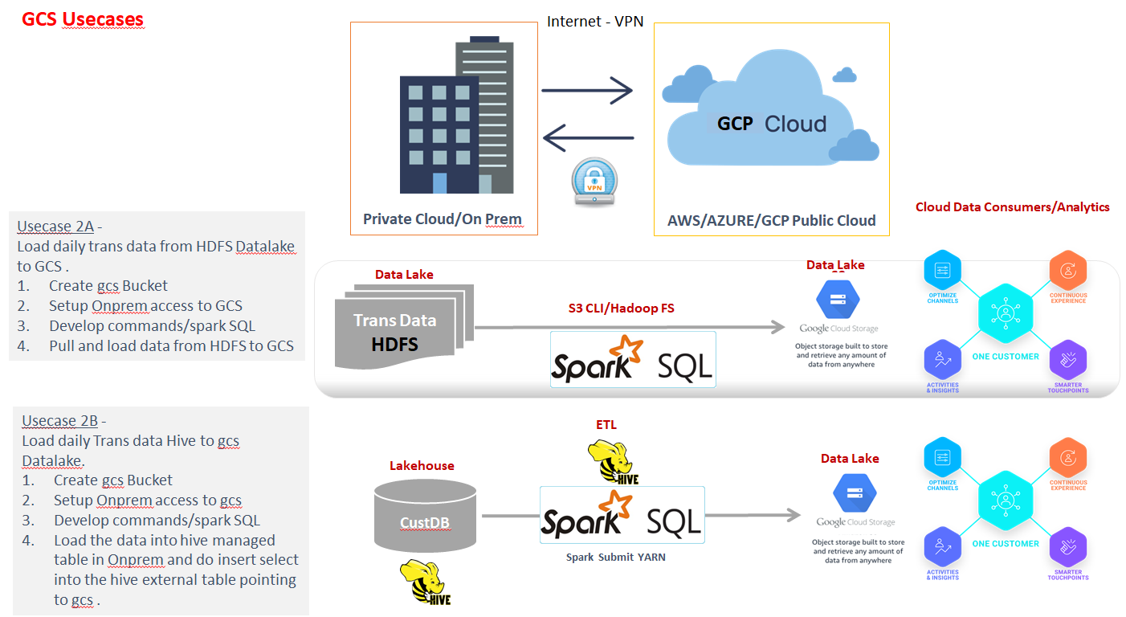

1. Prepare some data in our VM

hadoop fs -mkdir datatotransfer

hadoop fs -put /home/hduser/hive/data/custs /datatotransfer/

1. Place the below spark code and the service account json (uploaded in our gdrive) file inside /home/hduser/install

inceptez-wd-30-sa-key.json

gcs_job.py

1. Submit the spark job (if already you have copied the gcs-connector-hadoop-latest.jar in /usr/local/spark/jars location means, just delete it…)

**spark-submit --jars /home/hduser/install/gcs-connector-hadoop2-2.2.7.jar spark_gcs.py**

**Spark Code: (**we can use from third party tools with key-file no need of account or user to be added to project.That is how we are connecting from Pyspark)

from pyspark.sql.functions import *

from pyspark.sql.types import *

def main():

from pyspark.sql import SparkSession

# define spark configuration object

spark = SparkSession.builder\

.appName("HDFS - GCP GCS Read/Write") \

.enableHiveSupport()\

.getOrCreate()

#GCS Jar location

spark.sparkContext.setLogLevel("ERROR")

sc=spark.sparkContext

conf = spark.sparkContext._jsc.hadoopConfiguration()

conf.set("fs.gs.impl", "com.google.cloud.hadoop.fs.gcs.GoogleHadoopFileSystem")

conf.set("fs.AbstractFileSystem.gs.impl", "com.google.cloud.hadoop.fs.gcs.GoogleHadoopFS")

conf.set("google.cloud.auth.service.account.json.keyfile","/home/hduser/install/we30project-427ada2097c2.json")

#print("Data Transfer between HDFS to GCS and Vice versa")

hdfs_df=spark.read.csv("hdfs://localhost:54310/user/hduser/datatotransfer/")

print("HDFS Read Completed Successfully")

hdfscnt=hdfs_df.count()

curts = spark.createDataFrame([1], IntegerType()).withColumn("curts", current_timestamp()).select(date_format(col("curts"), "yyyyMMddHHmmSS")).first()[0]

print(curts)

hdfs_df.coalesce(1).write.csv("gs://com-inceptez-data-learn9-we41/custdata_"+curts)

gcs_df = spark.read.option("header", "false").option("delimiter", ",")\

.csv("gs://com-inceptez-data-learn9-we41/custdata_"+curts)

gcs_df.show(2)

gcscnt=gcs_df.count()

if (hdfscnt==gcscnt):

print("gcs Write Completed Successfully including Data Quality/Reconcilation check completed (equivalent to sqoop --validate)")

else:

print("gcs Write Issue")

main()

1. **HDFS Commands - Pull/push data into GCS bucket from HDFS (Cloud-Cloud) (Online Transfer)**
2. **Hive Queries - Pull/push data into GCS bucket from HDFS (Cloud-Cloud) (Online Transfer)**
3. **PySpark - Pull/push data into GCS bucket from HDFS (Cloud-Cloud) (Online Transfer)**

**VPC Networking:­­­­­**

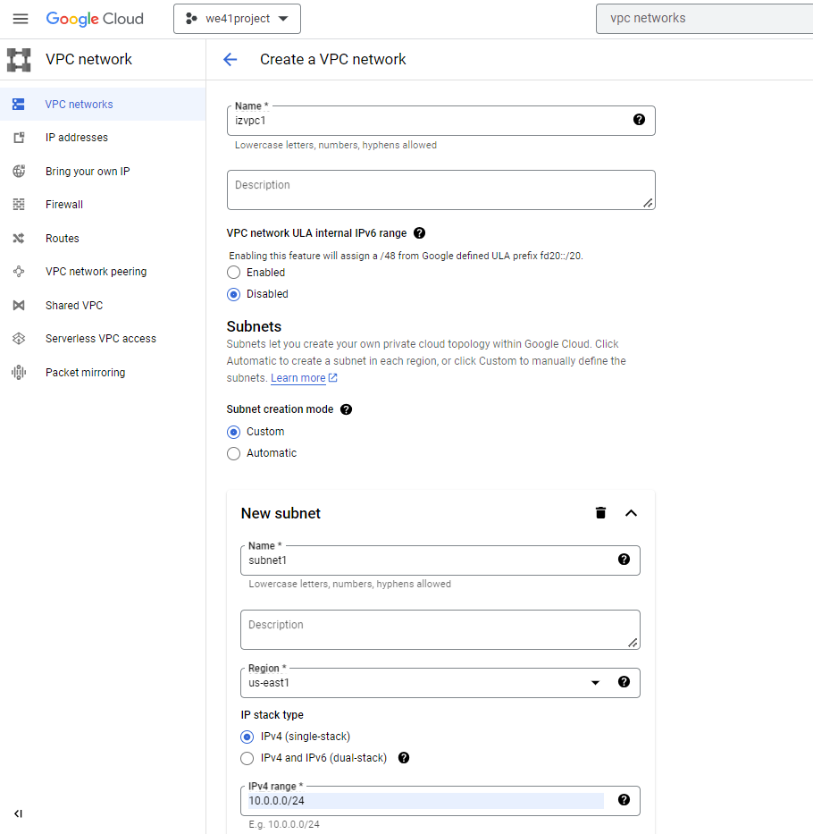

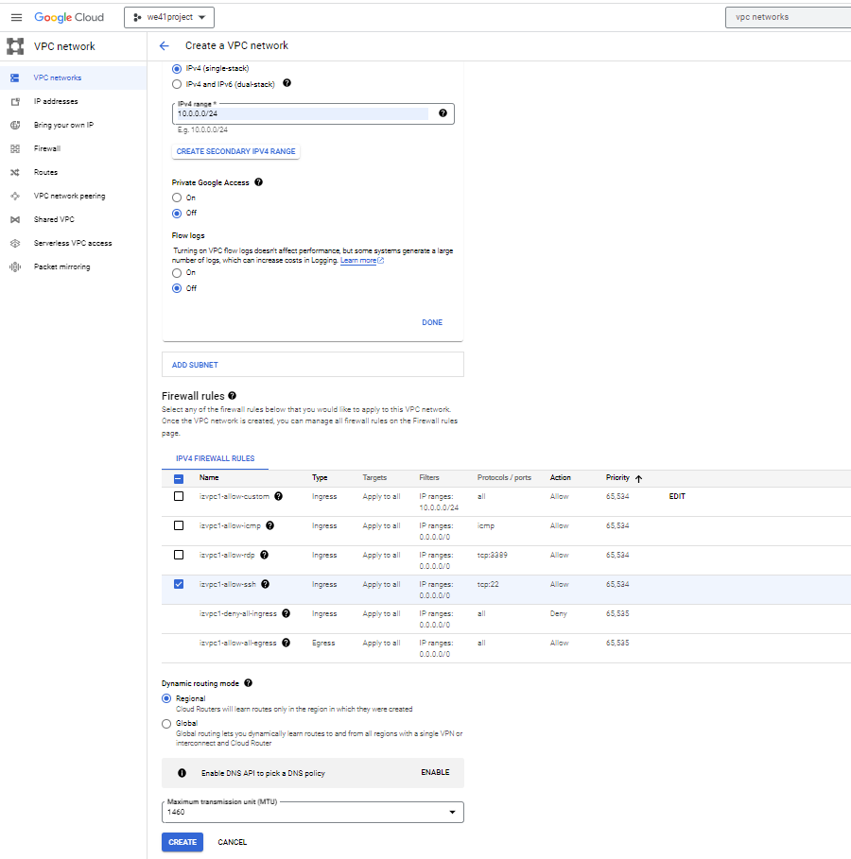

**Compute Engine (GCE Service):**

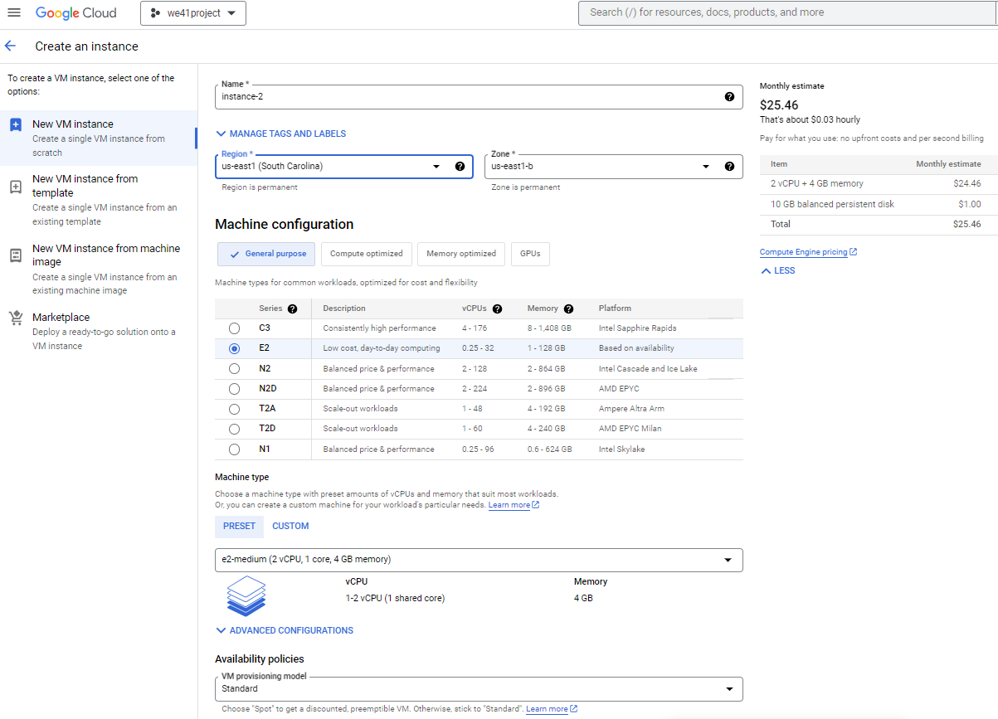

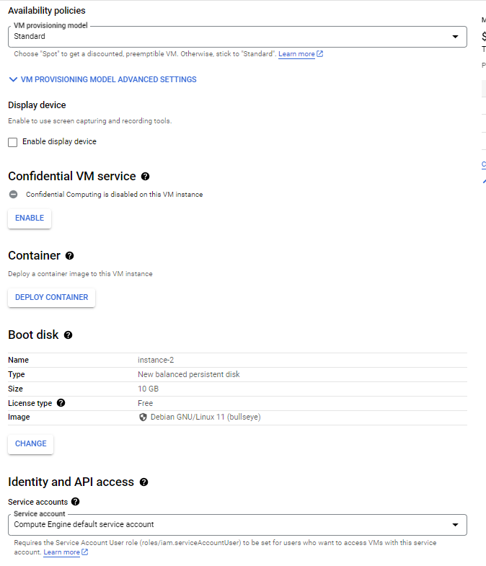

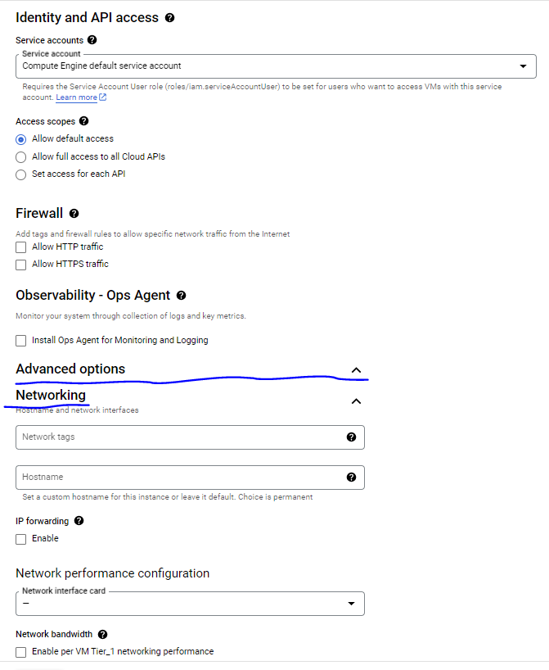

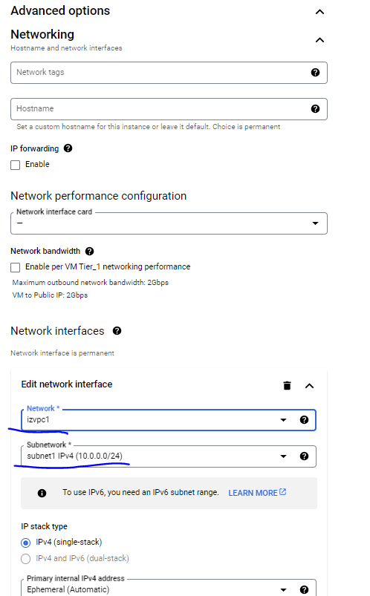

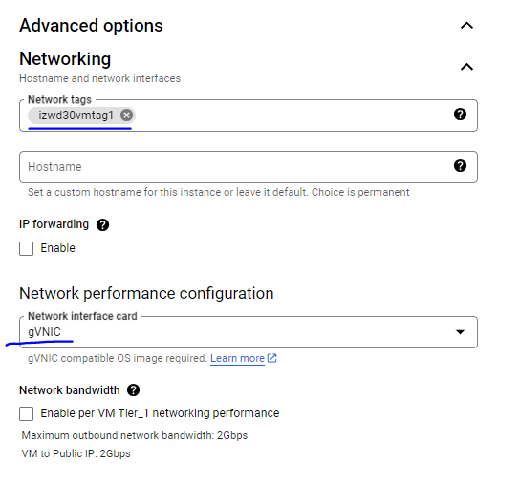

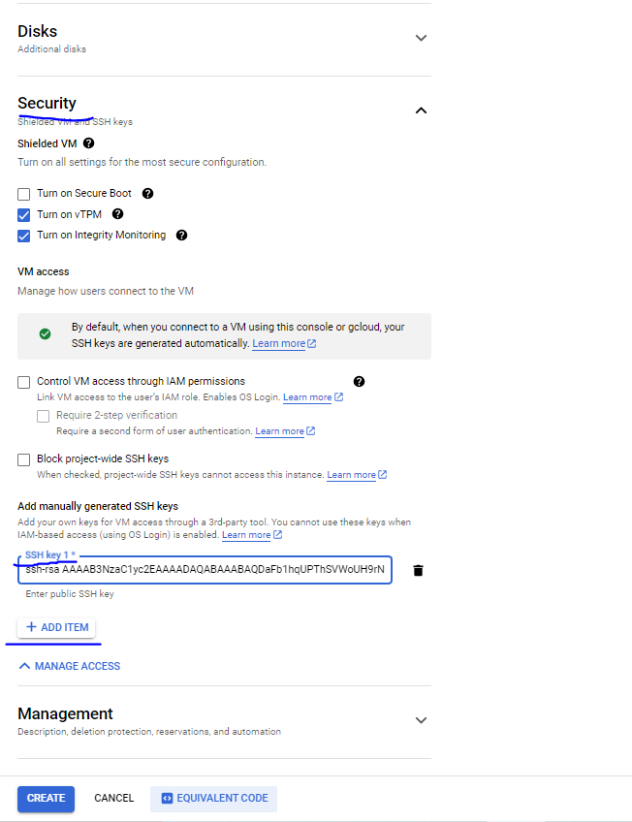



gcloud compute instances create wd30-instance1 --project=tactile-atlas-392806 --zone=us-east1-b --machine-type=e2-medium --network-interface=network-tier=PREMIUM,nic-type=GVNIC,stack-type=IPV4_ONLY,subnet=izwd30-sn1 --no-restart-on-failure --maintenance-policy=MIGRATE --provisioning-model=STANDARD --instance-termination-action=STOP --max-run-duration=10800s --service-account=706917108037-compute@developer.gserviceaccount.com --scopes=https://www.googleapis.com/auth/devstorage.read_only,https://www.googleapis.com/auth/logging.write,https://www.googleapis.com/auth/monitoring.write,https://www.googleapis.com/auth/servicecontrol,https://www.googleapis.com/auth/service.management.readonly,https://www.googleapis.com/auth/trace.append --tags=izwd30vmtag1,http-server,https-server --create-disk=auto-delete=yes,boot=yes,device-name=wd30-instance1,image=projects/debian-cloud/global/images/debian-11-bullseye-v20230814,mode=rw,size=50,type=projects/tactile-atlas-392806/zones/us-east1-b/diskTypes/pd-balanced --no-shielded-secure-boot --shielded-vtpm --shielded-integrity-monitoring --labels=goog-ec-src=vm_add-gcloud --reservation-affinity=any --deletion-protection

**Firewall:**

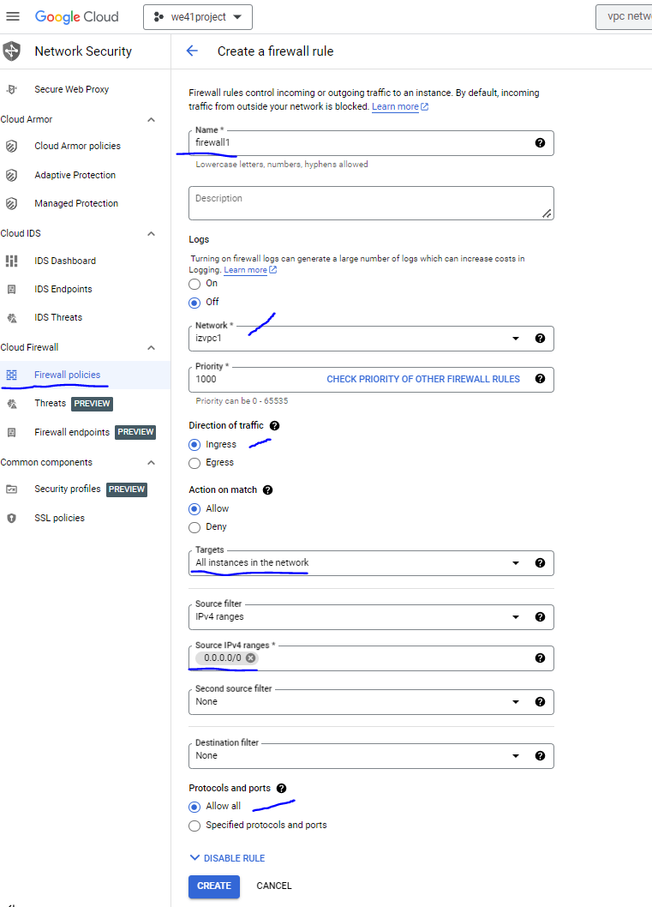

gcloud compute --project=tactile-atlas-392806 firewall-rules create izwd30-fw1 --description="to allow all instances in this network to be accessed by anyone using ssh port number 22" --direction=INGRESS --priority=1000 --network=iz-wd30-vpc --action=ALLOW --rules=all --source-ranges=0.0.0.0/0 --enable-logging

***To Connect with the VM Instance Created using gcloud ssh:***

ssh-keygen -t rsa -f ~/.ssh/cloud_sshkeywd30_new -C ashfaqalamlearning

cat ~/.ssh/cloud_sshkey3.pub

Edit the VM and add the above public key (lock) in the sshkey of the vm

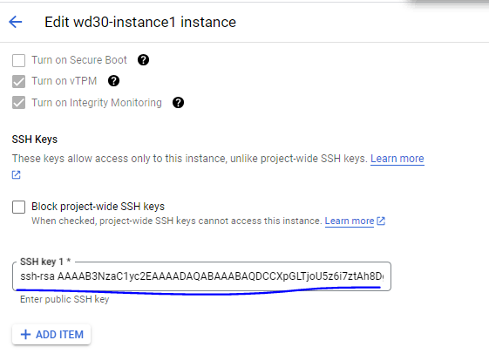

***Options to connect to the remote VM***

**Option1:** connect from the onprem edgenode (already pubkey and pvtkey handshake is made)

ssh ashfaqalamlearning@externalipaddr

[hduser@localhost .ssh]$ pwd

/home/hduser/.ssh

-rw-r--r--. 1 hduser hduser 400 Aug 23 08:57 cloud_sshkeywd30.pub

-rw-------. 1 hduser hduser 1679 Aug 23 08:57 cloud_sshkeywd30

$ssh [ashfaqalamlearning@35.225.78.185](mailto:ashfaqalamlearning@35.225.78.185)

**Option2:** connect from the onprem edgenode/windows using the username/sa name access

gcloud compute ssh --zone "asia-south1-a" "instance-1" --project "we30project"

**Option3:** connect from the onprem windows using the **private key provided** using putty tool

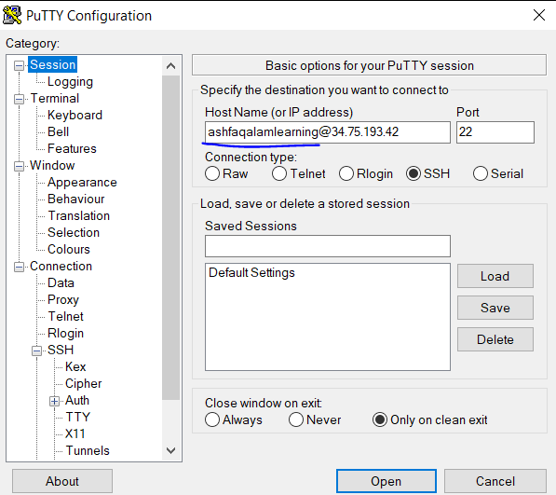

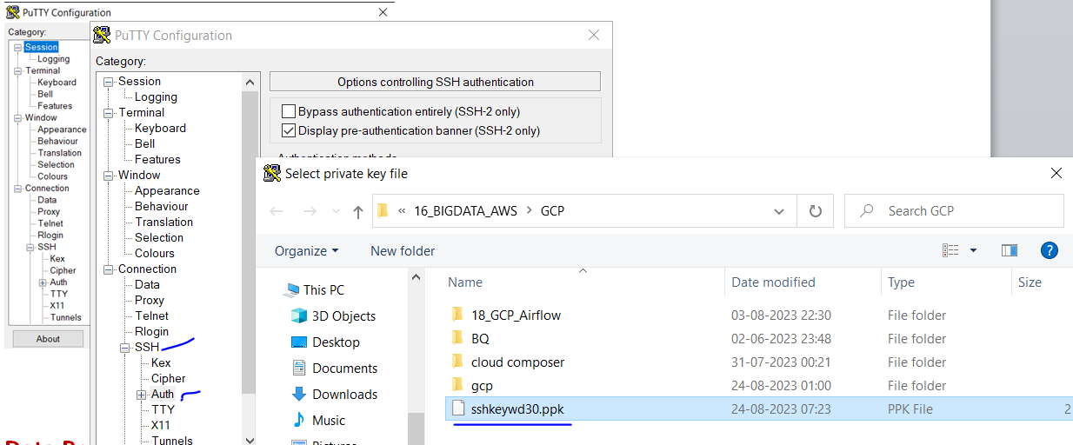

**Essential Services for DE & DA:**

**5th Service - Data Proc Service:**

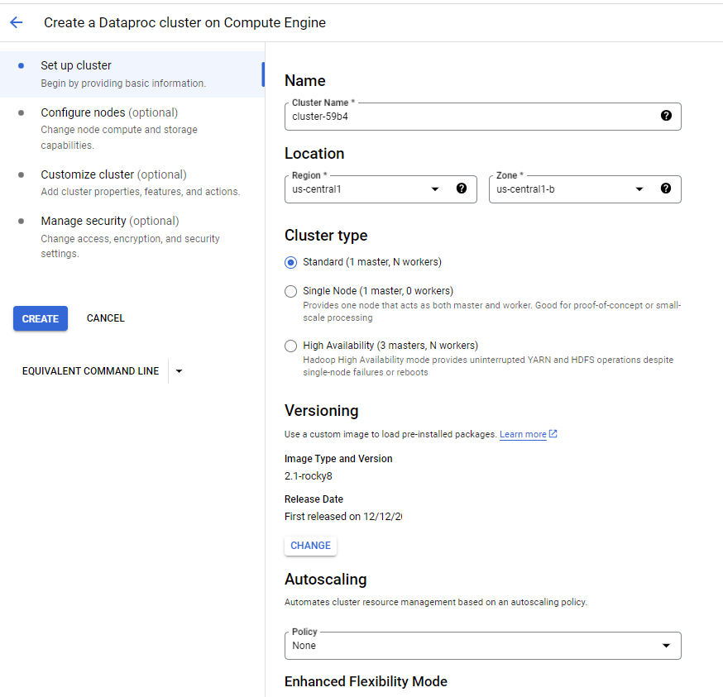

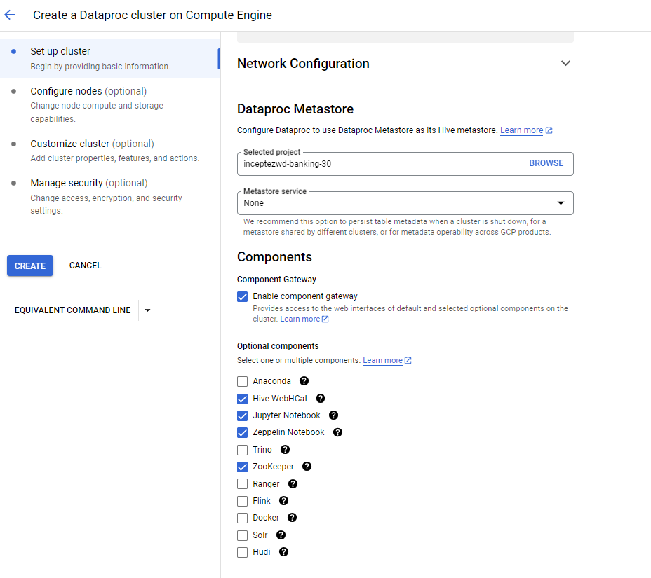

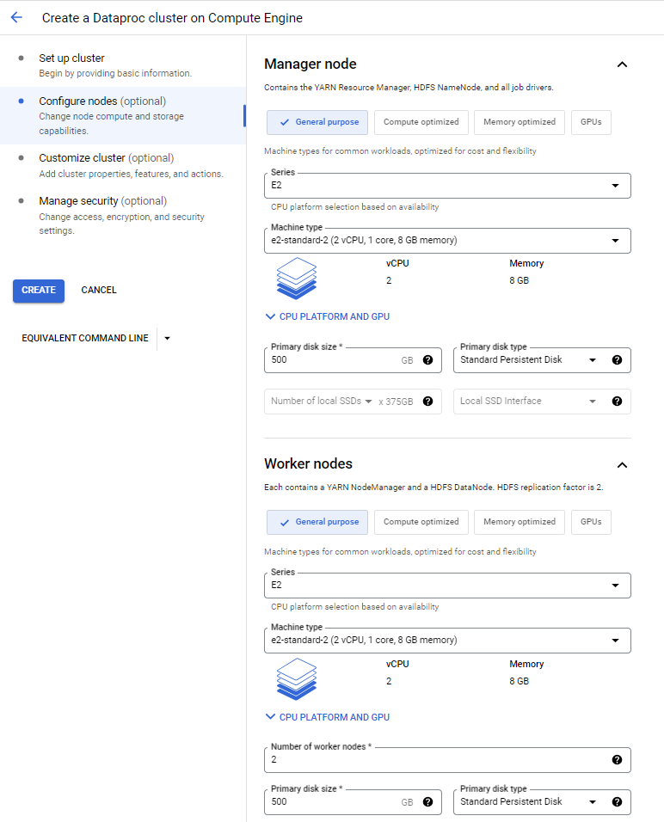

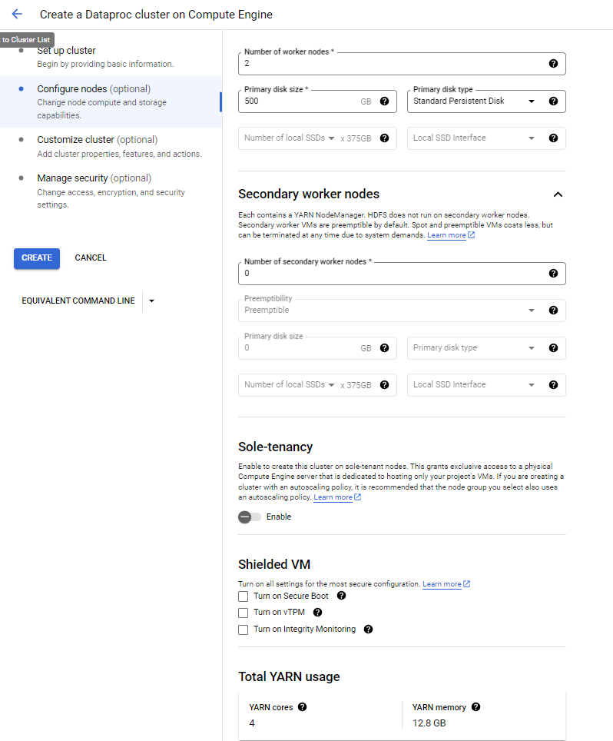

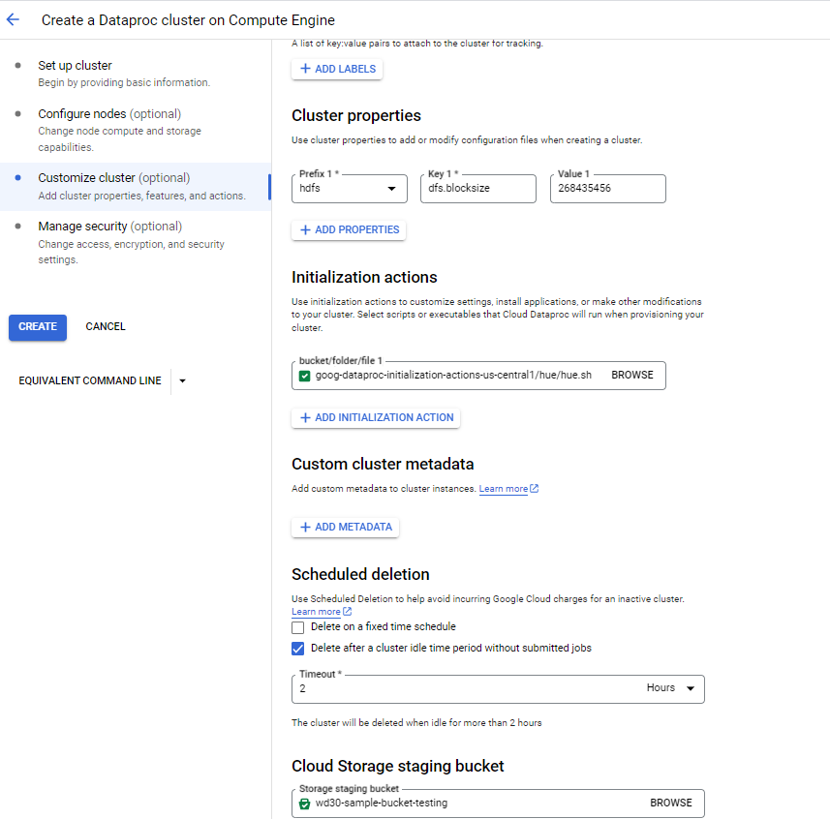

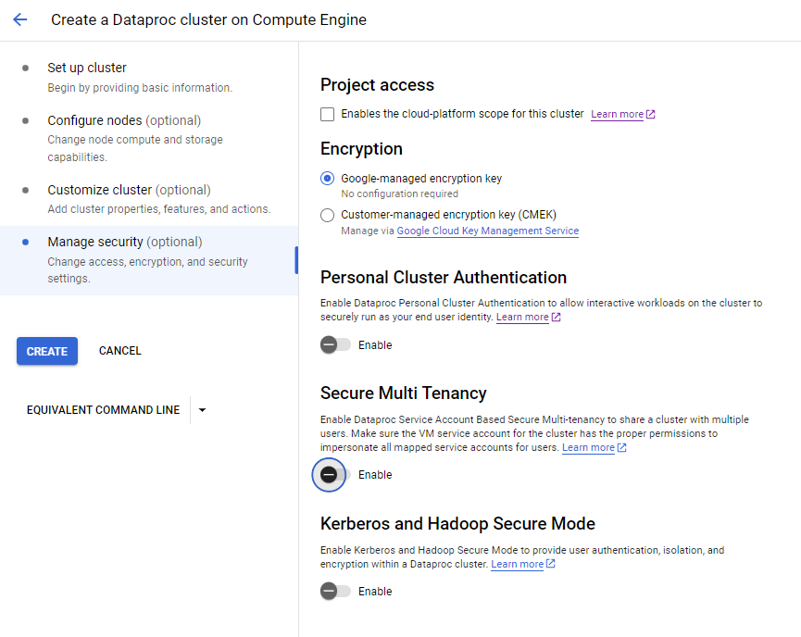

**Usecase3: Hive Usecase (Hybrid Cloud (SAAS Usecase) Long running cluster)**

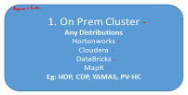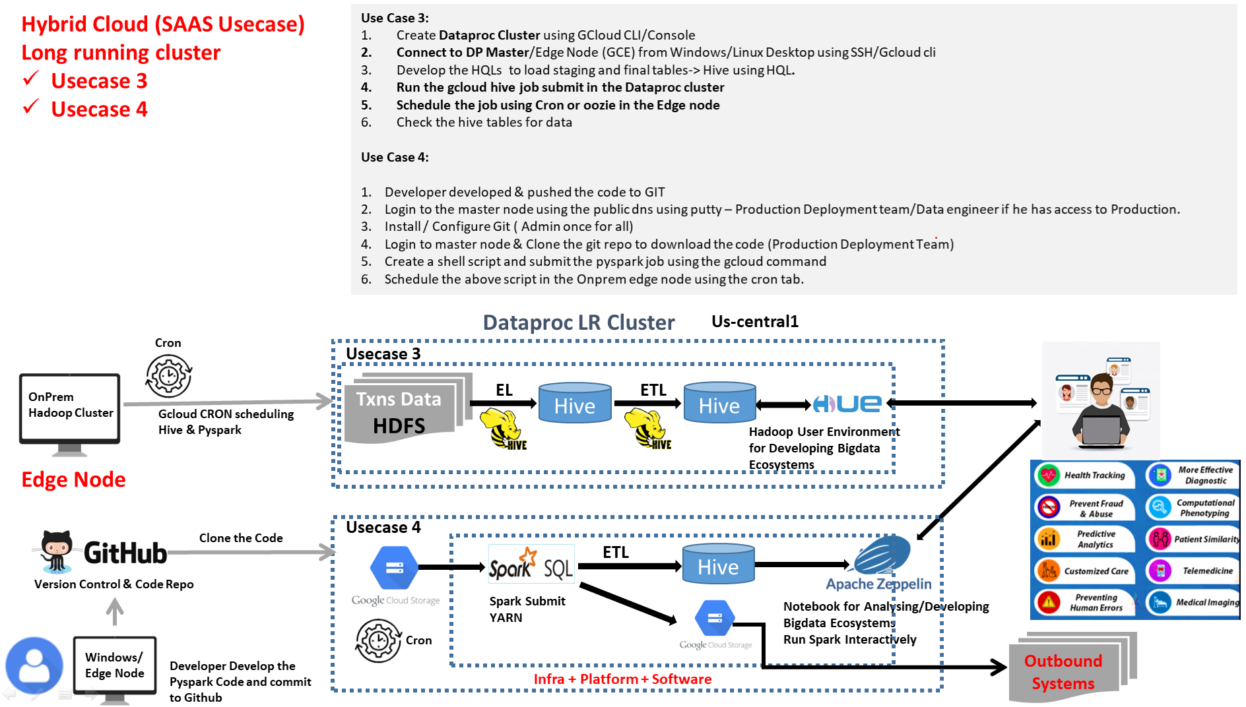

**Cron -> Shell Script -> data availability in HDFS -> Hive EL Raw Load (using hql)-> Hive ETL Curated/Discovery Load (using hql script with date param)-> generate hive reports (using web tools)**

1. **Once for all -** Create the Long running cluster (logging into the edge node of the onprem cluster):

***Note:******Modify the below projectname, bucket location, project name etc in the below***

gcloud dataproc clusters create cluster-iz-dplr --enable-component-gateway --bucket wd30-sample-bucket-testing --region us-east1 --zone us-east1-b --master-machine-type e2-standard-2 --master-boot-disk-size 500 --num-workers 2 --worker-machine-type e2-standard-2 --worker-boot-disk-size 500 --image-version 2.1-rocky8 --properties hdfs:dfs.blocksize=268435456 --optional-components HIVE_WEBHCAT,JUPYTER,ZEPPELIN,ZOOKEEPER --max-idle 7200s --initialization-actions 'gs://goog-dataproc-initialization-actions-us-east1/hue/hue.sh' --project tactile-atlas-392806

gcloud dataproc clusters describe cluster-iz-dplr --region=us-east1

1. **Once for all** - Open the Dataproc Master node **ssh (edge node of the cloud cluster)** and execute the below steps:

gcloud compute ssh --zone "us-east1-b" "cluster-iz-dplr-m" --project "tactile-atlas-392806"

sudo su hdfs

hadoop fs -mkdir -p /user/ashfaqalamlearning/project

hadoop fs -chmod -R 777 /user/ashfaqalamlearning

exit

**Get the data and code ready in the Dataproc cluster environment to use later**

hadoop fs -cp -f gs://incpetez-data-samples/dataset/txns /user/ashfaqalamlearning/project/ #done by source providers in a frequent interval

hadoop fs -cp -f gs://incpetez-data-samples/code/cust_etl.hql /user/ashfaqalamlearning/project #done by the deployment team

hadoop fs -cp gs://incpetez-data-samples/dataset/txns hdfs://cluster-iz-dplr-m/user/ashfaqalamlearning/project/

1. Run the below script or schedule in cron to run once in a day **(In our Centos VM)**:

**vi gcp_hive_schedule.sh**

#!/bin/bash

source /home/hduser/.bashrc

echo "`date` gcloud hive ETL script is started"

echo "`date` gcloud hive ETL script is started" &> /tmp/gcp_hive_schedule.log

**gcloud dataproc jobs submit** hive --cluster=cluster-iz-dplr --region us-east1 -e "create table if not exists transactions (txnno INT, txndate STRING, custno INT, amount DOUBLE,category string, product STRING, city STRING, state STRING, spendby STRING) row format delimited fields terminated by ',' stored as textfile" &> /tmp/gcp_hive_schedule.log

if [ $? -ne 0 ]

then

echo "`date` error occured in the hive table creation part of the EL" &> /tmp/gcp_hive_schedule.log

else

echo "`date` hive table creation part of the EL is completed successfully" &> /tmp/gcp_hive_schedule.log

fi

#in onprem I was calling hive queries like this “hive –e "load data inpath '/user/ashfaqalamlearning/project/txns' overwrite into table transactions" “

**gcloud** dataproc jobs submit hive --cluster=cluster-iz-dplr --region us-east1 -e "load data inpath '/user/ashfaqalamlearning/project/txns' overwrite into table transactions" &> /tmp/gcp_hive_schedule.log

if [ $? -ne 0 ]

then

echo "`date` error occured in the hive table load part of the EL" &> /tmp/gcp_hive_schedule.log

else

echo "`date` hive table load part of the EL is completed successfully" &> /tmp/gcp_hive_schedule.log

fi

loaddt=$(date '+%Y-%m-%d')

**gcloud dataproc jobs submit hive** --cluster=cluster-iz-dplr --region us-east1 --file=hdfs:///user/ashfaqalamlearning/project/cust_etl.hql --continue-on-failure --params=load_dt=$loaddt &> /tmp/gcp_hive_schedule.log

if [ $? -ne 0 ]

then

echo "`date` error occured in the hive table creation part of the EL" &> /tmp/gcp_hive_schedule.log

else

echo "`date` hive table creation part of the EL is completed successfully" &> /tmp/gcp_hive_schedule.log

fi

echo "`date` gcloud hive ETL script is completed" &> /tmp/gcp_hive_schedule.log

1. Create the below cust etl hql and place it in the gcs bucket.

hadoop fs -cp -f gs://incpetez-data-samples/code/cust_etl.hql /user/ashfaqalamlearning/project

**vi cust_etl.hql**

set mapreduce.input.fileinputformat.split.maxsize= 1000000;

set mapreduce.job.reduces=4;

set hive.exec.dynamic.partition.mode=nonstrict;

create external table if not exists ext_transactions(txnno INT, txndate STRING, custno INT, amount DOUBLE,category string, product STRING, city STRING, state STRING, spendby STRING) partitioned by (load_dt STRING)

row format delimited fields terminated by ','

stored as textfile

location '/user/ashfaqalamlearning/hiveexternaldata';

Insert into table ext_transactions partition (load_dt)

select txnno,txndate,custno,amount,category, product,city,state,spendby,'${hivevar:load_dt}'

from transactions ~~where loaddt>='${hivevar:load_dt}'~~;

1. To run the script manually

bash /home/hduser/gcplearn/gcp_hive_schedule.sh

1. Schedule the above script in the Onprem edge node using the cron tab.

hadoop fs -cp -f gs://incpetez-data-samples/dataset/txns /user/ashfaqalamlearning/project/ #done by source providers in a frequent interval

while true; do sleep 200; hadoop fs -cp -f gs://incpetez-data-samples/dataset/txns /user/ashfaqalamlearning/project/; done

crontab -e

*/5 * * * * /home/hduser/gcplearn/gcp_hive_schedule.sh

**Usecase 4 : Spark usecase – (Public Cloud (SAAS Usecase) Long running cluster)**

**Cron -> Shell Script -> Submit Spark job -> Read data from GCS -> load hive tables**

**-> user can generate hive reports at any time**

**Prerequisites (Issues to Fix):**

1. Change the bucket locations to your gcp bucket location when you write (where ever we are writing to the Inceptez buckets change to yours)
2. gcloud auth login gcloud config set account **your-cloud-admin-gmail-id@gmail.com**
3. gcloud config set project **your-project-id**

**Pyspark job submission in DP cluster:**

gcloud dataproc clusters create cluster-iz-dplr --region us-east1 --zone us-east1-b --enable-component-gateway --master-machine-type n1-standard-2 --master-boot-disk-size 200 --num-workers 3 --worker-machine-type n1-standard-2 --worker-boot-disk-size 200 --image-version 2.0-debian10 --max-age 10800s --optional-components ZEPPELIN --project inceptez-wd-394902

1. **Developer developed the pyspark code & pushed the code (Usecase4_GcpGcsReadWritehive_cloud.py) to GIT -** [**https://github.com/mohamedirfan/spark**](https://github.com/mohamedirfan/spark)

**#prerequisites**

**# Download the jar from https://storage.googleapis.com/hadoop-lib/gcs/gcs-connector-latest-hadoop2.jar**

**#spark-submit --jars /home/hduser/install/gcp/gcs-connector-latest-hadoop2.jar GcpGcsReadWritehivewe39_cloud.py**

**from pyspark.sql.functions import \***

**from pyspark.sql.types import \***

**def main():**

**from pyspark.sql import SparkSession**

**# define spark configuration object**

**spark = SparkSession.builder\**

**.appName("GCP GCS Hive Read/Write") \**

**.enableHiveSupport()\**

**.getOrCreate()**

**spark.sparkContext.setLogLevel("ERROR")**

**sc=spark.sparkContext**

**conf = spark.sparkContext._jsc.hadoopConfiguration()**

**conf.set("fs.gs.impl", "com.google.cloud.hadoop.fs.gcs.GoogleHadoopFileSystem")**

**conf.set("fs.AbstractFileSystem.gs.impl", "com.google.cloud.hadoop.fs.gcs.GoogleHadoopFS")**

**print("Use Spark Application to Read csv data from cloud GCS and get a DF created with the GCS data in the on prem, "**

**"convert csv to json in the on prem DF and store the json into new cloud GCS location")**

**print("Hive to GCS to hive starts here")**

**custstructtype1 = StructType([StructField("id", IntegerType(), False),**

**StructField("custfname", StringType(), False),**

**StructField("custlname", StringType(), True),**

**StructField("custage", ShortType(), True),**

**StructField("custprofession", StringType(), True)])**

**gcs_df = spark.read.csv("gs://incpetez-data-samples/dataset/custs",mode='dropmalformed',schema=custstructtype1)**

**gcs_df.show(10)**

**print("GCS Read Completed Successfully")**

**gcs_df.write.mode("overwrite").partitionBy("custage").saveAsTable("default.cust_info_gcs")**

**print("GCS to hive table load Completed Successfully")**

**print("Hive to GCS usecase starts here")**

**gcs_df=spark.read.table("default.cust_info_gcs")**

**curts = spark.createDataFrame([1], IntegerType()).withColumn("curts", current_timestamp()).select(date_format(col("curts"), "yyyyMMddHHmmSS")).first()[0]**

**print(curts)**

**gcs_df.repartition(2).write.json("gs://incpetez-data-samples/dataset/cust_output_json_"+curts) *#change to your cloud bucket location***

**print("gcs Write Completed Successfully")**

**print("Hive to GCS usecase starts here")**

**gcs_df=spark.read.table("default.cust_info_gcs")**

**curts = spark.createDataFrame([1], IntegerType()).withColumn("curts", current_timestamp()).select(date_format(col("curts"), "yyyyMMddHHmmSS")).first()[0]**

**print(curts)**

**gcs_df.repartition(2).write.mode("overwrite").csv("gs://incpetez-data-samples/dataset/cust_csv")  *#change to your cloud bucket location***

**print("gcs Write Completed Successfully")**

**main()**

1. **Login to the master/main node using the public ip/dns using putty – Jenkins CICD tool/Production Deployment team/Data engineer if he has access to Production.**
2. **Install / Configure Git (Admin once for all)**
3. **Login to master node & Clone the git repo to download the code (Production Deployment Team)**

#Deployment team or some automation tool like Jenkins

#sudo yum install git

git config --global user.name "mohamedirfan"

git config --global user.email "mohamedirfan@gmail.com"

git config --list

git init

cd .git/

wget https://github.com/mohamedirfan/spark.git

git clone <https://github.com/mohamedirfan/spark.git>

mkdir -p ~/project

cp /home/ashfaqalamlearning/.git/spark/**Usecase4_GcpGcsReadWritehive_cloud.py** ~/project

cp /home/ashfaqalamlearning/.git/spark/gcp_pyspark_yarn_client_schedule.sh ~/project

cp /home/ashfaqalamlearning/.git/spark/**gcp_pyspark_schedule.sh** ~/project

chmod 777 ~/project/*

bash ~/project/gcp_pyspark_yarn_client_schedule.sh

1. **Create a shell script and submit the pyspark job using the gcloud command**

**vi gcp_pyspark_yarn_client_schedule.sh**

#!/bin/bash

**gcloud dataproc jobs submit pyspark** --cluster=cluster-iz-dplr --region=us-east1 --zone us-east1-b --enable-component-gateway --properties="spark.driver.memory=2g","spark.executor.memory=2g","spark.executor.instances=4","spark.executor.cores=2","spark.submit.deployMode=client","spark.sql.shuffle.partitions=10","spark.shuffle.spill.compress=true" /home/ashfaqalamlearning/project/Usecase4_GcpGcsReadWritehive_cloud.py

#spark-submit --master yarn --mode client….

if [ $? -ne 0 ]

then

echo "`date` error occured in the Pyspark job" > /tmp/gcp_pyspark_schedule.log

else

echo "`date` Pyspark job is completed successfully" > /tmp/gcp_pyspark_schedule.log

fi

echo "`date` gcloud pyspark ETL script is completed" >> /tmp/gcp_pyspark_schedule.log

1. Schedule the above script in the **Dataproc Cloud edge node** using the cron tab.

crontab -e

*/5 * * * * /home/ashfaqalamlearning/project/gcp_pyspark_schedule.sh

1. To see the job run status and the resource dashboard

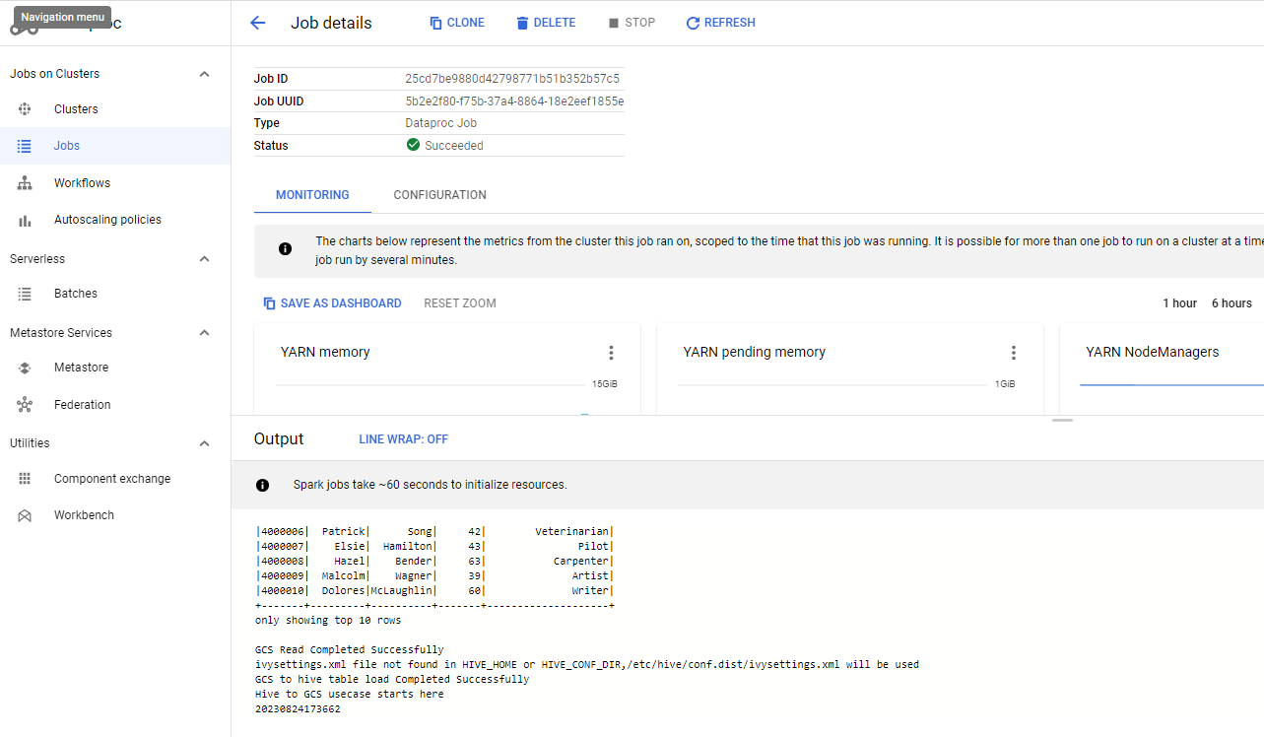

**Check whether the Hive table is loaded or not?**

gcloud dataproc jobs submit hive --cluster=cluster-iz-dplr --region=us-east1 -e="SELECT * FROM cust_info_gcs where custage>30"

**To stop the cluster temporarily:**

gcloud dataproc clusters stop cluster-iz-dplr --region=us-east1

***Note:*** *Applicable if the dp cluster doesn’t have secondary worker nodes or if doesn’t uses ssd storage for OS data store*

**To start the cluster:**

gcloud dataproc clusters start cluster-iz-dplr --region=us-east1

***Note: To delete the cluster permanently where all the hdfs/hive and all data will be deleted inside the cluster:***

gcloud dataproc clusters delete cluster-3f5f --region=us-east1

**Usecase 5 : Spark usecase – Public Cloud Cluster (Managed) (SAAS Usecase) Long running cluster**

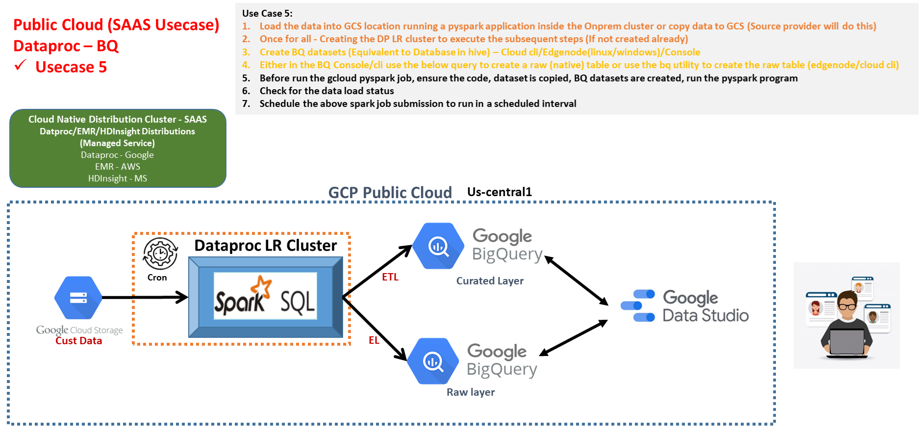

**Cron -> Shell Script -> data availability -> Create/Start Cluster (Once for all) -> Submit Spark job -> load BQ tables -> generate reports**

**Pyspark job submission in DP cluster:**

1. **Load the below cust data into GCS location (Source provider will do this)**

gsutil -m cp /home/hduser/hive/data/custs gs://incpetez-data-samples/dataset/

1. **Once for all - Creating the DP LR cluster to execute the subsequent steps (If not created already)**

gcloud dataproc clusters create cluster-iz-dplr --region us-east1 --zone us-east1-b --master-machine-type n1-standard-2 --master-boot-disk-size 100 --num-workers 3 --worker-machine-type n1-standard-2 --worker-boot-disk-size 100 --image-version 2.0-debian10 --max-idle 7200s --project inceptez-wd-394902

1. **Create BQ datasets (Equivalent to Database in hive) – Cloud cli/Edgenode(linux/windows)/Console**

bq mk rawds

bq mk curatedds

1. **Either in the BQ Console/cli use the below query to create a raw (native) table**

bq query --use_legacy_sql=false "create or replace table rawds.customer_raw(custno INT64, firstname STRING,lastname STRING,age INT64,profession STRING);"

**Or**

**use the bq utility to create the raw table (edgenode/cloud cli)**

bq mk --table --description "Raw cust table" \

we39project:rawds.customer_raw custno:INT64,firstname:STRING,lastname:STRING,age:INT64,profession:STRING

1. **Ensure to copy the code and data**

gsutil cp ~/hive/data/custs gs://incpetez-data-samples/dataset/

gsutil cp ~/gcplearn/Usecase5_gcsToBQRawToBQCurated.py gs://incpetez-data-samples/code/

1. **Pyspark BQ Code -** [**https://github.com/GoogleCloudDataproc/spark-bigquery-connector**](https://github.com/GoogleCloudDataproc/spark-bigquery-connector)

#**Note (Prerequisite): Please download the code from the below gcs bucket (**gs://incpetez-data-samples/code/Usecase5_gcsToBQRawToBQCurated.py**) and modify the buckets with your bucket where ever write is happening. For eg: change this bucket 'incpetez-data-samples/tmp' to your bucket**

#prerequisites

#gcloud dataproc jobs submit pyspark --cluster=wd28cluster --region=us-east1 /home/hduser/install/gcp/pyspark_bq.py

#gcloud dataproc jobs submit pyspark --cluster=wd28cluster --region=us-east1 --jars gs://com-inceptez-data/jars/spark-3.1-bigquery-0.27.1-preview.jar,gs://com-inceptez-data/jars/gcs-connector-latest-hadoop2.jar /home/hduser/install/gcp/gcsToBQRawToBQCurated.py

from pyspark.sql.functions import *

from pyspark.sql.types import *

def main():

from pyspark.sql import SparkSession

# define spark configuration object

spark = SparkSession.builder\

.appName("GCP GCS Read & Write to BigQuery") \

.getOrCreate()

spark.sparkContext.setLogLevel("ERROR")

sc=spark.sparkContext

conf = spark.sparkContext._jsc.hadoopConfiguration()

conf.set("fs.gs.impl", "com.google.cloud.hadoop.fs.gcs.GoogleHadoopFileSystem")

conf.set("fs.AbstractFileSystem.gs.impl", "com.google.cloud.hadoop.fs.gcs.GoogleHadoopFS")

print("Usecase5: Spark Application to Read from GCS and load to Bigquery (Raw) and load into another Bigquery (Curated) table in the GCP")

print("1. Ingestion layer data read from GCS - brought by some data producers")

gcs_df = spark.read.option("header", "false").option("delimiter", ",").option("inferschema", "true")\

.csv("**gs://**incpetez-data-samples/dataset/custs").toDF("custno","firstname","lastname","age","profession")

gcs_df.show()

print("1. GCS Read Completed Successfully")

print("Ensure to create the BQ datasets (rawds & curatedds) -> table creation (optional) ")

print("2. Writing GCS data to Raw BQ table")

# We need to set the below two properties to enable the inline view queries and dataset info

spark.conf.set("viewsEnabled","true")

spark.conf.set("materializationDataset","rawds")

#sourcesystem data -> pyspark DF -> write to temporaryGcsBucket -> read from GCS using a viewsEnabled -> store the final result materializationDataset -> 'rawds.customer_raw'

#db -> sqoop import -> hive (sqoop imports data from db and store the interiem data into HDFS (temp loc) -> hive table (load data inpath)

# We need to set the below properties to enable the temp GCS location ***(change to your GCS location)*** for bq write

gcs_df.write.mode("overwrite").format('bigquery') \

.option("temporaryGcsBucket",**'incpetez-data-samples/tmp'**)\

.option('table', 'rawds.customer_raw') \

.save()

#Execute the below steps if we have a seperate spark pipeline running to read data from BQ raw to the BQ curated

# gcs -> bqRawwrite -> bqRawread -> bqCuratedwrite

#(provided if the raw ingestion is managed by ingestion team and curation is taken care by curation team)

#print("Reading data from raw table and writing to BQ table in case if we create it as a seperate pipeline")

#sql = """select custno, concat(firstname,",", lastname) as name, age, coalesce(profession,"unknown") as profession from rawds.customer_raw where age>30""" #pushdown optimization

#print("raw BQ table to Curated BQ table load completed")

#df = spark.read.format("bigquery").load(sql)

#df.write.mode("overwrite").format('bigquery').option("temporaryGcsBucket",'incpetez-data-samples/tmp').option('table', 'curatedds.customer_curated').save()

print("3. GCS to Raw BQ raw table loaded")

# gcs -> bqRawwrite

# -> bqCuratedwrite

gcs_df.createOrReplaceTempView("raw_view")

curated_bq_df=spark.sql("select custno, concat(firstname,',', lastname) as name, age, coalesce(profession,'unknown') as profession from raw_view where age>30")

print("Read from rawds is completed")

# We need to set the below propertie to enable the temp GCS location for bq write

curated_bq_df.write.mode("overwrite").format('bigquery') \

.option("temporaryGcsBucket",'incpetez-data-samples/tmp')\

.option('table', 'curatedds.customer_curated') \

.save()

print("GCS to Curated BQ table load completed")

main()

1. **Before run the gcloud pyspark job, ensure the code, dataset is copied, BQ datasets are create**

gcloud dataproc jobs submit pyspark --cluster=**cluster-iz-dplr** --region=**us-east1** --jars gs://hadoop-lib/gcs/gcs-connector-hadoop3-2.2.7.jar,gs://spark-lib/bigquery/spark-3.1-bigquery-0.32.2.jar gs://incpetez-data-samples/code/Usecase5_gcsToBQRawToBQCurated.py

1. **Check for the data load status**

bq query --use_legacy_sql=false "select * from rawds.customer_raw limit 10"

1. **Schedule the above spark job submission to run in a scheduled interval (cron scheduler)**

Login to the master node using ssh, create a trigger_pyspark.sh, add the below cron entry in the crontab –e

**vi trigger_pyspark.sh**

#!/bin/bash

gcloud dataproc jobs submit pyspark --cluster=**cluster-iz-dplr** --region=**us-east1** --jars gs://hadoop-lib/gcs/gcs-connector-hadoop3-2.2.7.jar,gs://spark-lib/bigquery/spark-3.1-bigquery-0.32.2.jar gs://incpetez-data-samples/code/Usecase5_gcsToBQRawToBQCurated.py

if [ $? -ne 0 ]

then

echo "`date` error occured in the Pyspark job" > /tmp/gcp_pyspark_schedule.log

else

echo "`date` Pyspark job is completed successfully" > /tmp/gcp_pyspark_schedule.log

fi

echo "`date` gcloud pyspark ETL script is completed" >> /tmp/gcp_pyspark_schedule.log

crontab -e

*/2 * * * * /home/ashfaqalamlearning/trigger_pyspark.sh

**Usecase:6 – LR (Long Available if frequest start/stop of cluster in a given day is needed) Dedicated OnDemand Cluster Automation (Cost Saving)**

One major challenge in the LR cluster running for **24/7** is “costing too much”, how to reduce the cost?

Reason to go for Long **Available** cluster rather than Long **Running** cluster

* **First we can only perform EL/ELT/ETL using the cluster resources**
* **Avoid doing analytics using the cluster resources (hence use BQ rather than HIVE)**
* **My job is going to run on a scheduled fashion only on particular days of a week (Sunday, Tuesday, Thursday), any day adhoc run may happen**
* Source system/ML team -> trigger files (GCS) -> submit sparkjob in DP cluster
* Current scenario (continuous) – 24/7 we are running the cluster (30 nodes fixed slot) incurring 1000$ perday *(or 10 nodes fixed and 20 nodes autoscale even incur around 350$ perday)*
* **Solution arrived for cost saving** (on demand) – 30 nodes *5 hours * 3days per week -> 30 nodes * 15 hours running (700$ per week) rather running 30 nodes for 168 hours (7000$) – so cost saving is 7000$ per week to 700$ per week + stop time cost of the cluster for using the dataproc distribution & HDD storage (VM) 300$ = 700$+300$ =1000$ ***– 7 times cost saving we are achieving…***

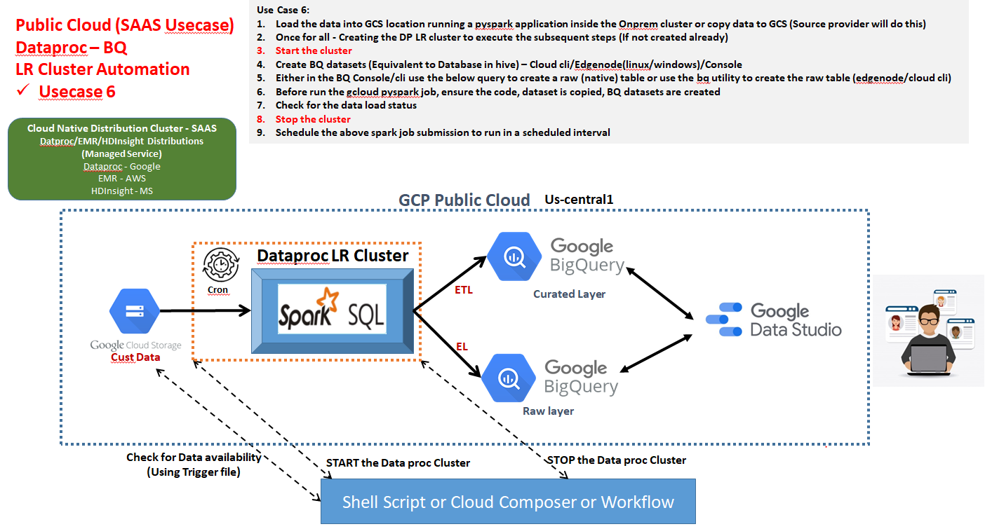

**Approach1 (usecase4): (We cannot go with usecase4 as is, hence moving from hive Lakehouse to BQ Biglake): Cron -> Shell Script -> data availability -> Start Cluster -> Submit Spark job -> ~~load hive tables -> generate hive reports~~ -> Stop Cluster**

***Drawback is – cluster is not available always to access the HDFS storage layer, hence storing the output to Bigquery/Bigtable/GCS is advisable than storing into hdfs and hive***

**Approach2 (usecase5): (Advisable, hence moving to BQ Biglake):**

**Cron -> Shell Script -> data availability -> Start Cluster -> Submit Spark job -> load BQ tables -> generate BQ reports (can happen any time even cluster is stopped) -> Stop Cluster**

Purpose of the below shell script is to reduce the cost incurred by running a LR cluster 24/7 – how?

Schedule the below script to run once in 10 minutes to check whether the file in the gcs location is present or not, if present start the cluster (which is in a stopped state now) then run the spark job then run the hive queries, after all the work is completed then stop the cluster.

1. **Source system load data on a regular interval**

**gsutil -m cp /home/hduser/hive/data/custs gs://incpetez-data-samples/dataset/**

**gsutil cp ~/gcplearn/custdata.trigger gs://incpetez-data-samples/dataset/custdata/**

1. **Create a Shell script to create cluster, submit job and stop the cluster once completed (FOR BETTER CUSTOMIZATION WE CREATE SHELL SCRIPTS).**

**gsutil cp gs://incpetez-data-samples/code/automate_lr_cluster_startstop_or_delete.sh ~/**

**vi /home/hduser/gcplearn/automate_lr_cluster_startstop_or_delete.sh**

set -x

# bash /home/hduser/gcplearn/automate_lr_cluster_**startstop**_or_delete.sh cluster-iz-dplr us-east1 us-east1-b gs://incpetez-data-samples/code/Usecase5_gcsToBQRawToBQCurated.py

clustername=$1

region=$2

zone=$3

scriptname=$4

cnt=`gcloud storage ls gs://incpetez-data-samples/dataset/custdata/*.trigger | wc -l`

if [ $cnt -ge 1 ]

then

clusterstate=`gcloud dataproc clusters list --region=$region --project=inceptez-wd-394902 | tr '\n' '-' | grep $clustername | awk -F'-' '{ print $7 }' | awk -F':' '{print $2}`

if [ $clusterstate == 'STOPPED' ]

then

echo "Cluster is stopped, hence starting it"

gcloud dataproc clusters **start** $clustername --region=$region --project=inceptez-wd-394902

elif [ $clusterstate == 'RUNNING' ]

then

echo "Cluster seems running, hence doing nothing…"

else

echo "No cluster is present, hence creating one"

gcloud dataproc clusters **create** $clustername --region $region --zone $zone --master-machine-type n1-standard-2 --master-boot-disk-size 200 --num-workers 3 --worker-machine-type n1-standard-2 --worker-boot-disk-size 100 --image-version 2.0-debian10 --max-age 7200s --project inceptez-wd-394902

fi

clusterstate=`gcloud dataproc clusters list --region=$region --project=inceptez-wd-394902 | tr '\n' '-' | grep $clustername | awk -F'-' '{ print $7 }' | awk -F':' '{print $2}`

if [ $clusterstate == 'RUNNING' ]

then

gcloud dataproc jobs submit pyspark --cluster=$clustername --region=$region --jars gs://hadoop-lib/gcs/gcs-connector-hadoop3-2.2.7.jar,gs://spark-lib/bigquery/spark-3.1-bigquery-0.32.2.jar --cluster=$clustername --region=$region $scriptname --project=inceptez-wd-394902

fi

if [ $? -eq 0 ]

then

echo "script completed – stopping/deleting the cluster"

gcloud dataproc clusters stop $clustername --region=$region --project=tactile-atlas-392806

#gcloud dataproc clusters delete $clustername --region=$region --project=tactile-atlas-392806

gsutil rm gs://incpetez-data-samples/dataset/custdata/*.trigger

else

echo "error occurred in the spark job"

fi

fi

1. **Run the script. (stop->provisioning->running->run job->stop)**

bash /home/hduser/gcplearn/automate_lr_cluster_startstop_or_delete.sh cluster-iz-dplr us-east1 us-east1-b gs://incpetez-data-samples/code/Usecase5_gcsToBQRawToBQCurated.py

1. **Schedule the script.**

**crontab -e**

*/10 6-10 * * * /home/hduser/gcplearn/automate_lr_cluster_startstop_or_delete.sh cluster-iz-dplr us-east1 us-east1-b gs://incpetez-data-samples/code/Usecase5_gcsToBQRawToBQCurated.py

**Usecase 7: Ephimeral cluster (if cluster is needed in a given days of the week is needed) automation (Cost Saving )**

* 30 nodes *5 hours * 3days per week -> 30 nodes * 15 hours running (700$ per week) rather running 30 nodes for 168 hours (7000$) – so cost saving is 7000$ per week to 700$ per week + ~~stop time cost of the cluster for using the dataproc distribution & HDD storage (VM)~~ ~~300$~~ = 700$~~+300$~~ =**700$** ***– 10 times cost saving we are achieving…***

Manually we have to do the following steps to run a spark program:

1. Create a Cluster with required configuration and machine types.

2. Execute the PySpark/Spark or Hadoop Job.

3. **Delete** the Cluster. (We loose all data, configs, we loose all settings, it takes time to create rather than just starting (initialization actions hue, oozie…))

4. Change the cluster stop to delete in the above script..

#gcloud dataproc clusters delete $clustername --region=$region

gcloud dataproc clusters delete $clustername --region=$region

**Usecase 8 : In the below usecase, we can Automate the same above process (usecase 7) using a different approaches (Approach 1: Cloud Scheduler & Approach2: Cloud Composer)**

1. **Schedule the pipeline using GCP Cloud Scheduler (service of GCP) rather than using ~~cron scheduler~~**
2. **Develop and automate the data pipeline Using Workflow Template feature of Dataproc, so we can automate the above steps, rather than creating ~~shell script~~**

**Worflow template (steps-jobs) -> Create DP Ephemeral cluster -> Run Pyspark jobs -> Terminate upon completion of the job (Managed cluster)**

**Worflow template (steps-jobs) -> Choose DP LR cluster -> Run Pyspark jobs -> Come out upon completion of the job (Cluster selector)**

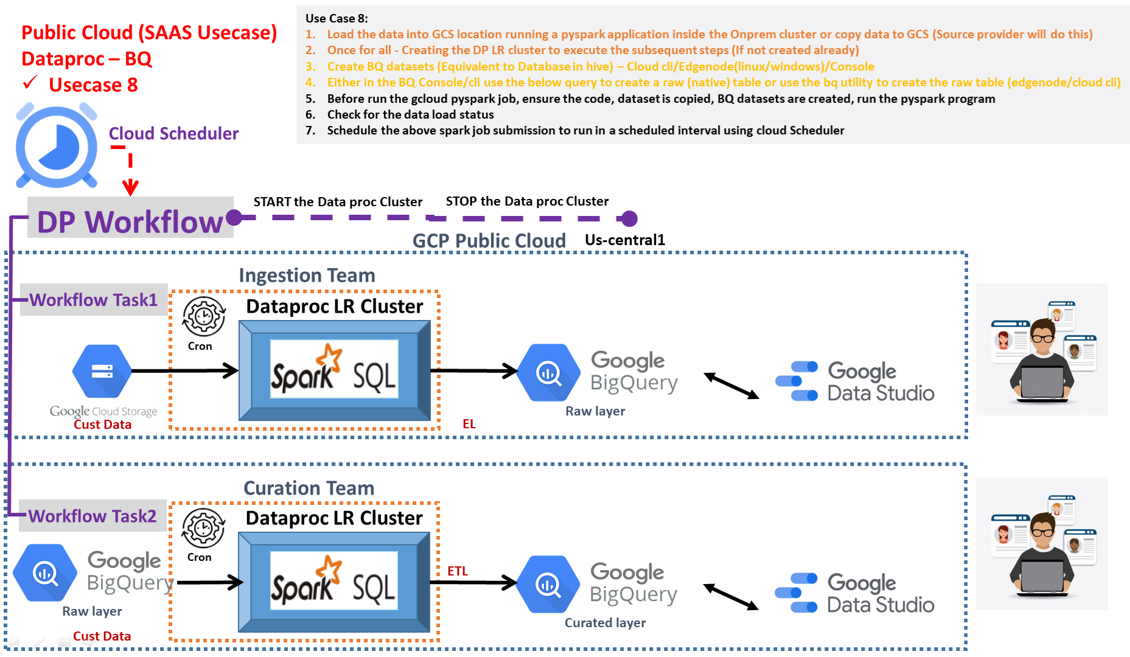

**What is Workflow Templates, Workflow (orchestrate by creating DAGs) and Jobs:**

The Dataproc [WorkflowTemplates API](https://cloud.google.com/dataproc/docs/reference/rest/v1/projects.regions.workflowTemplates) provides a flexible and easy-to-use mechanism for managing and executing workflows. A Workflow Template is a reusable workflow configuration

A Workflow is an operation that runs a Directed Acyclic Graph (DAG) of jobs on a cluster. If the workflow uses a ***managed cluster***, it creates the cluster, runs the jobs, and then deletes the cluster when the jobs are finished. If the workflow uses a ***cluster selector***, it runs jobs on a selected existing cluster.

* **Instantiating** a Workflow Template launches a Workflow. A Workflow is an operation that runs a Directed Acyclic Graph (DAG) of jobs on a cluster.
* If the workflow uses **a managed cluster**, it creates the cluster, runs the jobs, and then deletes the cluster when the jobs are finished.
* If the workflow uses a **cluster selector**, it runs jobs on a selected existing cluster.
* Workflows are ideal for **complex job flows**. You can create job dependencies so that a job starts only after its **dependencies** complete successfully.
* When you create a workflow template Dataproc does not create a cluster or submit jobs to a cluster. Dataproc creates or selects a cluster and runs workflow jobs on the cluster when a workflow template is ***instantiated***.

Ephemeral Cluster usecase using DP Workflow

1. Create a WorkFlow Template. (creating a blank shell script eg. vi shell1.sh)

gcloud dataproc workflow-templates create workflow-gcsbqbq-templatewd30 \

--region us-central1

2. Provide a Cluster Configuration and associate it to the workflow template.

**For Ephemeral Clusters:**

gcloud dataproc workflow-templates **set-managed-cluster** workflow-gcsbqbq-templatewd30 \

--region us-central1 --zone us-central1-b --master-machine-type n1-standard-2 --master-boot-disk-size 100 --num-workers 3 --worker-machine-type n1-standard-2 --worker-boot-disk-size 100 --image-version 2.0-debian10 --project inceptez-wd-394902

**Or**

**For LR Clusters:**

gcloud dataproc workflow-templates **set-cluster-selector** workflow-gcsbqbq-templatewd30 \

    --region=us-central1 \

    --cluster-labels=goog-dataproc-cluster-name=[singlenodecluster](https://console.cloud.google.com/dataproc/clusters/cluster-iz-dplr?region=us-central1&authuser=0&cloudshell=true&project=inceptez-wd-394902)

3. Provide a job script, assign a unique step-id and associate it to the workflow template.

Step1 – job1 addition to load data from gcs to bq raw:

**gcloud dataproc workflow-templates add-job** **pyspark** gs://incpetez-data-samples/code/Usecase8_step1_gcs_bq.py --step-id=step1-gcs-bqraw --jars="gs://hadoop-lib/gcs/gcs-connector-hadoop3-2.2.7.jar,gs://spark-lib/bigquery/spark-3.1-bigquery-0.32.2.jar" --workflow-template=workflow-gcsbqbq-templatewd30 --region=us-central1

Step2 – Job1 addition to the workflow to load data from bq raw to bq curated:

gcloud dataproc workflow-templates add-job pyspark gs://incpetez-data-samples/code/Usecase8_step2_bq_bq.py --step-id=step2-bqraw-bqcurated **--start-after=step1-gcs-bqraw** --jars="gs://hadoop-lib/gcs/gcs-connector-hadoop3-2.2.7.jar,gs://spark-lib/bigquery/spark-3.1-bigquery-0.32.2.jar" --workflow-template=workflow-gcsbqbq-templatewd30 --region=us-central1

4. Provide more jobs if required assigning unique step-id and associate them to workflow template.

Finally , instantiate the workflow template i.e. execute the workflow template which would create the cluster, run the jobs and finally delete the cluster(if it was a managed cluster).

gcloud dataproc workflow-templates instantiate workflow-gcsbqbq-templatewd30 --region=us-central1

5. To delete a step

gcloud dataproc workflow-templates remove-job workflow-gcsbqbq-template1 --step-id=step2-bqraw-bqcurated --region us-central1

**Approach1: Create a Cloud Scheduler (GCP Service) for scheduling job and schedule the Workflow (Orchestrator) to run.**

**What is Cloud Scheduler Service of GCP?**

Cloud Scheduler is a fully managed enterprise-grade cron job scheduler. It allows you to schedule virtually any job, including batch, big data jobs, and Cloud infrastructure operations. It provides simple time-based scheduling, for example, daily or hourly, without requiring you to write code.

**Advantages:**

* Enables time-based instantiation of workflow templates based on familiar cron expressions (crontab guru)
* No code to write

[**https://cloud.google.com/dataproc/docs/tutorials/workflow-scheduler**](https://cloud.google.com/dataproc/docs/tutorials/workflow-scheduler)



**Set the URL as given below:**

[https://dataproc.googleapis.com/v1/projects/**inceptez-wd-394902**/regions/**us-central1**/workflowTemplates/workflow-gcsbqbq-templatewd30:instantiate?alt=**json**](https://dataproc.googleapis.com/v1/projects/inceptez-wd-394902/regions/us-central1/workflowTemplates/workflow-gcsbqbq-templatewd30:instantiate?alt=json)

[https://dataproc.googleapis.com/v1/projects/**inceptez-wd-394902**/regions/**us-central1**/workflowTemplates/workflow-gcsbqbq-templatewd30:instantiate?alt=**json**](https://dataproc.googleapis.com/v1/projects/inceptez-wd-394902/regions/us-central1/workflowTemplates/workflow-gcsbqbq-templatewd30:instantiate?alt=json)

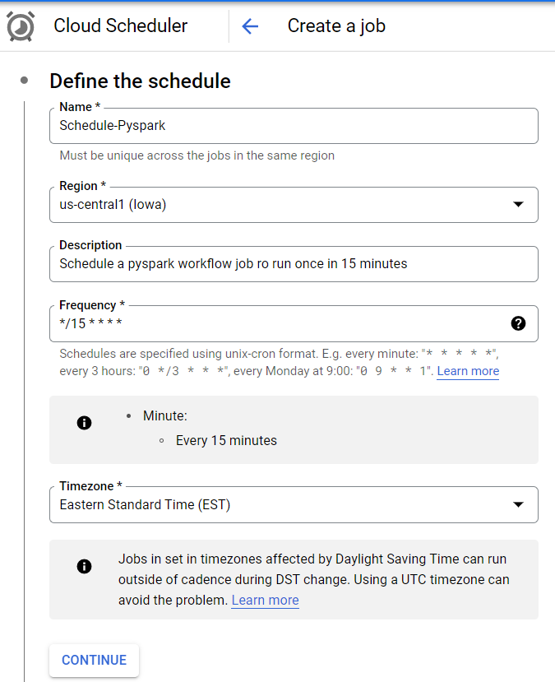

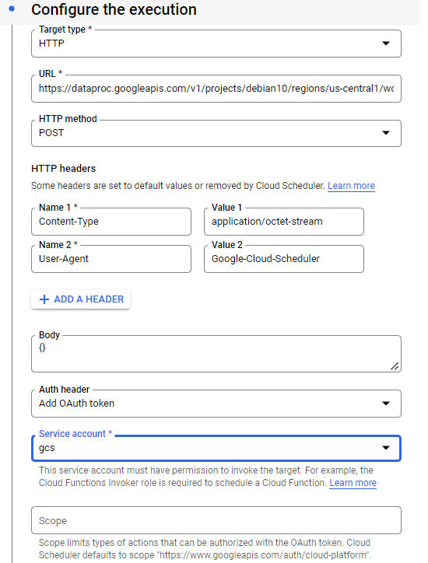

**Approach2: Create a Cloud Composer DAG (Orchestration) and schedule the Workflow to run**

**Create A cloud composer environment: Done by the Cloud Platform team, once for all..**

1. **Create a service account with composer administrator role**

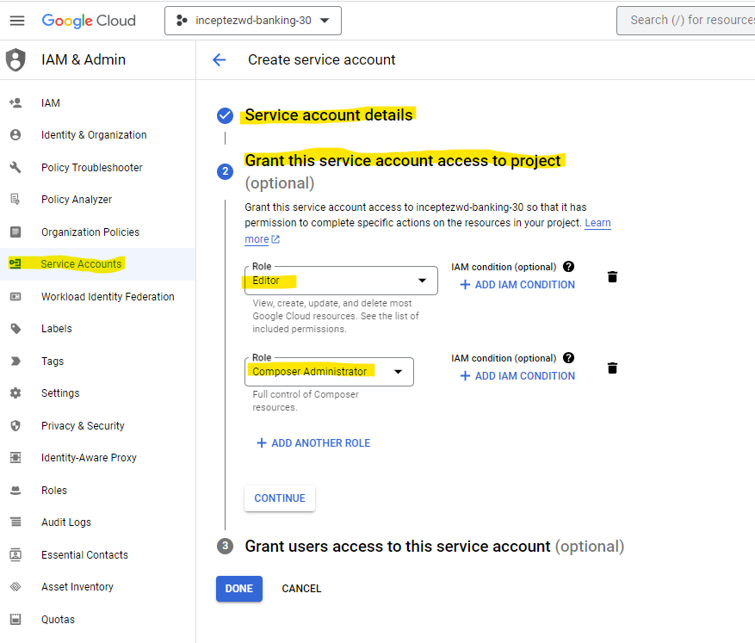

1. **Composer environment Creation:**
   1. **Once for all activity**
   2. **Performed by Cloud Platform Engineers/Admins**
   3. **Composer instances will run 24/7.**
   4. **All the project (Developers) will use the common (CC) Airflow Scheduler/Orchestrator as a common platform.**

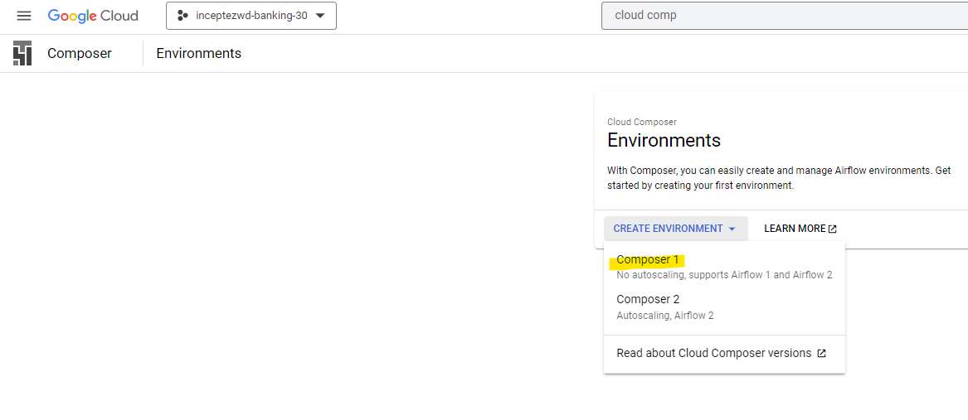

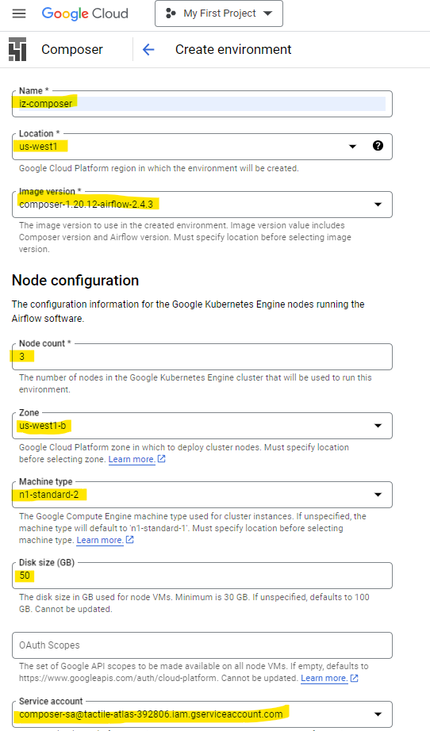

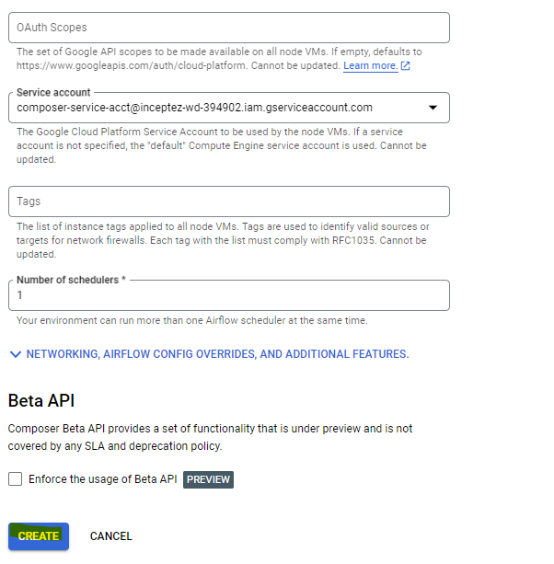

**Cloud Composer** is a managed Apache Airflow service you can use to create, schedule, monitor, and manage (orchestrating) workflows and any other cloud components.

**Advantages:**

* Supports time and ***event-based*** scheduling (sensor operators)
* Simplified calls to Dataproc using Operators (lot of functions (operators))
* Dynamically generate workflows and workflow parameters (DAG dynamically)
* Build data flows (Orchestration) that span multiple Google Cloud products (it support all the gcloud services orchestration and scheduling)

**Usecase 9: Create a Dataproc Cluster with single node and schedule the workflow to get triggered using the Cloud Composer DAG.**

***Development:***

* 1. Pyspark - py
  2. Workflow Template (cluster selector) – command line
  3. Airflow DAG – py

***Environment Readiness (once for all, done by Admin):***

* 1. **Dataproc *LR* Cluster – command line**
  2. **Cloud Composer cluster – WebGUI.**

**Note:** As we have only 8 total cores of processors available and we already created the Cloud composer instance with 6 cores, we can only create a single node cluster to work on this usecase

**Note: If you get any error, then fix by logging into the admin acct.**

ERROR: (gcloud.dataproc.clusters.create) PERMISSION_DENIED: Permission denied on resource project cluster-iz-dplr.

gcloud auth login

gcloud auth list

1. **Create a Single node LR Cluster**

gcloud dataproc clusters create singlenodecluster --region us-east1 --zone us-east1-a **--single-node --master-machine-type** n2-standard-2 --master-boot-disk-size 100 --image-version 2.1-debian11 --project tactile-atlas-392806

1. **Create a DP workflow template**

gcloud dataproc workflow-templates create workflow-gcsbq-template-composer-singlenodewd30 \

--region us-east1

1. **Add the cluster selector to the workflow template**

gcloud dataproc workflow-templates **set-cluster-selector** workflow-gcsbq-template-composer-singlenodewd30 \

--region=us-east1 \

--cluster-labels=goog-dataproc-cluster-name=singlenodecluster

1. **Add the job to the workflow template**

gcloud dataproc workflow-templates add-job pyspark gs://incpetez-data-samples/code/Usecase8_step1_gcs_bq.py --step-id=step1-gcs-bqraw --workflow-template=workflow-gcsbq-template-composer-singlenodewd30 --region=us-east1

1. **No need to instantiate the workflow manually, rather lets schedule using the *cloud composer***

#gcloud dataproc workflow-templates **instantiate** workflow-gcsbq-template-composer-singlenode --region=us-central1

1. **Create the Cloud composer Airflow DAG and submit the above workflow:**

import datetime

import pendulum

from airflow import models

from airflow.contrib.operators import dataproc_operator

from airflow.utils.dates import days_ago

project_id = "tactile-atlas-392806"

default_args = {

"start_date": pendulum.datetime(2023, 9, 6),

"project_id": project_id,

}

#airflow 1.8 -context manager, creating the object as dag

with models.DAG(

"dataproc_workflow_dag",

default_args=default_args,

schedule_interval="0 * * * *",

concurrency=1,

) as dag:

start_template_job = dataproc_operator.DataprocWorkflowTemplateInstantiateOperator(

# The task id of your job

task_id="dataproc_workflow_task1",

# The template id of your workflow

template_id="workflow-gcsbq-template-composer-singlenodewd30",

project_id=project_id,

region="us-east1"

)

**Copy the below dag dp_workflow_submit_dag.py in the cloud bucket location us-central1-iz-composer-4fa980c8-bucket/dags**

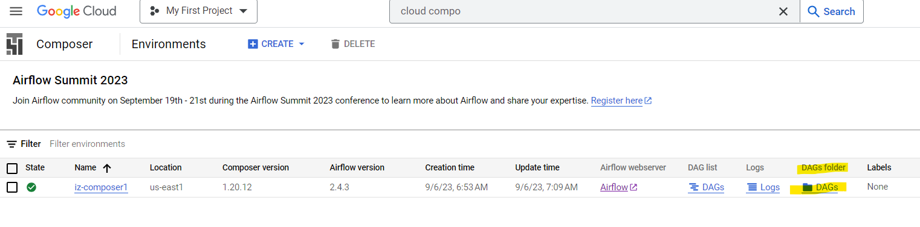

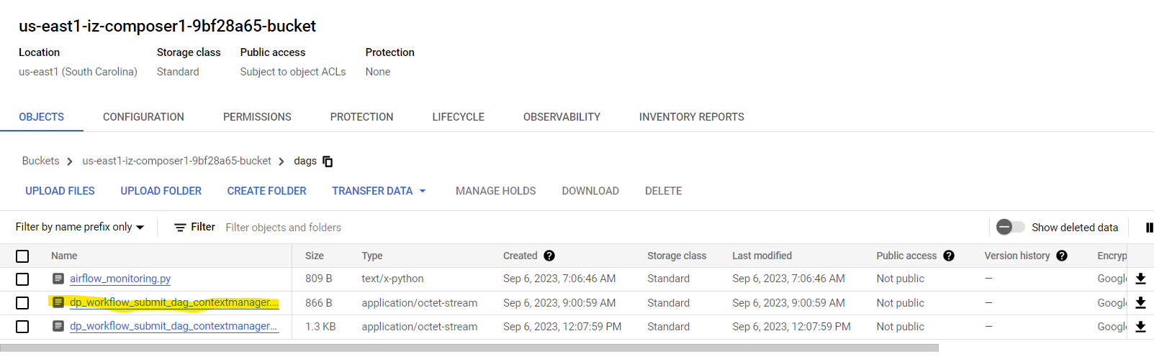

**Usecase 9.1: Create a Dataproc Cluster with single node and schedule the workflow to get triggered using the Cloud Composer DAG.**

***Development:***

* 1. Pyspark – py (load data from gcs to BQ)
  2. BQ Query file .sql (load data from BQ raw to BQ curated)
  3. Workflow Template (cluster selector) – command line
  4. **Airflow DAG (task1-DP workflow & task2-BQ file)– py**

***Environment Readiness (once for all, done by Admin):***

* 1. **Dataproc *LR* Cluster – command line**
  2. **Cloud Composer cluster – WebGUI.**

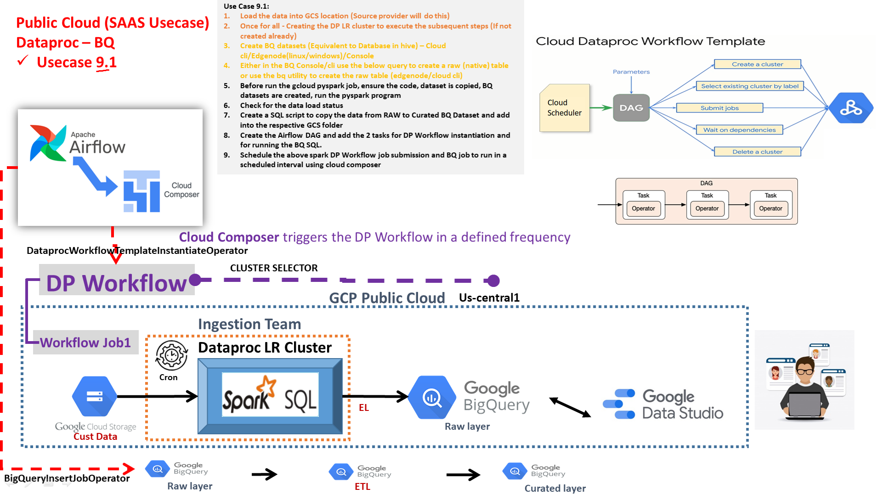

1. **Follow all the steps from Usecase9 from a to e and replace the f with this code:**

import datetime

import pendulum

from airflow import models

from airflow.contrib.operators import dataproc_operator

from airflow.providers.google.cloud.operators.bigquery import BigQueryInsertJobOperator

from airflow.utils.dates import days_ago

project_id = "tactile-atlas-392806"

default_args = {

"start_date": pendulum.datetime(2023, 9, 6),

"project_id": project_id,

}

with models.DAG(

"dataproc_workflow_dag_dataproc_bq",

default_args=default_args,

schedule_interval="*/30 * * * *",

concurrency=1,

template_searchpath="gs://incpetez-data-samples/code/curation_sql.sql"

) as dag:

start_template_task = dataproc_operator.DataprocWorkflowTemplateInstantiateOperator(

# The task id of your job

task_id="dataproc_workflow_task1",

# The template id of your workflow

template_id="workflow-gcsbq-template-composer-singlenodewd30",

project_id=project_id,

region="us-east1"

)

start_bq_task = BigQueryInsertJobOperator(

task_id="Curation_task2",

configuration={"query": {"query": "{% include 'curation_sql.sql' %}",

"useLegacySql": False}},

location="us-east1"

)

start_template_task >> start_bq_task

**Usecase10 : Spark Serverless : Submit the pyspark job in the serverless spark without worrying about the spark cluster management.**

**Benefits of Serverless:**

1. Faster availability
2. Maintenance
3. Cost effectiveness
4. Alternative for EPH and LA Clusters

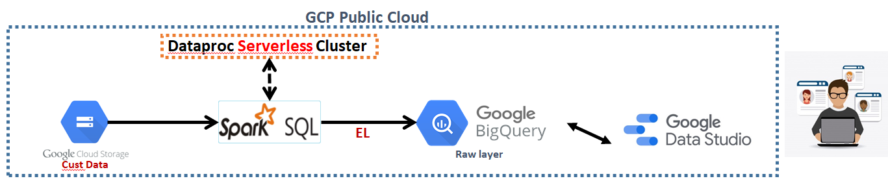

gcloud dataproc batches submit --project inceptez-wd-394902 \

--region us-central1 pyspark \

--batch **iz-serveless-spark-batch3** \

--properties="spark.executor.cores=4,spark.driver.cores=4,spark.executor.instances=2" \

--version 1.1 \

--subnet default \

--labels="label=iz_spark_serverless" \

gs://incpetez-data-samples/code/Usecase8_step1_gcs_bq.py

gcloud dataproc **batches** describe iz-serveless-spark-batch3 --region=us-central

--phs-server servername

--metastore-uri url

**Usecase 11: Dataproc AutoScaling**

**Benefits of Autoscaling:**

1. Variable workload requirements
2. Resource shortages or handling peak workload jobs.
3. Cost effectiveness
4. Alternative for EPH and LA Clusters

Cloud Dataproc autoscaling policies are reusable configurations that describe how clusters using the autoscaling policy should scale.

gcloud dataproc clusters create cluster-c15d **--autoscaling-policy autoscale2** --region us-central1 --zone us-central1-a --master-machine-type n2-standard-2 --master-boot-disk-size 100 --num-workers 2 --worker-machine-type n2-standard-2 --worker-boot-disk-size 100 --num-secondary-workers 1 --secondary-worker-boot-disk-type --secondary-worker-boot-disk-size 0 --num-secondary-worker-local-ssds 0 --image-version 2.1-debian11 --max-age 7200s --secondary-worker-type preemptible --project inceptez-wd-394902 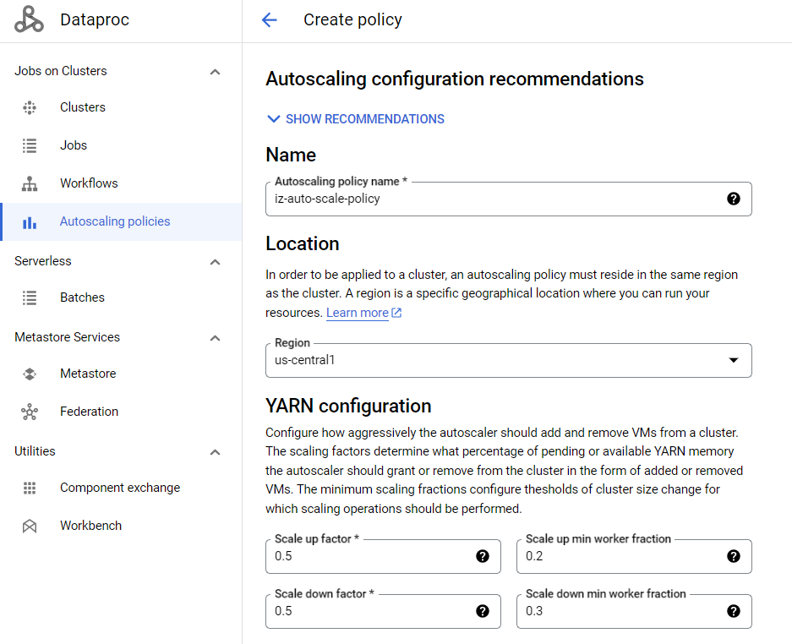 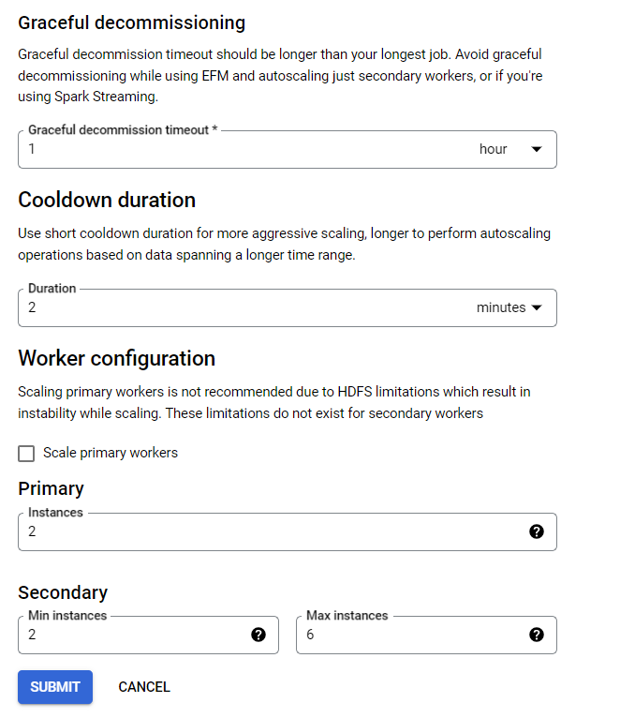

**BIGQUERY Usecases:**

Typical **Onprem** –

HDFS -> **Hive Load** -> Hive Managed table (Raw layer)-> ETL HQL (simply insert select) -> Hive Ext/managed table with orc/parquet with partition/bucketed (Curated)-> Tableau visualization

HDFS -> **refer the data** -> Hive external table (Raw layer)-> ETL HQL (simply insert select) -> Hive Ext/managed table with orc/parquet with partition/bucketed (Curated) -> Tableau visualization

**How we are going to implement the above same pipeline using cloud native solution (pure SAAS) ???**

**Don’t use spark or dataproc cluster, just complete the same task of loading the data from GCS to BQ and BQ using some utilities**

**Biquery Approach:**

GS -> **BQ Loader** -> BQ Native table (Raw layer)-> ETL BQL (insert select with some curation logic writterned) -> BQ managed table with bq native columnar format with partition/clustered (Curated)-> Looker/Datastudio visualization

HDFS -> **refer the data** -> Hive external table (Raw layer)-> ETL HQL (simply insert select) -> Hive Ext/managed table with orc/parquet with partition/bucketed (Curated) -> Tableau visualization

**Usecase1: Complete SAAS model (Very very important & must know usecase)**

**Pure Bigquery pipeline without using Opensource native components ~~Hive, Spark, Dataproc~~ rather only by using the GCloud native components BQ**

**Enable End to End Data pipeline using BigQuery across the Datalake Layers..:**

--bq query --use_legacy_sql=false "create schema rawds"

**gsutil cp gs://incpetez-data-samples/code/bq/usecase1_consumer_bq_raw_load.sql ~/**

**bq query --use_legacy_sql=false < usecase1_consumer_bq_raw_load.sql**

1. Load the Raw Layer using load commands:

***Either in the BQ Console or using bq command use the below query to create a raw tables***

**incpetez-data-samples/code/bq/usecase1_consumer_bq_raw_load.sql**

--drop table rawds.trans_online;

--drop table rawds.consumer;

--drop table rawds.trans_pos;

--drop table rawds.trans_mobile_channel;

--drop table curatedds.consumer_full_load;

--drop table curatedds.trans_online_part;

--drop table curatedds.trans_pos_part_cluster;

--drop table `curatedds.trans_mobile_autopart_2021`;

--drop table `curatedds.trans_mobile_autopart_2022`;

--drop table `curatedds.trans_mobile_autopart_2023`;

create schema if not exists rawds options(location='us-central1');

select current_timestamp,"Load started";

select current_timestamp,"Create and Load CSV data into BQ Managed table with defined schema";

--Complete Load (Delete/Truncate and Load)

LOAD DATA OVERWRITE `rawds.trans_pos` (txnno numeric,txndt string,custno int64,amt float64,category string,product string,city string, state string, spendby string)

FROM FILES (

format = 'CSV', uris = ['gs://incpetez-data-samples/dataset/bqdata/store_pos_product_trans.csv'],

field_delimiter=',');

select current_timestamp,"Create and Load JSON data into BQ Managed table using auto detect schema";

LOAD DATA OVERWRITE rawds.trans_online

FROM FILES (

format = 'JSON', uris = ['gs://incpetez-data-samples/dataset/bqdata/online_products_trans.json']);

select current_timestamp,"Create manually the table and Load CSV data into BQ Managed table, skip the header column in the file";

create table if not exists rawds.consumer(

custno INT64,

firstname STRING,

lastname STRING,

age INT64,

profession STRING);

LOAD DATA OVERWRITE rawds.consumer

FROM FILES (

format = 'CSV', uris = ['gs://incpetez-data-samples/dataset/bqdata/custs_header'],

skip_leading_rows=1,field_delimiter=',');

select current_timestamp,"Create the table using auto detect schema using the header column and Load CSV data into BQ Managed table";

LOAD DATA OVERWRITE `rawds.trans_mobile_channel`

FROM FILES (

format = 'CSV', uris = ['gs://incpetez-data-samples/dataset/bqdata/mobile_trans.csv'],

field_delimiter=',');

select current_timestamp,"Load completed Successfully";

1. ***Load the raw data from BQ Raw to the BQ Curated layer commands:***

Data governance/Stewards – Raw data discovery and Classification of the raw data before exposing to next layers. By creating views (Redaction/Masking) the data can be certified to use further for applicable tables.

*We are only inserting the data from source system to raw layer using BQ loaderbut we'll not get access in original table, data governance team will give access to views in another data set for procedding further like raw layer to curated layer.*

create view rawds.consumer_offshore_vw as

select custid,firstname,lastname,reverse(replace(lower(profession),'a','b')) profession from rawds.consumer

where profession <>'Librarian';

create view rawds.consumer_onshore_dgv as

select custid,firstname,lastname,sha1(profession) profession

from inceptez-wd-394902.rawds.consumer

where profession not in ('Judge')

limit 100;

**Data Engineers will do a Data Exploration/Data Discovery (EDA) -> Data Munging (Cleansing/Scrubbing) -> Transformation(Curation) -> Customization ->**

**gsutil cp gs://incpetez-data-samples/code/bq/usecase1_b_consumer_bq_curation_load.sql ~/**

**bq query --use_legacy_sql=false < usecase1_b_consumer_bq_curation_load.sql**

The **procedural language** using (declare, begin and end) lets you execute multiple statements in one (block) as a multi-statement query. You can create begin-end blocks to:

* Run multiple related/block/module of statements in a sequence.

**declare flag string;**

**Set flag as arg;**

**begin**

create temp table tbl1(id int64,name string) as select custid,firstname from rawds.consumer;

**if flag=’count’**

select count(*) from tbl1;

**else**

select max(id) from tbl1;

**end if;**

**end;**

* Automate management tasks such as creating or dropping tables once the end is found (temp table).
* Implement complex logic using programming constructs such as IF and WHILE/FOR.

**Business logic Implemented:**

1. Data Exploration/Discovery (EDA) – identify format of data, nulls, duplicates

--null check

select * from rawds.consumer where profession is null;

--duplicate check

insert into rawds.consumer select * from rawds.consumer where custid=4007830;

select custid,firstname,lastname,age,profession,count(1) from rawds.consumer

group by 1,2,3,4,5

having count(1)>1;

select count(custid)-count(distinct custid) from rawds.consumer;

--this query (select count(distinct *)) works in most of the dbs, but not in BQ directly...

select count(1) from

(select distinct custid,firstname,lastname,age,profession from rawds.consumer)inline_view;

--9989 distinct cnt

--9990 cnt

-- de-duplicate (avoid) removal (cleansing)

select custid,firstname,lastname,age,profession from

( ,row_number() over(partition by custid order by age desc) rnk from rawds.consumer)inline_view

where rnk=1;

SELECT custid,concat(firstname,' ',lastname),age,

extract(year from date_add(current_date,interval -`age`*12 month)) as yearofbirth,

--extract(year from current_date)-`age` as yearofbirth,

--case when profession is null then 'not provided' else profession end as profession,

coalesce(profession,'not provided') profession

,current_timestamp,date(current_timestamp) as loaddt

FROM

(select custid,firstname,lastname,age,profession,row_number() over(partition by custid order by age desc) rnk from rawds.consumer)inline_view

where rnk=1)tmp;

select current_date;

select date_add(current_date,interval -41*12 month);

select extract(year from date_add(current_date,interval -41*12 month));

1. Data Structurizations/Standardization/schema migration (nested data to simple data using ***unnest*** function)

select customerid,unnested_products from rawds.trans_online,unnest(products) as unnested_products

 limit 10;

1. Combining of columns (merging of fields), replacing of nulls…

declare loadts timestamp;

set loadts=(select current_timestamp());

--loadts=2023-09-10 10:23:10

begin

--How to achieve Complete Refresh (delete the entire target data and reload with the entire source data)

--option1:drop the existing table and recreate the table with the same structure then later reload the entire customer data (both structure and data deleted)

--option2:Truncate table and insert option can be used to load the table later (if the entire data has to be deleted) (entire data (only) deleted)

--option2:****insert overtwrite into table option is not supported in BQ as like hive

--option3:delete table (only the given date/hour) and insert option can be used later (entire/portion of data (only) deleted)

--interview questions: Difference between drop (create or replace table) (preference2), truncate (preference1) and delete(preference3).

--interview questions: Difference between Hive & Bigquery - (Bigquery doesn't support insert overtwrite and hive doesn't support create or replace table.

--interview questions: Difference between Hive & Bigquery - (Bigquery support delete and hive doesn't support Delete directly (we need some workaround)

create schema if not exists curatedds options(location='us-central1');

create or replace table curatedds.consumer_full_load(

custno INT64,

fullname STRING,

age INT64,

yearofbirth INT64,

profession STRING,

loadts timestamp,

loaddt date);

--truncate table curatedds.consumer_full_load;

--delete from curatedds.consumer_full_load where filters....;

--Biquery will support only date or integer columns type and not string for partitioning, where as hive supports string also

--Biquery will support only single partitioning columns (no multi level partition), where as hive supports multiple (multi level) partitions columns

--Syntax wise, bigquery can have the column for partition in both create table columns list and partition list also, where as hiveonly support the column in the partition which should not be defined in the create table columns list.

--Partition management in Bigquery is simplified eg. We don't have msck repair/refreshing of the partition by keeping data in hdfs are not needed as like hive (because hive has metadata layer and data layer seperated).

--*** Important - challenge in migrating from hive to BQ

-- Since, insert overtwrite into table option is not supported in BQ as like hive, we can't do insert overwrite partition also.

-- as a workaround, we have to delete the data seperately, then load into the partition table. delete from table where loaddt=loaddt(variable)

--Partitions can be created only on the low cardinal Date & Number columns, Maximum number of partitions can be only 4000

create table if not exists curatedds.trans_online_part

(transsk numeric,customerid int64,productname string,productcategory string,productprice int64,productidint int64,prodidstr string ,loadts timestamp,loaddt date)

partition by loaddt

OPTIONS (require_partition_filter = FALSE);

--require_partition_filter will enforce a mandatory partition filter to be used mandatorily for the user of the table

--Bigquery supports clustering (sorting and grouping/bucketing of the clustered columns) to improve filter and join performances

--BQ clustering is exactly equivalent to hive bucketing only syntax varies, symantics remains same...

--bq syntax(cluster by col1,col2..), hive syntax is (clustered by col1,col2... into 3 buckets sort by col1,col2)

create table if not exists curatedds.trans_pos_part_cluster

(txnno numeric,txndt date,custno int64,amount float64,category string,product string,city string, state string, spendby string,loadts timestamp,loaddt date)

partition by loaddt

cluster by custno,txnno,loaddt

OPTIONS (description = 'point of sale table with partition and clusters');

--Block1 for loading raw consumer data to the curated consumer table (Full Refresh) - using inline views (some name for the memory)

begin

--truncate table curatedds.consumer_full_load;

--clensing - de duplication

--scrubbing - replacing of null with some values

--curation (business logic) - concat

--Data enrichment - deriving a column from exiting or new column

--inline view (from clause subquery) is good for nominal data size, but not good for holding large volume of data in memory.. if volume is large, go with temp view.

insert into curatedds.consumer_full_load

SELECT custid,concat(firstname,' ',lastname),age,

extract(year from date_add(current_date,interval -`age`*12 month)) as yearofbirth,

--extract(year from current_date)-`age` as yearofbirth,

--case when profession is null then 'not provided' else profession end as profession,

coalesce(profession,'not provided') profession

,loadts,date(loadts) as loaddt

FROM (select custid,firstname,lastname,age,profession from

(select custid,firstname,lastname,age,profession,row_number() over(partition by custid order by age desc) rnk

from rawds.consumer)inline_view

where rnk=1)dedup;

end;

begin

--Temporary table concept in BQ - Temp table is a session table, that holds data in the underlying colossus store only rather than memory as like inline view, but exist only till the session exist (begin end).

--When we go for temp table, if we get some performance issue while handling very large volume of data (in inline views) which can't be hold in the memory, then use temp view.

--Temp table will help you reuse of some query result in multiple places inside the given block.

--Curation Logic -

--Converting from Semistructured to structured using unnest function (equivalent to explode in hive)

--generating surrogate key (unique identifier)

--Splitting of columns by extracting the string and number portion from the product column

--select regexp_replace('4B2A', '[^0-9]','')

--below stardardization will convert blankspace/nulls/number only to blankspace then to 'na', allow only the string portition to the target otherwise

--case when coalesce(trim(regexp_replace(lower(prod_exploded.productid),'[^a-z]','')),'')='' then 'na'

--adding some date and timestamp columns for load data.

--Reusability feature of temp table and performance feature of temp table.

--generate_uuid will generate unique id alphanumeric value, convert to number (hashing) using farm_fingerprint, make it positive value using abs function

create or replace temp table online_trans_view as

select abs(farm_fingerprint(generate_uuid())) as transk

,customerid

,prod_exploded.productname

,prod_exploded.productcategory

,prod_exploded.productprice

,cast(regexp_replace(prod_exploded.productid,'[^0-9]','') as int64) as prodidint

,case when coalesce(trim(regexp_replace(lower(prod_exploded.productid),'[^a-z]','')),'')=''

then 'na'

else regexp_replace(lower(prod_exploded.productid),'[^a-z]','')

end as prodidstr,

loadts,

date(loadts) as loaddt

from `rawds.trans_online` p,unnest (products) as prod_exploded;

----Nested

--4000015,[{Table,Furniture,440,34P},{Chair,Furniture,440,42A}]

--Unnested

--4000015,Table,Furniture,440,34P

--4000015,Chair,Furniture,440,42A

--visagan - I saw this delete statement based on load date with in our project in the begining of the each query file and they said its for job restartability/rerun of the jobs

delete from curatedds.trans_online_part where loaddt=date(loadts);

--as like hive, we don't need parition(), we can't use insert overwrite -

--insert overwrite table curatedds.trans_online_part partition(loaddt) select * from online_trans_view;

--in BQ we have to delete the partition explicitly and load the data, if any data is going to be repeated.

--Loading of partition table in BQ,

insert into curatedds.trans_online_part select * from online_trans_view;

--to understand reusability feature of the temp table created above.

--how to create a table structure from another table without loading data.

create table if not exists curatedds.trans_online_part_furniture as select * from online_trans_view where 1=2;

truncate table curatedds.trans_online_part_furniture;

insert into curatedds.trans_online_part_furniture select * from online_trans_view where productcategory='Furniture';

end;

begin

--CURATION logic

--date format conversion and casting of string to date

--data conversion of product to na if null is there

--converted columns/some of the selected columns in an order, are not selected again by using except function

insert into curatedds.trans_pos_part_cluster

SELECT txnno,parse_date('%m-%d-%Y',txndt) txndt,custno,amt,coalesce(product,'NA'),* except(txnno,txndt,custno,amt,product),loadts,date(loadts) as loaddt

FROM `rawds.trans_pos`;

end;

begin

--curation logic

--In the below usecase, storing the data into 3 year tables, because ...

--To improve the performance of picking only data from the given year table

--To reduce the cost of storing entired data in more frequent data access layer (active storage), rather old year may be accessed once in a quarter or half yearly or yearly which data is stored in (long term storage) of BQ saves the cost.

--Drawback is - we need to combine all these tables using union all or union distinct to get all table data in one shot, but BQ

--provides a very good feature of wild card search for the table names... eg. select * from `dataset.tablename*`

--merging of columns of date and time to timestamp column

--merging of long and lat to geopoint data type to plot in the google map to understand where was my customer when the trans was happening

--Usecases: autopartition (without defining our own partition, BQ itself will create and maintain the partition of the internal clock load date) - simply we can still create date partitions if we don't have date data in our dataset.

--geography datatype - is used to hold the long,lat gps (geo) coordinates of the location.

--wildcard table queries

--table segregation for all the above reasons mentioned.

--for current year 2023 date alone, we are making the future date as current date using INLINE VIEW/FROM CLAUSE SUBQUERY, to correct the data issue from the source.

CREATE TABLE if not exists curatedds.trans_mobile_autopart_2021

(txnno numeric,dt date,ts timestamp,geo_coordinate geography,net string,provider string,activity string,postal_code int,town_name string,loadts timestamp,loaddt date)

PARTITION BY

_PARTITIONDATE;

insert into `curatedds.trans_mobile_autopart_2021` (txnno,dt,ts,geo_coordinate,net,provider,activity,postal_code,town_name,loadts,loaddt)

select txnno,cast(dt as date) dt,timestamp(concat(dt,' ',hour)) as ts,ST_GEOGPOINT(long,lat) geo_coordinate,net,provider,activity,postal_code,town_name,loadts,date(loadts) as loaddt

from `rawds.trans_mobile_channel`

where extract(year from cast(dt as date))=2021;

CREATE TABLE if not exists curatedds.trans_mobile_autopart_2022

(txnno numeric,dt date,ts timestamp,geo_coordinate geography,net string,provider string,activity string,postal_code int,town_name string,loadts timestamp,loaddt date)

PARTITION BY

_PARTITIONDATE;

insert into curatedds.trans_mobile_autopart_2022 (txnno,dt,ts,geo_coordinate,net,provider,activity,postal_code,town_name,loadts,loaddt)

select txnno,cast(dt as date) dt,timestamp(concat(dt,' ',hour)) as ts,ST_GEOGPOINT(long,lat) geo_coordinate,net,provider,activity,postal_code,town_name,loadts,date(loadts) as loaddt

from `rawds.trans_mobile_channel`

where extract(year from cast(dt as date))=2022;

CREATE TABLE if not exists curatedds.trans_mobile_autopart_2023

(txnno numeric,dt date,ts timestamp,geo_coordinate geography,net string,provider string,activity string,postal_code int,town_name string,loadts timestamp,loaddt date)

PARTITION BY

_PARTITIONDATE;

insert into curatedds.trans_mobile_autopart_2023 (txnno,dt,ts,geo_coordinate,net,provider,activity,postal_code,town_name,loadts,loaddt)

select txnno,cast(dt as date) dt,timestamp(concat(dt,' ',hour)) as ts,ST_GEOGPOINT(long,lat) geo_coordinate,net,provider,activity,postal_code,town_name,loadts,date(loadts) as loaddt

from (select case when cast(dt as date)>current_date() then current_date() else dt end as dt,* except(dt) from `rawds.trans_mobile_channel`) t

where extract(year from cast(dt as date))=2023;

end;

end;

1. **Load the raw data from BQ Curated tables to the BQ Discovery/Analytical layer:**

Data Engineers - Wrangling -> Analytical functionalities..

**gsutil cp gs://incpetez-data-samples/code/bq/usecase1_c_consumer_bq_discovery_load.sql ~/**

**bq query --use_legacy_sql=false < usecase1_c_consumer_bq_discovery_load.sql**

create schema if not exists discoveryds options(location='us-central1');

create table if not exists discoveryds.consumer_trans_pos_mob_online

(txnno numeric,txndt date,custno int64,fullname string,age int64,profession string,trans_day string,trans_type string,net string,online_pos_amount float64,geo_coordinate geography,provider string,activity string,spendby string,city string,state string,online_pos_category string,product string,loadts timestamp,loaddt date);

--Data Wrangling - Joining and widening of the data and denormalization

--with clause query we call it as CTE - Common Table Expression

--Queries looks simple (since we are writing once) for both writing and reading

--Though it is same Query, it will run one time and loaded to memory and referenced multiple times

--enrichment, coverage of data (to avoid nulls), stitching of events generated by consumers accross multiple channels

--good for small volume of data

--by joining we are standardizing, wide table creation

insert into discoveryds.consumer_trans_pos_mob_online

with

pos_mob_trans as (select mob.txnno as mob_txnno,pos.txnno as pos_txnno,

case when mob.dt=pos.txndt then 'Same Day Trans'

else 'Multi Day Trans' end as trans_day,

coalesce(mob.dt,pos.txndt) as txndt,

case when mob.txnno is null then 'POS'

when pos.txnno is null then 'MOB'

else 'POS_MOB' end as trans_type,

mob.net,

pos.amount,

mob.geo_coordinate,

mob.provider,

case when mob.activity='STILL' then 'In Store Pickup' else mob.activity end as activity,

pos.spendby,pos.city,pos.state,

pos.product,pos.category,

pos.loadts pos_loadts,pos.loaddt pos_loaddt,mob.loadts mob_loadts,mob.loaddt mob_loaddt,pos.custno

from `curatedds.trans_mobile_autopart_20*` mob

full join `curatedds.trans_pos_part_cluster` pos

on mob.txnno=pos.txnno ),

cust_online_trans as (select *,case when transsk is not null then 'online' else null end as trans_type

from `curatedds.consumer_full_load` cust

left join `curatedds.trans_online_part` trans

on cust.custno=trans.customerid)

select coalesce(mob_txnno,pos_txnno) txnno,trans.txndt,trans.custno,fullname,age,profession,trans_day,coalesce(cust.trans_type,trans.trans_type) trans_type,coalesce(net,'na') net,coalesce(productprice,coalesce(amount,0.0)) online_pos_amount,geo_coordinate,coalesce(provider,'na') provider,coalesce(activity,'na') activity, coalesce(spendby,'na') spendby, coalesce(city,'unknown') city, coalesce(state,'unknown') state,coalesce(productcategory,category) online_pos_category,product,coalesce(pos_loadts,mob_loadts) loadts,coalesce(pos_loaddt,mob_loaddt) loaddt

from cust_online_trans cust left outer join pos_mob_trans trans

on trans.custno=cust.custno;

create table if not exists discoveryds.trans_aggr

(state string,city string,category string,product string,max_amt float64,min_amt float64,sum_amt float64,approx_cnt_cust int64,states_cnt int64,mid_amt_cnt int64,high_amt_cnt int64);

truncate table discoveryds.trans_aggr;

insert into discoveryds.trans_aggr

select state,city,category,product,max(amount) max_amt,min(amount) min_amt,sum(amount) sum_amt,

approx_count_distinct(t.custno) approx_cnt_cust,

countif(state in ('Nevada','Texas','Oregon')) as states_cnt,

countif(amount<100) mid_amt_cnt,

countif(amount>=100) high_amt_cnt

--count(case when amount<100 then 1 else 0 end) mid_amt_cnt

from (select t.txnno,c.custno,age,yearofbirth,profession,amount,category,product,city,state,spendby,net,provider,activity,t.txndt

from curatedds.consumer_full_load c

inner join curatedds.trans_pos_part_cluster t

on c.custno=t.custno

inner join `curatedds.trans_mobile_autopart_2023` t23

on t.txnno=t23.txnno) t

group by state,city,category,product;

1. Load the raw data from BQ Curated tables to the BQ Outbound Layer/Egress Layer/Downstream systems layer:

**gsutil cp gs://incpetez-data-samples/code/bq/usecase1_d_consumer_bq_Outbound_data_load.sql ~/**

**bq query --use_legacy_sql=false < usecase1_d_consumer_bq_Outbound_data_load.sql**

EXPORT DATA

OPTIONS (

uri = 'gs://incpetez-data-samples/dataset/bqexport/*.csv',

format = 'CSV',

overwrite = true,

header = true,

field_delimiter = ',')

AS (

select custno,txnno,search(category,'Outdoor') as outdoor_cat,category,strpos(category,'R') strpos_cat,rpad(category,30,' ') rpad_cat,reverse(category) rev_cat,

length(category) len_cat,

amount,

row_number() over(partition by custno order by amount) rownum_amt ,

rank() over(partition by custno order by amount) rnk_amt ,

dense_rank() over(partition by custno order by amount) densernk_amt ,

cume_dist() over(partition by custno order by amount) cumedist_amt,

first_value(amount) over(partition by custno order by amount) first_trans_amt,

nth_value(amount,3) over(partition by custno order by amount) third_highest_trans,

lead(amount) over(partition by custno order by amount) next_trans,

lag(amount) over(partition by custno order by amount) prev_trans,

from `curatedds.trans_pos_part_cluster`

where loaddt=current_date()

);

**--Usecase1 for end to end BQ DE pipeline is completed here……**

**_____________________________________________________________________________________**

**Few Additional supportive metadata Queries:**

**To see the structure of the table:**

SELECT *

FROM inceptez-wd-394902.rawds.INFORMATION_SCHEMA.COLUMNS

WHERE table_name = 'customer_raw_json';

**To see the ddl of the table:**

SELECT DDL

FROM inceptez-wd-394902.rawds.INFORMATION_SCHEMA.TABLES

WHERE table_name = 'customer_raw_json';

**To See the partition informations:**

select table_name,partition_id from inceptez-wd-394902.curatedds.INFORMATION_SCHEMA.PARTITIONS;

**To See the materialized view informations:**

SELECT * FROM inceptez-wd-394902.curatedds.INFORMATION_SCHEMA.TABLES  
WHERE table_type = 'MATERIALIZED VIEW';

**To create a BQ table using the cli using legacy sql(not much used other than using batch scripts)**

bq mk --table --description " Raw cust Native table" \

we39project:rawds.customer_raw_json custno:INT64,firstname:STRING,lastname:STRING,age:INT64,profession:STRING

**Preferred mechanism of writing bq script not using legacy sql, rather using ansi/iso standard sql:**

bq query –use_legacy_sql=**False** “create table we39project:rawds.customer_raw_json(custno INT64,firstname STRING,lastname STRING,age INT64,profession STRING);”

**To load the json data into the above NATIVE table**

#https://cloud.google.com/bigquery/docs/reference/standard-sql/other-statements#load_data_statement

bq load \

--autodetect \  
--replace \

--source_format=NEWLINE_DELIMITED_JSON \

we39project:rawds.customer_raw_json gs://incpetez-data-samples/dataset/cust_json.json

**Usecase2: Complete SAAS model (Very very important & must know usecase)**

**Pure Bigquery pipeline without using Opensource native components ~~Hive, Spark, Dataproc~~ rather only by using the GCloud native components BQ**

**Conceptes Covered:**

1. **BQ External Tables**
2. **BQ BigLake concept**

**Lakehouse** (if we enable DWH layer in Datalake platform in onprem)

hdfs/lfs/any other systems -> ext table hive -> query

**Biglake** (if we enable DWH layer in Datalake platform in cloud)

gcs/any other systems -> ext table bigquery -> query

1. **Incremental/Refresh data load (CDC) – SCD1 & SCD2**
2. **DML & Merge/Upsert Feature. Src(1,Chennai),(2,Hyderabad) -> Tgt(1,Mumbai-> Chennai) ,(2,Hyderabad)**
3. **Automation & Parameterization – using BQ Script and Stored Procedure**
4. **Dynamic SQL –**

**Building BQ frameworks (project -> GCS (sql queries) -> Cloud Function -> BQ-metasql -> Composer -> BQ SP <arg_query> -> query executed dynamically)**

**GCS – File (sql query – insert into curated table select * from raw table;)**

1. **Stored Procedure**

**Google BigLake (Hive Lakehouse):**

**External table created on top of any external storage layer (GCS/S3/Blob/Bigtable/Cloud spanner)**

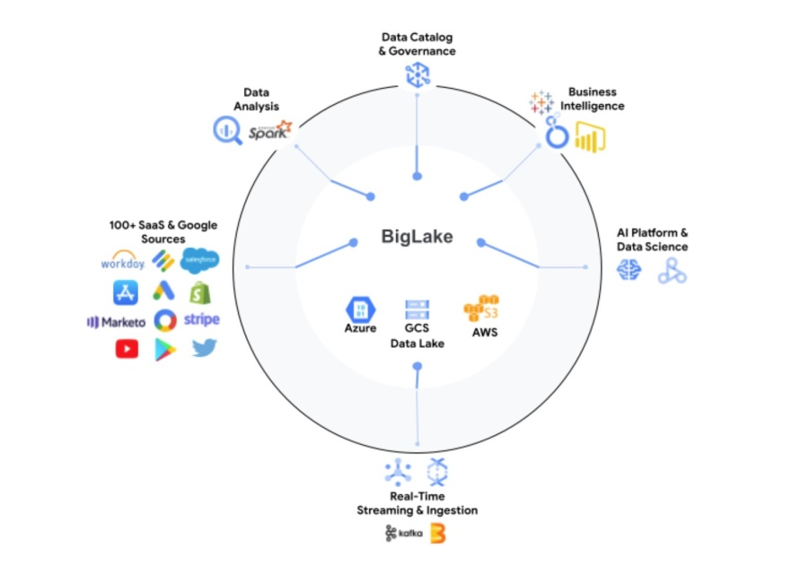

Referred the GCS data/***Cloud SQL/Cloud spanner*** -> Create a BQ External table (Raw layer)-> ETL BQ Query (simply log the progress in some audit table) -> BQ **Native** Partitioned/clustering (both table (Curated)) -> Datastudio(looker) visualization

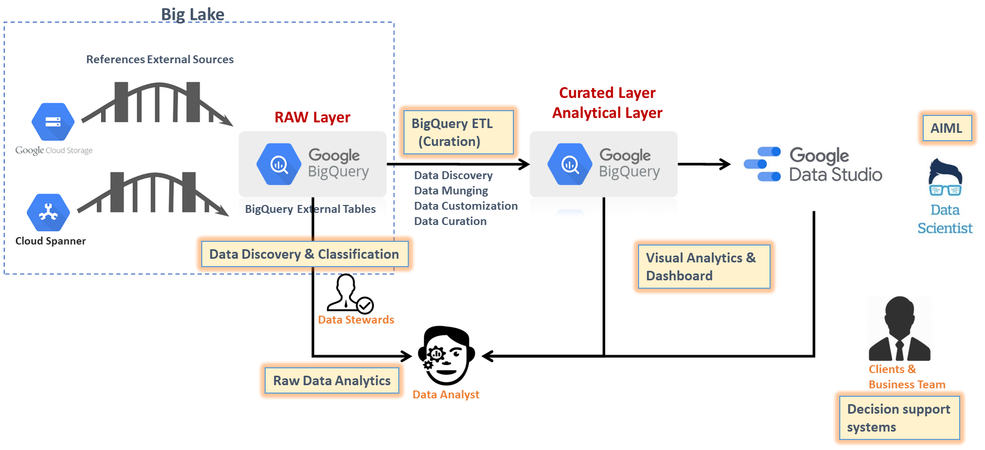

**Step1: To create external table to refer data from external storage like GCS/S3/Blob/Cloud Spanner… rather loading the data into colossus layer and instead of using Juypyter petabit/second network:**

CREATE OR REPLACE **EXTERNAL** TABLE rawds.cust_ext

(

 custno INT64,

firstname STRING,

lastname STRING,

age INT64,

profession STRING)

OPTIONS (

  format = 'CSV',

  uris = ['gs://incpetez-data-samples/dataset/bqdata/custs_header'],

  field_delimiter = ',',

  max_bad_records = 2, skip_leading_rows=1);

**--BQ works like spark for auto schema inference…**

CREATE OR REPLACE **EXTERNAL** TABLE rawds.cust_ext_auto

OPTIONS (format = 'CSV',

  uris = ['gs://incpetez-data-samples/dataset/bqdata/custs_header'],

  field_delimiter = ',',

  max_bad_records = 2);

select * from `rawds.cust_ext` limit 10;

**--BQ works like spark for auto schema inference…**

CREATE OR REPLACE EXTERNAL TABLE rawds.cust_json

OPTIONS (

  format = 'JSON',

  uris = ['gs://incpetez-data-samples/dataset/bqdata/online_products_trans.json']);

select * from `rawds.cust_json` limit 10;

* External tables are **similar to standard BigQuery tables, in that these tables store their metadata and schema in BigQuery storage**. However, their ***data resides*** in an external source.

~~Colossus -> Jupyter network~~ -> leafs (mappers) -> mixers (reducer)

External sources -> leafs (mappers) -> mixers (reducer)

* ***Query performance*** for external tables might be **low** compared to querying data in a native BigQuery table. If query speed is a priority, load the data into BigQuery instead of setting up an external data source. The performance of a query that includes an external table depends on the external storage type & performance. For example, querying data stored in Cloud Storage is faster than querying data stored in Drive. Another eg: data in orc is faster than data in csv or avro or json
* ***You cannot modify external data tables*** using **DML** or other methods. External tables are read-only for BigQuery.
* ***Drop table will not remove the base data.***

**--SCD2 Implementation (maintain the history and loading new data without affecting the history)**

***--Day1 Run***

create table if not exists curatedds.cust_part_curated (custno INT64,name STRING,

age INT64,profession STRING,datadt date) partition by datadt;

delete from curatedds.cust_part_curated where datadt='2023-09-08';

Insert into `curatedds.cust_part_curated`

select custid, concat(firstname,",", lastname) as name,age, coalesce(profession,'na'),cast('2023-09-08' as date)

from rawds.cust_ext;

***--Day2 Run***

create table if not exists curatedds.cust_part_curated (custno INT64,name STRING,

age INT64,profession STRING,datadt date) partition by datadt;

delete from curatedds.cust_part_curated where datadt='2023-09-09';

Insert into `curatedds.cust_part_curated`

select custid, concat(firstname,",", lastname) as name,age, coalesce(profession,'na'),cast('2023-09-09' as date)

from rawds.cust_ext;

select * from `curatedds.cust_part_curated` where datadt='2023-09-09'

**Step2: Incremental delete & load or Merge (source is from the biglake table created in the above step):**

**Eg:**

MERGE dataset.Target_table T  
USING dataset.Source_table S  
ON T.product = S.product  
WHEN MATCHED AND quantity < 20 THEN  
  UPDATE SET T.quantity=S.quantity,T.supply_constrained=S.supply_constrained  
WHEN NOT MATCHED THEN  
  INSERT(product, quantity, supply_constrained)  
  VALUES(product, quantity, false);

**Usecase1:**

gcs -> **Extract & Load (load command)** -> rawds.cust_native (Hive & Spark) -> SQL Query (**Extract Transform Load**) -> curatedds.cust_part_curated

**Usecase2:**

gcs -> rawds.cust_ext (Spark) -> SQL Query (**Extract** **Transform Load**) -> curatedds.cust_part_curated

**--For learning the concept manually first….**

**--CDC - incremental Load/Delta Load ETL operation**

--2023-09-15 -> 9000 customers -> target curated table (partition 2023-09-15)

--2023-09-16 -> 500 customers -> target curated table (partition 2023-09-16)

--2023-09-17 -> 200 customers -> target curated table (partition 2023-09-17)

**--SCD2 - If We want to maintain the history, we can use insert statement**

**create table if not exists curatedds.cust_part_curated (custno INT64,name STRING,**

**age INT64,profession STRING,datadt date) partition by datadt;**

delete from curatedds.cust_part_curated where datadt=v_datadt;

Insert into curatedds.cust_part_curated

**select custno, concat(firstname,",", lastname) as name,age, coalesce(profession,’na’),v_datadt**

**from rawds.cust_ext;**

select datadt,COUNT(1) from curatedds.cust_part_curated GROUP BY DATADT limit 10;

**create table if not exists curatedds.cust_part_curated_merge (custno INT64,name STRING,**

**age INT64,profession STRING,datadt date) partition by datadt;**

**--CDC - Complete Refresh (using merge) ETL operation**

--2023-09-15 -> 9000 customers -> target curated table (partition 2023-09-15)

--2023-09-16 -> 900 customers (500 new customers and 400 are modified) -> target curated table (partition 2023-09-16)

--Merge operation (insert if not exists in the target else update)

--2023-09-17 -> 200 customers (150 new customer and 50 are modified)-> target curated table (partition 2023-09-17)

--Merge operation (insert if not exists in the target else update)

**--SCD1 - If We don't want to maintain the history, we can use merge statement**

create table if not exists curatedds.cust_part_curated_merge (custno INT64,name STRING,

age INT64,profession STRING,datadt date) partition by datadt;

MERGE `curatedds.cust_part_curated_merge` T

USING (SELECT custid, concat(firstname,",", lastname) as name,age, coalesce(profession,'na') profession,cast('2023-09-09' as date) datadt FROM rawds.cust_ext) S

ON T.custno = S.custid

WHEN MATCHED THEN

UPDATE SET T.name = S.name,T.age = S.age,T.profession = S.profession,T.datadt=S.datadt

WHEN NOT MATCHED THEN

INSERT (custno,name,age,profession,datadt) VALUES (S.custid,S.name,S.age,S.profession,S.datadt);

select * from  curatedds.cust_part_curated_merge;

**1.Automate the above scd1 and scd2 concepts in a bql script.**

**Features of going with Procedural Language (PL) along with Declarative Language (SQL):**

* Run multiple statements in a sequence, with shared state (have variables shared across, temp tables shared across the SP/Script..)
* Automate management tasks such as creating or dropping tables (temp tables).
* Implement complex logic using programming constructs such as IF and WHILE/FOR.
* Dynamic sql implementation with parameterization can be done.
* Implementation of logging and Exception handling can be done.

**Running a BQ Script file: like a HQL**

gsutil cp gs://incpetez-data-samples/code/bq/usecase2_consumer_bq_raw_partition_load.sql ~/

bq query **--use_legacy_sql=false** **--parameter=param1::'gs://incpetez-data-samples/dataset/bqdata/ext_src_data/custs_header_20230908'** < usecase2_consumer_bq_raw_partition_load.sql

bq query **--use_legacy_sql=false** **--parameter=param1::'gs://incpetez-data-samples/dataset/bqdata/ext_src_data/custs_header_20230909'** < usecase2_consumer_bq_raw_partition_load.sql

bq query **--use_legacy_sql=false** **--parameter=param1::'gs://incpetez-data-samples/dataset/bqdata/ext_src_data/custs_header_20230910'** < usecase2_consumer_bq_raw_partition_load.sql

~~hdfs~~ -> load -> hive (hdfs)

lfs -> load -> hive (hdfs)

gcs -> load -> BQ (colossus)

declare x int64;

declare y int64;

set x=100;

set y=200;

begin

--session we have created...

--supports procedural language

--parameterization

--temp table managment

begin

select x+y;

end;

begin

select x-y;

end;

end;

**--Dynamic SQL concept example:**

create or replace procedure rawds.sp1(user_dsql1 string,user_dsql2 string)

begin

declare sql1 string;

declare sql2 string;

set sql1=user_dsql1;

set sql2=user_dsql2;

begin

execute immediate concat(user_dsql1,user_dsql2);

end;

end;

call rawds.sp1('create or replace table rawds.dynamictbl as ',"select * from rawds.trans_pos;");

call rawds.sp1('create or replace table rawds.dynamictbl1 as ',"select * from rawds.trans_online;");

CREATE OR REPLACE EXTERNAL TABLE `rawds.cust_ext`

(

 custno INT64,

firstname STRING,

lastname STRING,

age INT64,

profession STRING)

OPTIONS (

  format = 'CSV',

  uris = ['gs://incpetez-data-samples/dataset/bqdata/ext_src_data/custs_header_20230909'],

  field_delimiter = ',',

  skip_leading_rows=1);

select * from `rawds.cust_ext`;

create table if not exists `curatedds.cust_part_curated` (custno INT64,name STRING,

age INT64,profession STRING,datadt date) partition by datadt;

--since we don't have inser overwrite partition in bq, we are deleting explicitly

delete from curatedds.cust_part_curated where datadt='2023-09-09';

Insert into `curatedds.cust_part_curated`

select custno, concat(firstname,",", lastname) as name,age, coalesce(profession,'na'),cast('2023-09-09' as date)

from rawds.cust_ext;--using the ref table cust_ext, we are loading data from gcs to curated table.

select * from `curatedds.cust_part_curated` order by 1;--99+5 (scd2), scd1 - 99(2update)+3inserted 102

MERGE curatedds.cust_part_curated T

USING rawds.cust_ext S

ON T.custno = S.custno

WHEN MATCHED THEN

  UPDATE SET T.profession=S.profession,T.datadt='2023-09-09'

WHEN NOT MATCHED THEN

  INSERT(custno, name, age,profession,datadt)

  VALUES(S.custno,concat(S.firstname,',',S.lastname),S.age, S.profession, '2023-09-09');

**How do write sequence of code to automate the SCD process using BQL Script:**

gsutil cp gs://incpetez-data-samples/code/bq/usecase2_consumer_bq_raw_partition_load.sql ~/

*latestfile=`gsutil ls gs://incpetez-data-samples/dataset/bqdata/ext_src_data/custs_header* | tail -1`*

*bq query --use_legacy_sql=false --parameter=param1::$latestfile < usecase2_consumer_bq_raw_partition_load.sql*

bq query **--use_legacy_sql=false** **--parameter=param1::'gs://incpetez-data-samples/dataset/bqdata/ext_src_data/custs_header_20230908'** < usecase2_consumer_bq_raw_partition_load.sql

bq query **--use_legacy_sql=false** **--parameter=param1::'gs://incpetez-data-samples/dataset/bqdata/ext_src_data/custs_header_20230909'** < usecase2_consumer_bq_raw_partition_load.sql

bq query **--use_legacy_sql=false** **--parameter=param1::'gs://incpetez-data-samples/dataset/bqdata/ext_src_data/custs_header_20230910'** < usecase2_consumer_bq_raw_partition_load.sql

declare v_uri string;

declare v_datadt date;

declare v_datadtraw string;

declare dynamicsql string;

--set v_uri='gs://incpetez-data-samples/dataset/bqdata/ext_src_data/custs_header_20230908';

set v_uri=**@**param1;

set v_datadtraw=(select right(v_uri,8));

set v_datadt=(select parse_date('%Y%m%d',v_datadtraw));

--combining 3 different strings to make it as a single string by adding uri in the middle.

set dynamicsql=CONCAT('CREATE OR REPLACE EXTERNAL TABLE rawds.cust_ext ( custno INT64,firstname STRING,lastname STRING,age INT64,profession STRING) OPTIONS ( format = "CSV", uris = ["',v_uri, '"],max_bad_records = 2, skip_leading_rows=1)');

begin

--CREATE OR REPLACE EXTERNAL TABLE rawds.cust_ext ( custno INT64,firstname STRING,lastname STRING,age INT64,profession STRING) OPTIONS ( format = "CSV", uris = ["gs://incpetez-data-samples/dataset/bqdata/ext_src_data/custs_header_20230908"],max_bad_records = 2, skip_leading_rows=1);

--executing the single dynamic sql query string built in the above statement as a sql query using execute immediate function.

**EXECUTE IMMEDIATE dynamicsql;**

--SCD2 Implementation (maintain the history and loading new data without affecting the history)

create table if not exists curatedds.cust_part_curated (custno INT64,name STRING,

age INT64,profession STRING,datadt date) partition by datadt;

delete from curatedds.cust_part_curated where datadt=v_datadt;

Insert into curatedds.cust_part_curated

select custno, concat(firstname,",", lastname) as name,age, coalesce(profession,'na') as profession,v_datadt from rawds.cust_ext;

select datadt,COUNT(1) from curatedds.cust_part_curated GROUP BY DATADT limit 10;

--SCD1 - If We don't want to maintain the history, we can use merge statement

create table if not exists curatedds.cust_part_curated_merge (custno INT64,name STRING,

age INT64,profession STRING,datadt date) partition by datadt;

MERGE `curatedds.cust_part_curated_merge` T

USING (SELECT custno, concat(firstname,",", lastname) as name,age, coalesce(profession,'na') profession,cast(v_datadt as date) datadt FROM rawds.cust_ext) S

ON T.custno = S.custno

WHEN MATCHED THEN

UPDATE SET T.name = S.name,T.age = S.age,T.profession = S.profession,T.datadt=S.datadt

WHEN NOT MATCHED THEN

INSERT (custno,name,age,profession,datadt) VALUES (S.custno,S.name,S.age,S.profession,S.datadt);

select datadt,COUNT(1) from curatedds.cust_part_curated_merge GROUP BY DATADT limit 10;

end;

**Schedule & Orchestrate this using Cloud composer -> Automate the above scd1 and scd2 concepts in a sql script.**

**2.Automate the above scd1 and scd2 concepts in a SP.**

**Running the above ETL pipeline using Stored Procedure with audit logging mechanism enabled:**

BQ ***procedural language*** (SP or script) lets you execute multiple statements in one query as a multi-statement query -

**Features of going with Procedural Language with Declarative Language:**

* Run multiple statements in a sequence, with shared state (have variables shared across, temp tables shared across the SP/Script..)
* Automate management tasks such as creating or dropping tables (temp tables).
* Implement complex logic using ***programming constructs such as IF and WHILE/FOR.***
* Dynamic sql implementation with parameterization can be done.
* ***Implementation of logging/auditting and Exception handling can be done.***

drop table if exists curatedds.audit_tbl;

create table if not exists curatedds.audit_tbl (processid STRING,jobname STRING,processtype String,errormsg string,errtype string,TS TIMESTAMP);

select * from curatedds.audit_tbl order by ts;

Simple SP statement:

create or replace procedure `curatedds.proc1`(param1 string)

begin

declare x int64;

declare y int64;

set x=1;

set y=1;

while x <= 3

do

select param1;

set x=x+y;

end while;

end;

--call `inceptez-wd-394902.curatedds.sp_cust_etl`('gs://incpetez-data-samples/dataset/bqdata/ext_src_data/custs_header_20230908','scd2');

--select * from curatedds.audit_tbl order by TS;

CREATE OR REPLACE PROCEDURE `inceptez-wd-394902.curatedds.sp_cust_etl`(p_uri STRING, flag STRING)

BEGIN

declare v_uri string;

declare v_datadt date;

declare v_datadtraw string;

declare dynamicsql string;

--set v_uri='gs://incpetez-data-samples/dataset/bqdata/ext_src_data/custs_header_20230908';

set v_uri=p_uri;

set v_datadtraw=(select right(v_uri,8));

set v_datadt=(select parse_date('%Y%m%d',v_datadtraw));

--combining 3 different strings to make it as a single string by adding uri in the middle.

set dynamicsql=CONCAT('CREATE OR REPLACE EXTERNAL TABLE rawds.cust_ext ( custno INT64,firstname STRING,lastname STRING,age INT64,profession STRING) OPTIONS (  format = "CSV", uris = ["',v_uri, '"],max_bad_records = 2, skip_leading_rows=1)');

--External Table reference load

begin

create table if not exists curatedds.audit_tbl (processid STRING,jobname STRING,processtype String,errormsg string,errtype string,TS TIMESTAMP);

INSERT INTO `curatedds.audit_tbl` (processid,jobname,processtype,errormsg,errtype,ts) values(GENERATE_UUID(),'sp_cust_etl','1.Creating external table cust_ext referring the gcs parameter location','','START',current_timestamp());

EXECUTE IMMEDIATE dynamicsql;

INSERT INTO `curatedds.audit_tbl` (processid,jobname,processtype,errormsg,errtype,ts) values(GENERATE_UUID(),'sp_cust_etl','1.Created external table cust_ext referring the gcs parameter location','','SUCCESS',current_timestamp());

EXCEPTION WHEN ERROR THEN

INSERT INTO `curatedds.audit_tbl` (processid,jobname,processtype,errormsg,errtype,ts)

values(GENERATE_UUID(),'sp_cust_etl','1. Created external table cust_ext referring the gcs parameter location Failed',@@error.message,'FAILURE',current_timestamp());

end;

 IF flag='scd2' THEN

begin

create table if not exists curatedds.cust_part_curated (custno INT64,name STRING,

age INT64,profession STRING,datadt date) partition by datadt;

delete from curatedds.cust_part_curated where datadt=v_datadt;

INSERT INTO `curatedds.audit_tbl` (processid,jobname,processtype,errormsg,errtype,ts) values(GENERATE_UUID(),'sp_cust_etl','2.curated table cust_part_curated load','','START',current_timestamp());

Insert into curatedds.cust_part_curated

select custno, concat(firstname,",", lastname) as name,age, coalesce(profession,'na') as profession,v_datadt from rawds.cust_ext;

INSERT INTO `curatedds.audit_tbl` (processid,jobname,processtype,errormsg,errtype,ts) values(GENERATE_UUID(),'sp_cust_etl','2.curated table cust_part_curated load','','SUCCESS',current_timestamp());

EXCEPTION WHEN ERROR THEN

INSERT INTO `curatedds.audit_tbl` (processid,jobname,processtype,errormsg,errtype,ts) values(GENERATE_UUID(),'sp_cust_etl','2.curated table cust_part_curated load Failed',@@error.message,'FAILURE',current_timestamp());

select datadt,COUNT(1) from curatedds.cust_part_curated  GROUP BY DATADT limit 10;

end;

 ELSEIF flag='scd1' then

begin

create table if not exists curatedds.cust_part_curated_merge (custno INT64,name STRING,

age INT64,profession STRING,datadt date) partition by datadt;

INSERT INTO `curatedds.audit_tbl` (processid,jobname,processtype,errormsg,errtype,ts) values(GENERATE_UUID(),'sp_cust_etl','3.curated table cust_part_curated_merged load','','START',current_timestamp());

MERGE `curatedds.cust_part_curated_merge` T

USING (SELECT custno, concat(firstname,",", lastname) as name,age, coalesce(profession,'na') profession,cast(v_datadt as date) datadt FROM rawds.cust_ext) S

ON T.custno = S.custno

WHEN MATCHED THEN

UPDATE SET T.name = S.name,T.age = S.age,T.profession = S.profession,T.datadt=S.datadt

WHEN NOT MATCHED THEN

INSERT (custno,name,age,profession,datadt) VALUES (S.custno,S.name,S.age,S.profession,S.datadt);

select datadt,COUNT(1) from curatedds.cust_part_curated_merge  GROUP BY DATADT limit 10;

INSERT INTO `curatedds.audit_tbl` (processid,jobname,processtype,errormsg,errtype,ts) values(GENERATE_UUID(),'sp_cust_etl','3.curated table cust_part_curated_merged load','','SUCCESS',current_timestamp());

EXCEPTION WHEN ERROR THEN

INSERT INTO `curatedds.audit_tbl` (processid,jobname,processtype,errormsg,errtype,ts) values(GENERATE_UUID(),'sp_cust_etl','3.curated table cust_part_curated_merged load Failed',@@error.message,'FAILURE',current_timestamp());

select datadt,COUNT(1) from curatedds.cust_part_curated_merged  GROUP BY DATADT limit 10;

end;

ELSE

  drop table if exists rawds.cust_ext;

  INSERT INTO `curatedds.audit_tbl` (processid,jobname,processtype,errormsg,errtype,ts) values(GENERATE_UUID(),'sp_cust_etl','0. Nothing happened due to unexpected argument passed, expected is scd1 or scd2','','SUCCESS',current_timestamp());

END IF;

END;

call curatedds.sp_cust_etl('gs://incpetez-data-samples/dataset/bqdata/ext_src_data/custs_header_20230908');

**Supportive BQ Queries for Additional Learnings:**

**Partition Table incremental Load in Bigquery:**

create table curatedds.cust_part_curated (custno INT64,name STRING,

profession STRING, age INT64,datadt date) partition by datadt

OPTIONS (require_partition_filter = TRUE);

delete from curatedds.cust_part_curated where datadt=current_date();

Insert into curatedds.cust_part_curated

select custno, concat(firstname,",", lastname) as name, profession,age,current_date() from rawds.cust_ext where age>30;

select datadt,COUNT(1) from curatedds.cust_part_curated where datadt=current_date()  GROUP BY DATADT limit 10;

**Historical Refresh (Insert if the source contains new customers else update the existing customer data):**

create or replace table curatedds.cust_part_curated_merged as select * from curatedds.cust_part_curated;

**MERGE** `curatedds.cust_part_curated_merged` T

USING (SELECT custno, concat(firstname,",", lastname) as name,age, profession FROM rawds.cust_ext) S

ON T.custno = S.custno

WHEN MATCHED and T.datadt=v_datadt THEN

UPDATE SET T.name = S.name,T.age = S.age,T.profession = S.profession

WHEN NOT MATCHED THEN

INSERT (custno,name,age,profession) VALUES (S.custno,S.name,S.age,S.profession)

;

select datadt,COUNT(1) from curatedds.cust_part_curated_merged  GROUP BY DATADT limit 10;

**DML Statements (**DML statements are only supported only for BQ Native tables**):**

~~update rawds.cust_ext set profession='unknown' WHERE profession is null and datadt=current_date();~~

update curatedds.cust_part set profession='unknown' WHERE profession is null and datadt=current_date();

DELETE curatedds.cust_part WHERE custno= 4000112 and datadt=current_date();

SELECT * FROM `curatedds.cust_part` WHERE profession <>'unknown' and datadt=current_date();

SELECT * FROM `curatedds.cust_part` WHERE profession ='unknown' and datadt=current_date();

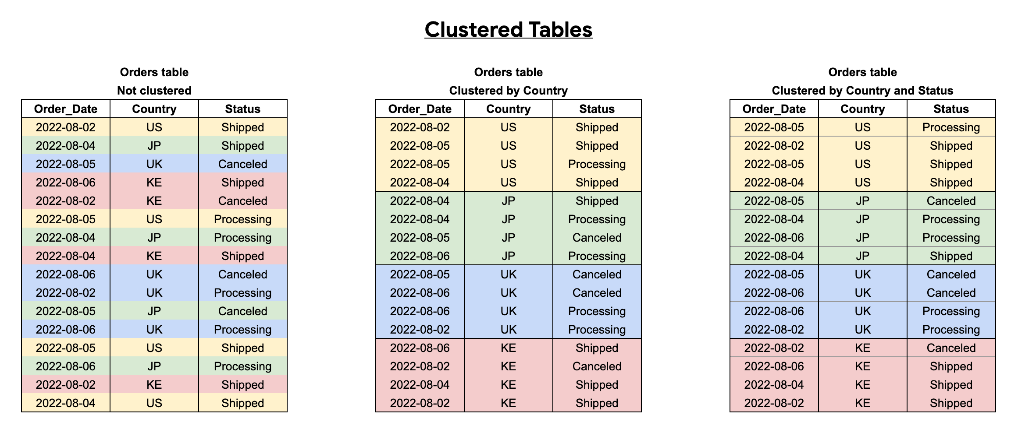

create or replace table rawds.customer_raw_cluster(

custno INT64,

firstname STRING,

lastname STRING,

age INT64,

profession STRING)

cluster by age;

insert into rawds.customer_raw_cluster (custno,firstname,lastname,age,profession) select tmp.* from rawds.customer_raw as tmp;

**Views:**

**View is a stored query to reduce complexity of writing the complex queries again and again , but view will not store data rather refers the data from the underlying table**

**--Trade off between Inline view, Temp table, CTE, Regular Views**

--inline (memory) view (from clause subquery) -can be used only once in the given query

--Queries looks complex for both writing and reading

--Though it is same Query, it will run multiple times where ever used inline

--good for small volume of data

select loaddt,max(cnt) cnt from (

SELECT loaddt,count(1) as cnt FROM `inceptez-wd-394902.curatedds.trans_mobile_autopart_2023`

group by loaddt

) iv1

group by loaddt

union distinct

select loaddt,min(cnt) cnt from (

SELECT loaddt,count(1) as cnt FROM `inceptez-wd-394902.curatedds.trans_mobile_autopart_2023`

group by loaddt

) iv2

group by loaddt;

--CTE (memory) Common table expression

--Queries looks simple (since we are writing once) for both writing and reading

--Though it is same Query, it will run one time and loaded to memory and referenced multiple times

--good for small volume of data

with cte1 as(SELECT loaddt,count(1) as cnt FROM `inceptez-wd-394902.curatedds.trans_mobile_autopart_2023`

group by loaddt)

select loaddt,max(cnt) cnt from cte1

group by loaddt

union distinct

select loaddt,min(cnt) cnt from cte1

group by loaddt;

--temp table (disk) of the given session (begin and end)

--Queries looks simple (since we are writing once) for both writing and reading

--Though it is same Query, it will run one time and loaded to disk and referenced multiple times

--good for large volume of data

begin

create temp table mobile_cnt as SELECT loaddt,count(1) as cnt

FROM `inceptez-wd-394902.curatedds.trans_mobile_autopart_2023`

group by loaddt;

select loaddt,max(cnt) cnt from mobile_cnt

group by loaddt

union distinct

select loaddt,min(cnt) cnt from mobile_cnt

group by loaddt;

end;

--view (stored query), used for data governance, masking, redaction of data etc.,

--Queries looks simple (since we are writing once) for both writing and reading

--Though it is same Query, it will run multiple times and loaded to memory and referenced multiple times

--good for small volume of data

create view curatedds.mobile_cnt as SELECT loaddt,count(1) as cnt

FROM `inceptez-wd-394902.curatedds.trans_mobile_autopart_2023`

group by loaddt;

select loaddt,max(cnt) cnt from curatedds.mobile_cnt

group by loaddt

union distinct

select loaddt,min(cnt) cnt from curatedds.mobile_cnt

group by loaddt;

**--Another Example for the difference between views:**

--inline view - don't recommend, because writing the same code 3 times

--inline not recommended, because execution of the same code 3 times needed, run not just once

select 'cnt' metric,count(custid) value from (

select custid,firstname,lastname,sha1(profession) profession

from inceptez-wd-394902.rawds.consumer

where profession not in ('Judge')

) t

union all

select 'max' metric,max(custid) value from (

select custid,firstname,lastname,sha1(profession) profession

from inceptez-wd-394902.rawds.consumer

where profession not in ('Judge')

)t

union all

select 'min' metric,min(custid) value from (

select custid,firstname,lastname,sha1(profession) profession

from inceptez-wd-394902.rawds.consumer

where profession not in ('Judge')

)t

--CTE -Common table expression - recommended

--CTE recommended, because writing the same code 3 times not needed, write just once

--CTE recommended, because execution of the same code 3 times not needed, run just once

--not recommended for large data

with t as (select custid,firstname,lastname,sha1(profession) profession

from inceptez-wd-394902.rawds.consumer

where profession not in ('Judge'))

select 'cnt' metric,count(custid) value from t

union all

select 'max' metric,max(custid) value from t

union all

select 'min' metric,min(custid) value from t

--temp table - recommended

--CTE recommended, because writing the same code 3 times not needed, write just once

--CTE recommended, because execution of the same code 3 times not needed, run just once

-- recommended for large data because data is stored in the session tables's disk

begin

create or replace temp table t as

select custid,firstname,lastname,sha1(profession) profession

from inceptez-wd-394902.rawds.consumer

where profession not in ('Judge');

select 'cnt' metric,count(custid) value from t

union all

select 'max' metric,max(custid) value from t

union all

select 'min' metric,min(custid) value from t;

end;

--regular view (just store the query in a name, not data)- recommended for using outside of the session by any users/consumers

--view recommended, because writing the same code 3 times not needed, write just once

--view not recommended, because execution of the same code 3 times needed

-- recommended for masking, redaction, restriction of data access

create or replace view curatedds.t as

select custid,firstname,lastname,sha1(profession) profession

from inceptez-wd-394902.rawds.consumer

where profession not in ('Judge');

select 'cnt' metric,count(custid) value from curatedds.t

union all

select 'max' metric,max(custid) value from curatedds.t

union all

select 'min' metric,min(custid) value from curatedds.t;

--materialized view (store the query and data in a snapshot name) - recommended for using outside of the session by any users/consumers

--mv - because writing the same code 3 times not needed, write just once

--mv execution of the same code 3 times needed

-- recommended for masking, redaction, restriction of data access

-- diff between normal view and mv -  the data stored in the mv will be queried every time rather than querying from base table, where first time when

-- the mv is created the query plan/graph with optimization will be created by BQ and store for further reference, so mv is good in performance, because BQ don't have to create plan/graph again and again for performance tuning.

create or replace materialized view curatedds.mv as

select custid,firstname,lastname,sha1(profession) profession

from inceptez-wd-394902.rawds.consumer

where profession not in ('Judge');

select 'cnt' metric,count(custid) value from curatedds.mv

union all

select 'max' metric,max(custid) value from curatedds.mv

union all

select 'min' metric,min(custid) value from curatedds.mv;

create view curatedds.cust_redacted_or_masked_v as select custno,replace(replace(name,'a','b'),'c','d') as masked_name,age+5 as masked_age

from `curatedds.cust_part_curated`

where profession not in ('Police Officer','Doctor');

**Materialized Views:**

When we write query on mv (BQ will bring all data from mv and missing/modified data from the base table if any) . user <-> MV . user <->MV(unmodified) , Base table (modified/inserted)

In BigQuery, materialized views are precomputed views that periodically **cache** the results of a query for increased performance and efficiency.

BigQuery leverages precomputed results from materialized views and [whenever possible](https://cloud.google.com/bigquery/docs/materialized-views-use#incremental_updates) reads only ***delta changes from the base tables*** to compute up-to-date results.

Materialized views can be queried directly or can be used by the BigQuery optimizer to process queries to the base tables.

Materialized views can significantly improve the performance of workloads that have the characteristic of common and repeated queries.

* **Pre-aggregate data**
* **Pre-filter data**
* **Pre-join data**
* **Refreshed in 5 minutes (by bigquery)**

create materialized view curatedds.cust_day1_mv as select * from `curatedds.cust_part_curated` where profession not in ('Police Officer','Doctor');

select custno,profession from curatedds.cust_day1_mv;

ALTER MATERIALIZED VIEW curatedds.cust_day1_mv  
SET OPTIONS (enable_refresh = true , refresh_interval_minutes = 60);

CALL BQ.REFRESH_MATERIALIZED_VIEW('curatedds.cust_day1_mv');

**Sample public data query for performance test of BQ**

SELECT COUNT(*) FROM `bigquery-public-data.google_analytics_sample.ga_sessions_*`;

--903653

SELECT

  (SUM (total_transactions_per_user) / COUNT(fullVisitorId) ) AS avg_total_transactions_per_user

FROM (

  SELECT

    fullVisitorId,

    SUM (totals.transactions) AS total_transactions_per_user

  FROM

    `bigquery-public-data.google_analytics_sample.ga_sessions_*`

  WHERE

    _TABLE_SUFFIX BETWEEN '20170701'

    AND '20170731'

    AND totals.transactions IS NOT NULL

  GROUP BY

    fullVisitorId )

**Visualize the data using Data Studio/looker:**

***Terminologies of Visualization & Dashboards:***

* + - **Facts –** Values of the actual happenings. Eg. online_pos_amount, geo_coordinate
    - **Measure –** Quantifying the values of facts. – Measuring the average age, measuring total sales.
    - **Dimensions –** Different perspective of different measures. Eg. profession, age, city, state, activity, category, spendby
    - **Metrics –** Standards/Qualifying of measuring different Measures across dimensions. Eg. Total sales happened across the states, Types of transactions happened, what are the recurring activities (Using the dims+facts+measures we can build metrics)
    - **KPI –** Key Performance Indicators (Vital metrics that helps our business to make some decition).
    - **Reporting -** Producing the metrics and measures for the given dimension in a value format. Eg. Csv download of the given data.
    - **Visualization** - Producing the metrics and measures for the given dimension in a **single visual format.** Eg. Single Pie chart for showing the occupancy/coverage of sales happened across the city, Single Bar chart for comparing the occupancy/coverage of the product sold across the state.
    - **Dashboard** - Producing the metrics and measures for the given dimensions in multiple visual formats as a single dashboard (**collection of different visualizations**).

***Different Types of Charts:***

* + - **Scorecard/Metrics -** To display a summary of a single metric.
    - **Table/Grid -** To turn your data into a detailed chart with sorting.
    - **Pie -** To show data as "slices of pie," or ***proportions of a whole***
    - **Bar -** To categorize with subcategories the groups of data used mainly for **comparison.**
    - **Time Series –** To look at how your **data changes over time**
    - **Combo -** To show each data series as a different marker type, either a column or a line.
    - **Geo -** To show a map of a country, continent, or region
    - **Map -** To  explore geographic data
    - **Area -** To emphasize graphically the differences of changes in value between categories of data.
    - **Scattered -** To look for trends and patterns between two variables (x & Y Axes)
    - **Gauge -**  To see how well a given metric is performing against a target goal
    - **Sankey -** Use a sankey chart to display a flow from one set **of values to another**
    - **Pivot Table -** Use a pivot table to reorganize and summarize your data

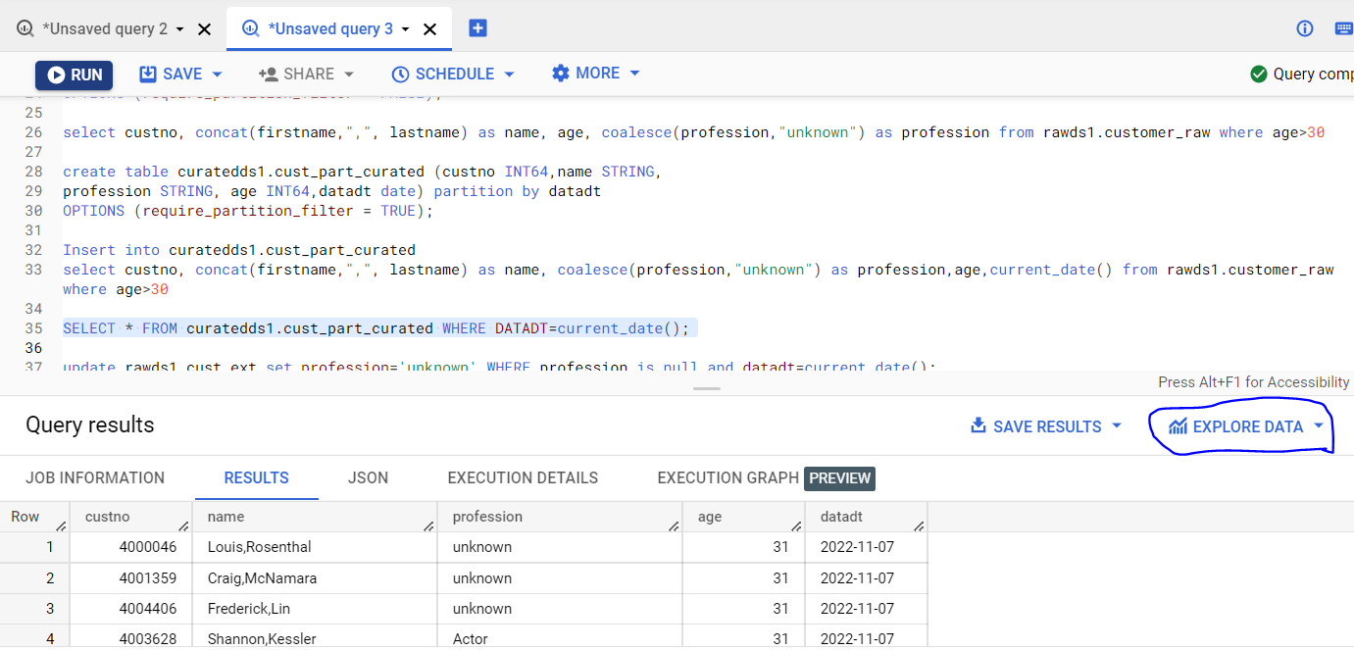

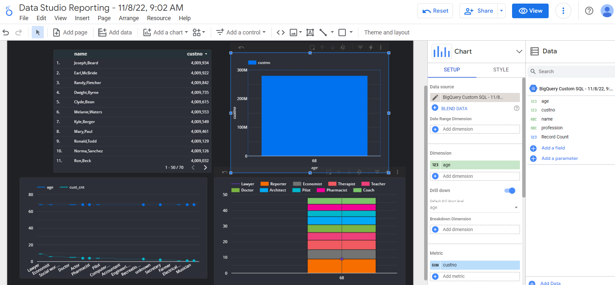

1. **Cloud Composer: Usecases:**

**Create A cloud composer environment: Done by the Cloud Platform team, once for all..**

1. **Create a service account with composer administrator role**



**How to create a Composer environment (with Airflow instances started):**

* 1. **Once for all activity**
  2. **Performed by Cloud Platform Engineers/Admins**
  3. **Composer instances will run 24/7.**
  4. **All the project (Developers) will use the common (CC) Airflow Scheduler/Orchestrator as a common platform.**







**Cloud Composer** is a managed Apache Airflow service you can use to create, schedule, monitor, and manage (orchestrating) workflows and any other cloud components.

**Advantages:**

* Supports time and ***event-based*** scheduling (sensor operators)
* Simplified calls to Dataproc using Operators (lot of functions (operators))
* Dynamically generate workflows and workflow parameters (DAG dynamically)
* Build data flows (Orchestration) that span multiple Google Cloud products (it support all the gcloud services orchestration and scheduling)

**Steps to follow to deploy the DAGs in Airflow**

* + 1. Create a Cloud Composer Environment using the steps provided above.
    2. Open the Airflow browser and DAG folder by clicking the below link

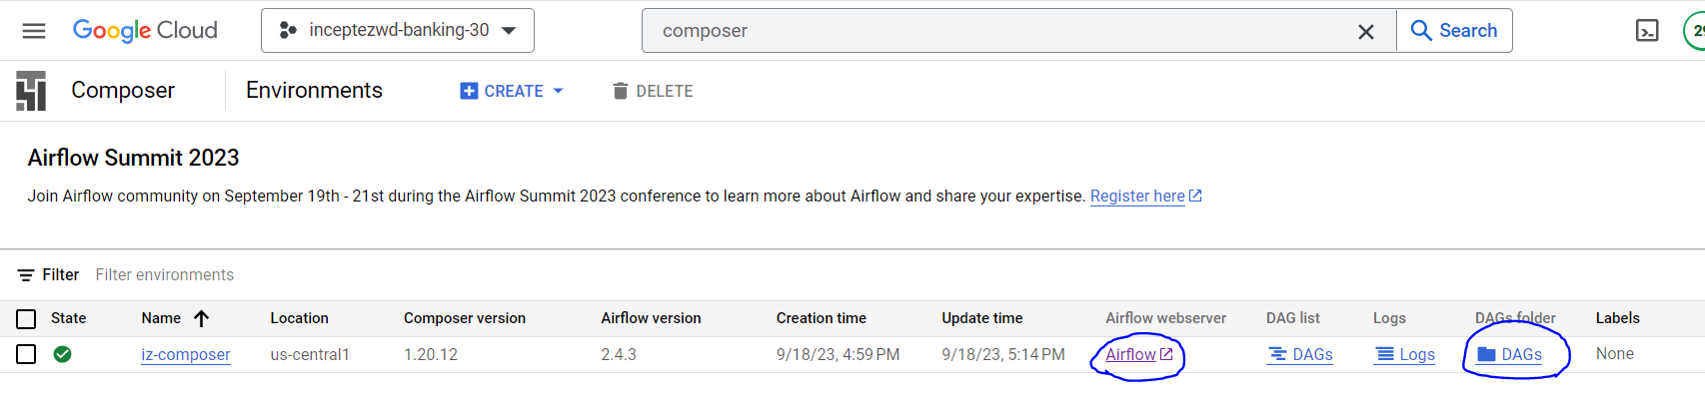

* + 1. Copy the dag usecase.py file in the DAG folder as per the given screenshot.

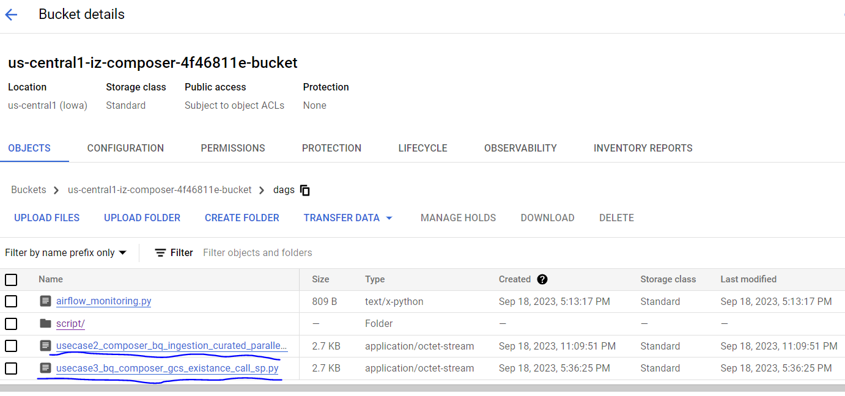

* + 1. Copy the SQL and params files in the script path of the DAG folder as per the given snapshot.

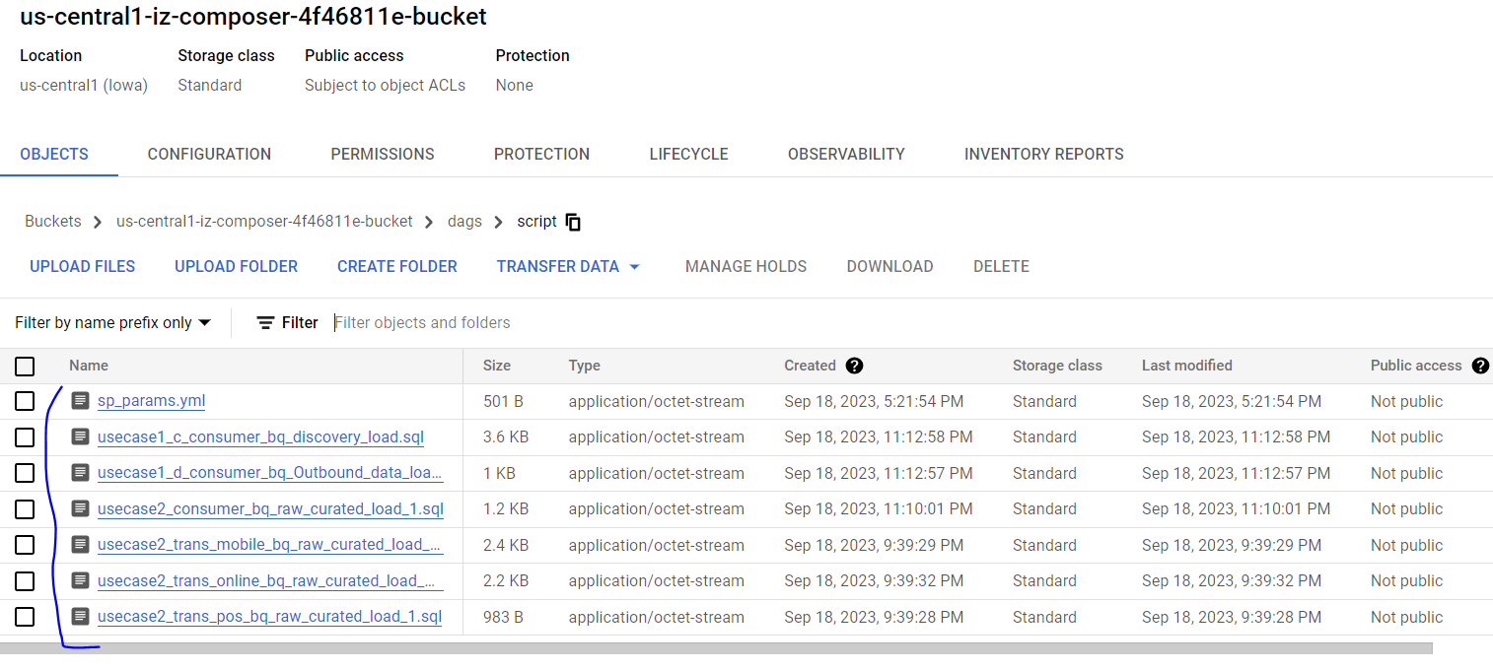

* + 1. Go to the Airflow UI and see whether the DAG placed in the above DAGs bucket is refreshed and running in the Airflow.

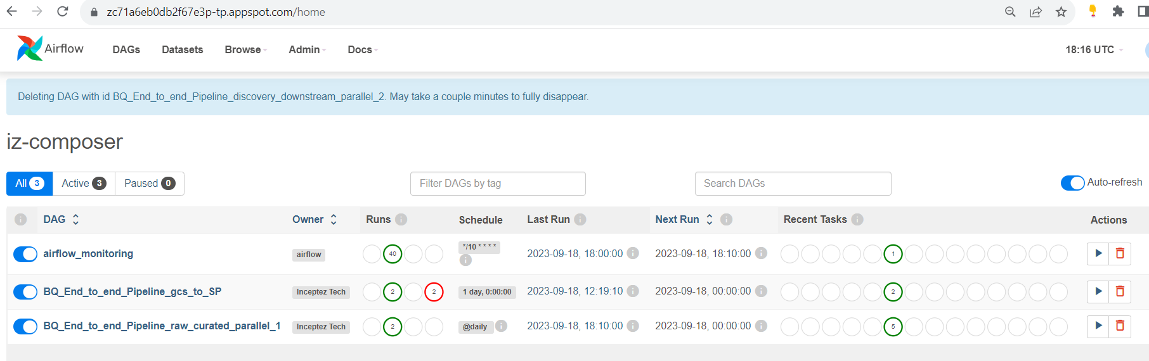

**Composer (Airflow) Usecases:**

**Usecase1:**

* 1. Download the below composer code with data into the Windows disk location

<https://drive.google.com/drive/folders/1E3LeqHmqmfvmCT8pHy9OClMLYoSjr68v?usp=drive_link>

* 1. Copy the usecase1_composer_bq_e2e_pipeline_seq.py code from composer_bq_seq_usecase1 folder to the dags gcs folder and the sql scripts to the dags/script folder.

**Usecase2:**

* 1. Copy the usecase1_composer_bq_e2e_pipeline_seq.py code from composer_bq_seq_usecase1 folder to the dags gcs folder and the sql scripts to the dags/script folder.

**Usecase3:**

* 1. Create the sp in the BQ console **sp_cust_etl.sql**
  2. Modify the yaml file with your project id and upload into the dags/script path
  3. Copy the usecase3_bq_composer_gcs_existance_call_sp.py code from composer_bq_SP_usecase3folder to the dags gcs folder.

1. **Cloud Spanner:**

**(Google’s own RDBMS) – Fully Managed Service**

Horizontally scalable RDBMS DB of GCP (equivalent to Oracle(Grid) in our onprem or AuroraDB/Redshift in AWS) - Cloud Spanner is a fully managed relational database service that offers transactional consistency and high availability at global scale



**Big-Lake:**

BigLake is a storage engine that unifies DBs, data warehouses and lakes by enabling BigQuery and open source frameworks like Spark to access data with fine-grained access control.

Data continues to grow in volume and is increasingly distributed across lakes, warehouses, clouds, and file formats. As more users demand more use cases, **the traditional approach to build data movement infrastructure is proving difficult to scale**. Unlocking the full potential of data requires breaking down these silos, and is increasingly a top priority for enterprises.

**cloud spanner/Cloud SQL using Bigquery ext table? If yes, then that concept is Biglake**

* 1. **Create a Spanner DB**

**Create Free trial instance**

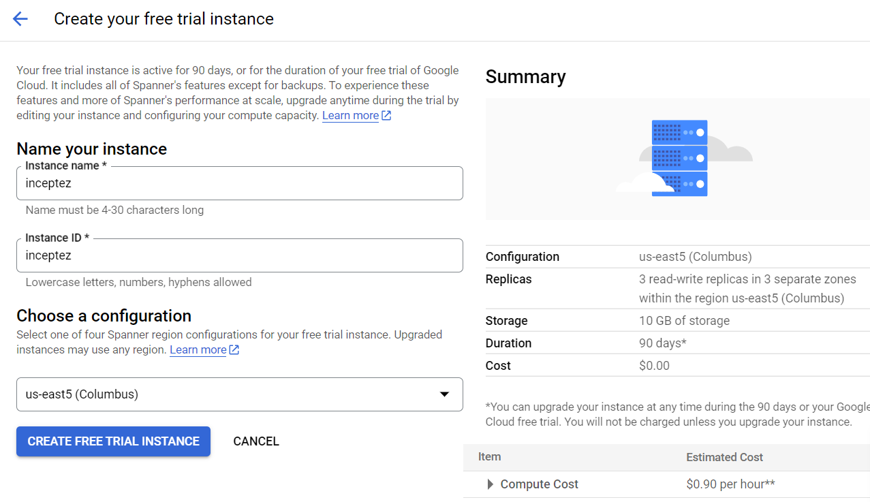

**2. Create Database (postgres Dialect)**

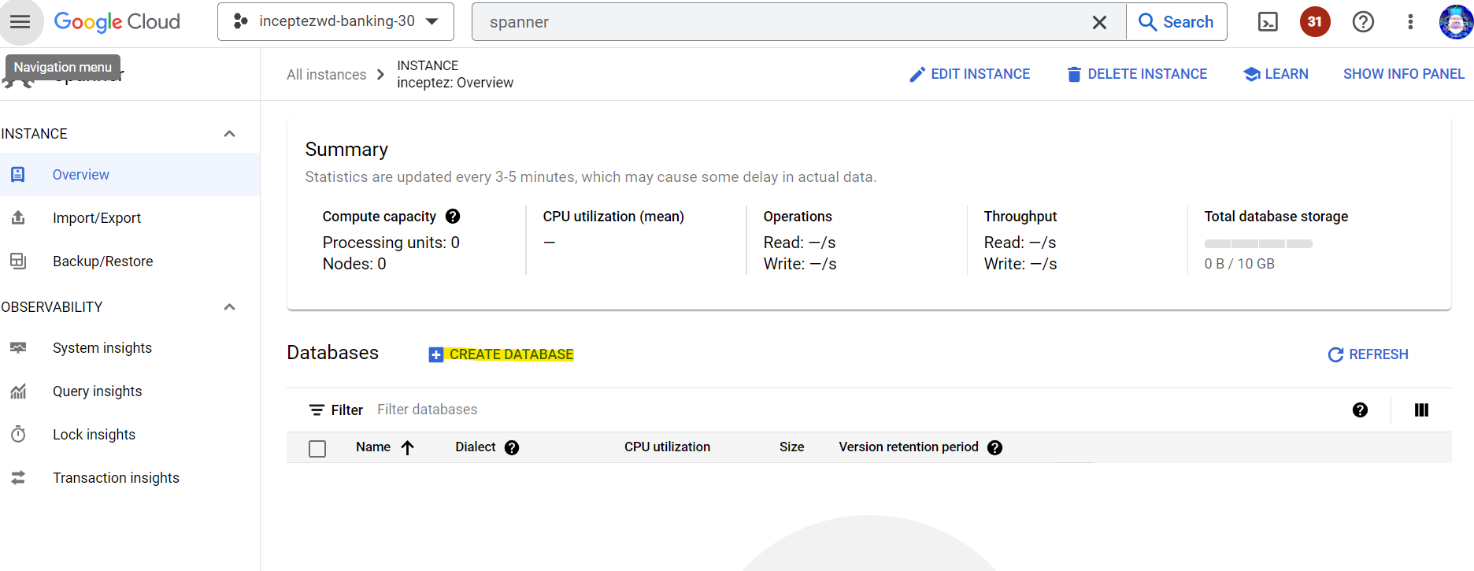

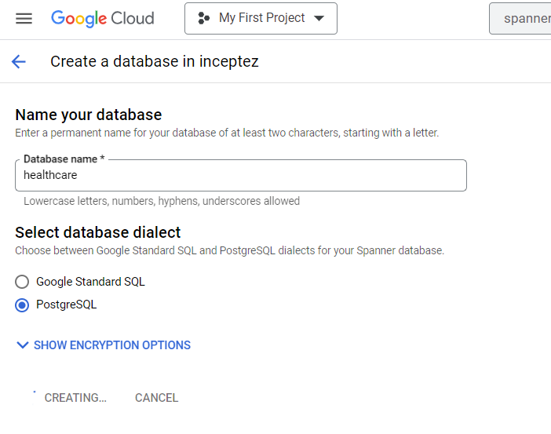



**­­­­3. Login to the Spanner Studio and Insert data using the below SQL.**

**Google Syntax:**

create table drugs (uniqueid INT64, drugname STRING(100) , condition STRING(100),rating INT64,date STRING(10),usefulcount INT64) PRIMARY KEY(uniqueid)

INSERT INTO drugs (uniqueid,drugname,condition,rating,date,usefulcount) values(163740,'Mirtazapine 40','Depression',10,'2022-10-01',22);

INSERT INTO drugs (uniqueid,drugname,condition,rating,date,usefulcount) values(206473,'Mesalamine','Crohns Disease, Maintenance',8,'2022-10-01',17);

INSERT INTO drugs (uniqueid,drugname,condition,rating,date,usefulcount) values(159672,'Bactrim','Urinary Tract Infection',9,'2022-10-01',3);

INSERT INTO drugs (uniqueid,drugname,condition,rating,date,usefulcount) values(39293,'Contrave 10','Weight Loss',9,'2022-10-01',35);

INSERT INTO drugs (uniqueid,drugname,condition,rating,date,usefulcount) values(977681,'Cyclafem 35','BP  Control',9,'2022-10-01',4);

INSERT INTO drugs (uniqueid,drugname,condition,rating,date,usefulcount) values(208087,'Zyclara',,4,'2022-10-01',13);

INSERT INTO drugs (uniqueid,drugname,condition,rating,date,usefulcount) values(215892,'Copper ',' BP  Control ',6,'2022-10-01',1);

INSERT INTO drugs (uniqueid,drugname,condition,rating,date,usefulcount) values(169852,'Amitriptyline','Migraine Prevention',9,'2022-10-01',32);

INSERT INTO drugs (uniqueid,drugname,condition,rating,date,usefulcount)  values(232952,'Methadone','Opiate Withdrawal',7,'2022-10-01',21);

INSERT INTO drugs (uniqueid,drugname,condition,rating,date,usefulcount) values(714283,'Levora','BP  Control ',2,'2022-10-01',3);

INSERT INTO drugs (uniqueid,drugname,condition,rating,date,usefulcount)  values(232954,'Methadone','Opiate Withdrawal',7,'2022-10-01',21);

INSERT INTO drugs (uniqueid,drugname,condition,rating,date,usefulcount) values(714284,'Levora','BP  Control ',2,'2022-10-01',3);

INSERT INTO drugs (uniqueid,drugname,condition,rating,date,usefulcount)  values(232132,'Bidazen 40','OrthoPAEDIC ',7,'2022-10-01',21);

INSERT INTO drugs (uniqueid,drugname,condition,rating,date,usefulcount) values(188669,'Tayo 60','',3,'2022-10-01',3);

select * from drugs;

**Postgres Syntax:**

--create database healthcare;

create table drugs (uniqueid integer PRIMARY KEY, drugname varchar(100),condition varchar(300),rating integer,date varchar(10),usefulcount int);

INSERT INTO drugs (uniqueid,drugname,condition,rating,date,usefulcount) values(163740,'Mirtazapine','Depression',10,'2022-10-01',22);

INSERT INTO drugs (uniqueid,drugname,condition,rating,date,usefulcount) values(206473,'Mesalamine','Crohns Disease, Maintenance',8,'2022-10-01',17);

INSERT INTO drugs (uniqueid,drugname,condition,rating,date,usefulcount) values(159672,'Bactrim','Urinary Tract Infection',9,'2022-10-01',3);

INSERT INTO drugs (uniqueid,drugname,condition,rating,date,usefulcount) values(39293,'Contrave','Weight Loss',9,'2022-10-01',35);

INSERT INTO drugs (uniqueid,drugname,condition,rating,date,usefulcount) values(97768,'Cyclafem 1','BP Control',9,'2022-10-01',4);

INSERT INTO drugs (uniqueid,drugname,condition,rating,date,usefulcount) values(208087,'Zyclara','Keratosis',4,'2022-10-01',13);

INSERT INTO drugs (uniqueid,drugname,condition,rating,date,usefulcount) values(215892,'Copper','BP Control',6,'2022-10-01',1);

INSERT INTO drugs (uniqueid,drugname,condition,rating,date,usefulcount) values(169852,'Amitriptyline','Migraine Prevention',9,'2022-10-01',32);

INSERT INTO drugs (uniqueid,drugname,condition,rating,date,usefulcount)  values(23295,'Methadone ','Opiate Withdrawal',7,'2022-10-01',21);

INSERT INTO drugs (uniqueid,drugname,condition,rating,date,usefulcount) values(71428,'Levora ','BP Control',2,'2022-10-01',3);

INSERT INTO drugs (uniqueid,drugname,condition,rating,date,usefulcount)  values(232954,' Methadone','Opiate Withdrawal',7,'2022-10-01',21);

INSERT INTO drugs (uniqueid,drugname,condition,rating,date,usefulcount) values(714284,' Levora','BP  Control ',2,'2022-10-01',3);

INSERT INTO drugs (uniqueid,drugname,condition,rating,date,usefulcount)  values(232132,'Bidazen 40','OrthoPAEDIC ',7,'2022-10-01',21);

INSERT INTO drugs (uniqueid,drugname,condition,rating,date,usefulcount) values(188669,' Tayo 60','',3,'2022-10-01',3);

select * from drugs;

projects/ninth-physics-399809/instances/inceptez/databases/healthcare

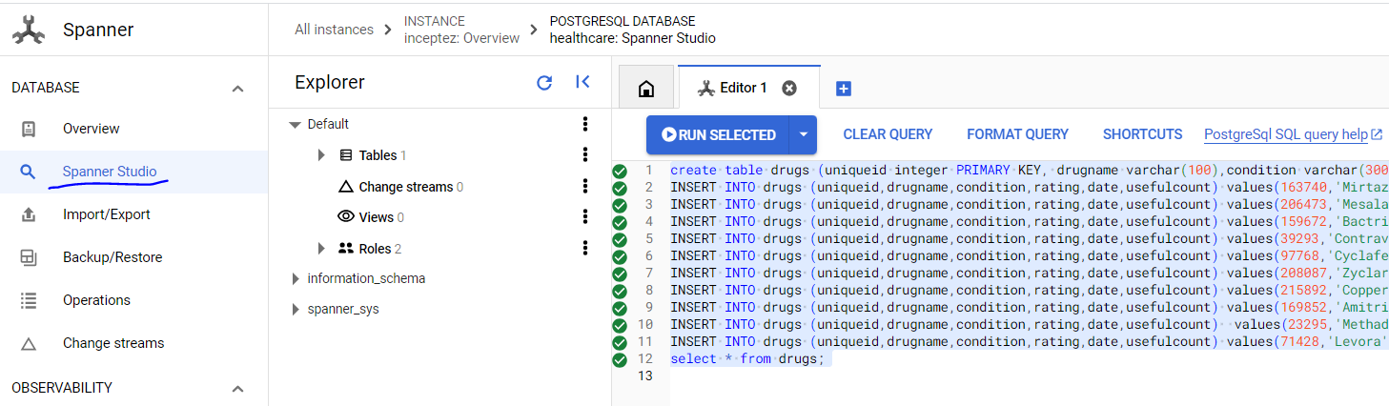

4. **Go to Bigquery** and create an Add -> connection to external data sources.

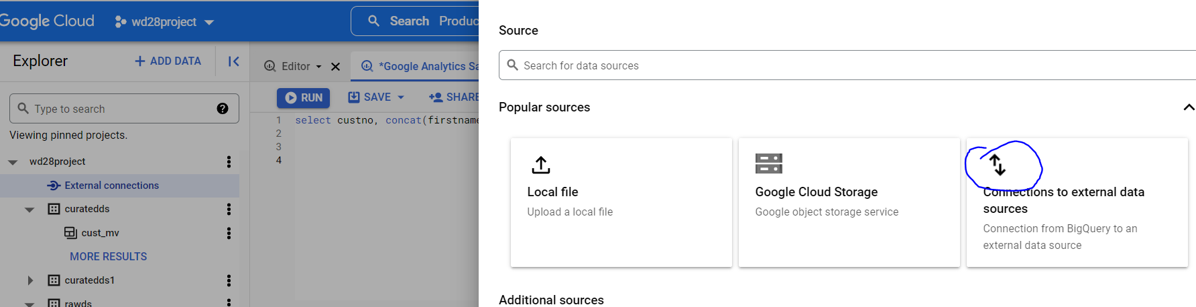

Choose the external data sources – Cloud spanner and mention the below Database name parameter

projects/**ninth-physics-399809**/instances/**inceptez**/databases/**healthcare**

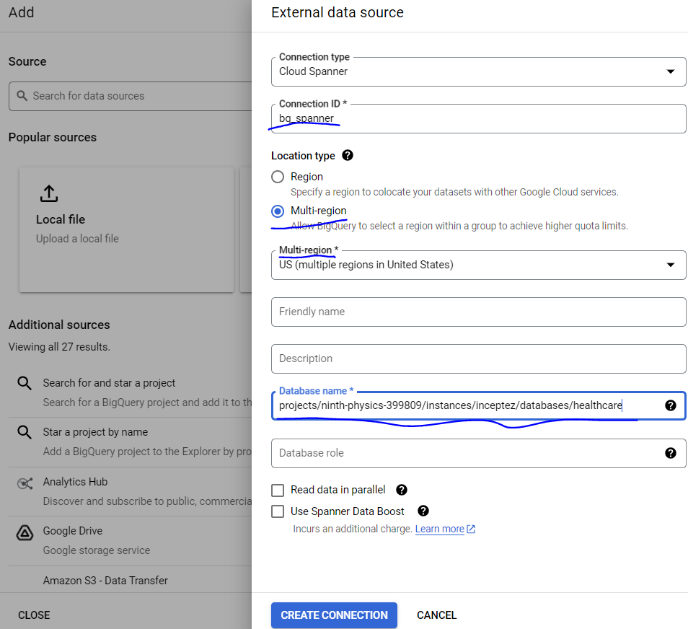

SELECT * FROM EXTERNAL_QUERY("ninth-physics-399809.us.bq_spanner", "SELECT * FROM  drugs WHERE date>='2022-10-01';");

Create schema if not exists curatedds;

create table `curatedds.bq_drugs` (uniqueid INT64,name string);

insert into curatedds.bq_drugs (uniqueid,name)

SELECT uniqueid,upper(drugname) as name FROM EXTERNAL_QUERY("ninth-physics-399809.us.bq_spanner", "SELECT * FROM  drugs WHERE date>='2022-10-01';");

--We are performing ET (Spanner) and T (Bigquery)

SELECT drugname,count(1) FROM

EXTERNAL_QUERY("ninth-physics-399809.us-central1.inceptezdb", "SELECT uniqueid,drugname,condition FROM drugs;")

group by drugname;

5. Change Stream:

CREATE CHANGE STREAM drugs_conddate FOR drugs(condition, date);

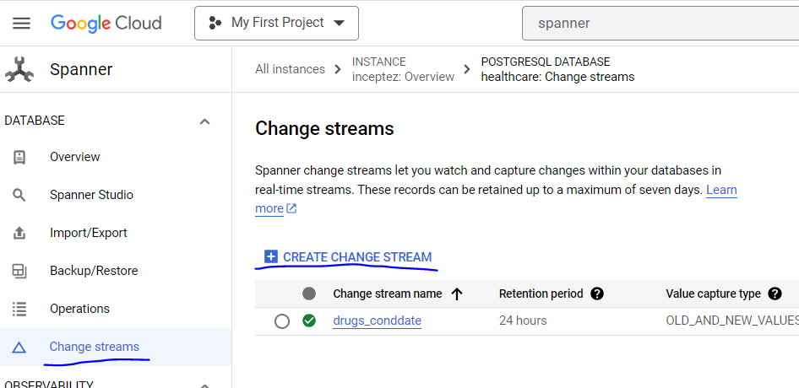

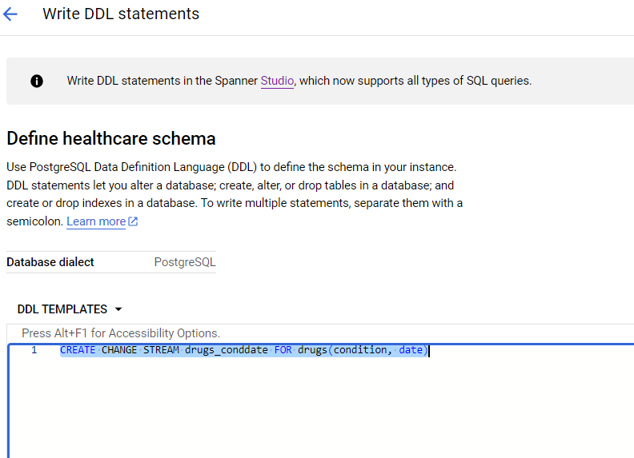

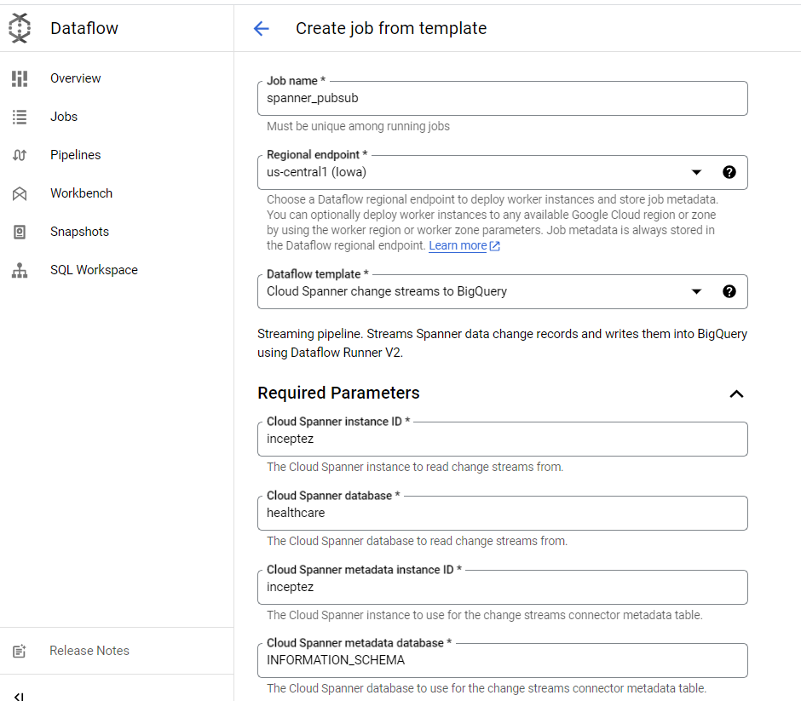

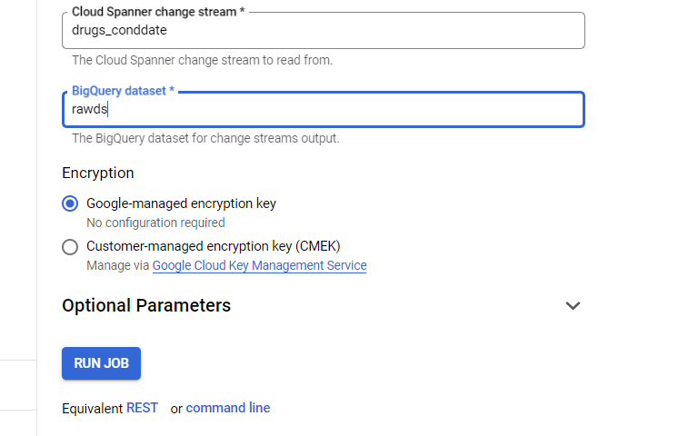

1. **Cloud SQL:**

BigQuery

(Repair_curated)

()

**Cloud SQL (Repair data)**

**(R)**

Pyspark **ETL** (Dataproc)

Federation/Unification/

Complex transformation

**AWS RDS (Provisioning data)**

**(R)**

RDBMS DB of GCP (equivalent to mysql in our onprem or RDS in AWS)

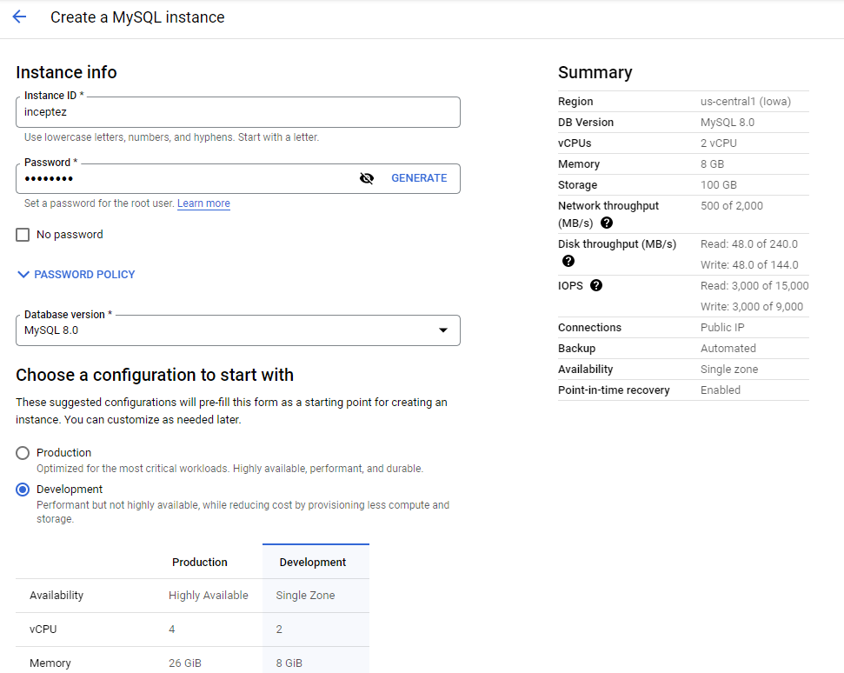

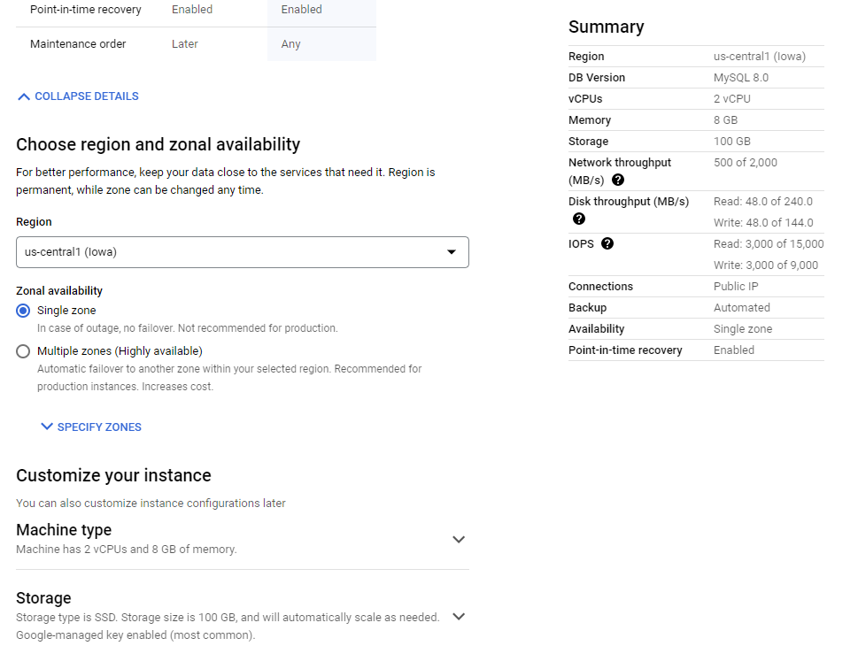

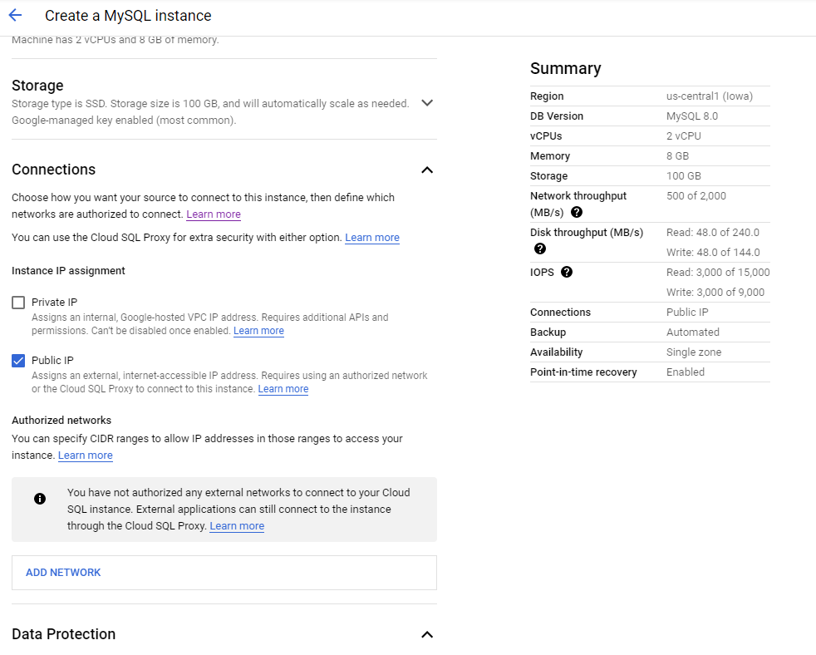

**MYSQL Syntax:**

**dfdb1=spark.read.jdbc(url="jdbc:mysql://172.27.160.3:3306/healthcare?user=root&password=inceptez",table="drugs",properties={"driver":"com.mysql.jdbc.Driver"})**

create database healthcare;

use healthcare;

create table drugs (uniqueid int , drugname varchar(100),symptoms varchar(300),rating int,dt varchar(10),usefulcount int);

INSERT INTO drugs (uniqueid,drugname, symptoms ,rating,dt,usefulcount) values(163740,'Mirtazapine','Depression',10,'2022-10-01',22);

INSERT INTO drugs (uniqueid,drugname, symptoms ,rating,dt,usefulcount) values(206473,'Mesalamine','Crohns Disease, Maintenance',8,'2022-10-01',17);

INSERT INTO drugs (uniqueid,drugname, symptoms ,rating,dt,usefulcount) values(159672,'Bactrim','Urinary Tract Infection',9,'2022-10-01',3);

INSERT INTO drugs (uniqueid,drugname, symptoms ,rating,dt,usefulcount) values(39293,'Contrave','Weight Loss',9,'2022-10-01',35);

INSERT INTO drugs (uniqueid,drugname, symptoms ,rating,dt,usefulcount) values(97768,'Cyclafem 1 / 35','BP  Control',9,'2022-10-01',4);

INSERT INTO drugs (uniqueid,drugname, symptoms ,rating,dt,usefulcount) values(208087,'Zyclara','Keratosis',4,'2022-10-01',13);

INSERT INTO drugs (uniqueid,drugname, symptoms ,rating,dt,usefulcount) values(215892,'Copper','BP  Control',6,'2022-10-01',1);

INSERT INTO drugs (uniqueid,drugname, symptoms ,rating,dt,usefulcount) values(169852,'Amitriptyline','Migraine Prevention',9,'2022-10-01',32);

INSERT INTO drugs (uniqueid,drugname, symptoms ,rating,dt,usefulcount)  values(23295,'Methadone','Opiate Withdrawal',7,'2022-10-01',21);

INSERT INTO drugs (uniqueid,drugname, symptoms ,rating,dt,usefulcount) values(71428,'Levora','BP  Control',2,'2022-10-01',3);

select * from drugs;

1. **DataPrep: For creating some Batch workflows (ETL pipeline) using Dataflow**

Spanner/SQL/GCS/BQ -> ETL (munging/wrangling/custom/standard….) -> BQ/GCS

Solutions:

1. Bring data to **BQL** and perform all activity in BQ – writing **SQL (heavy ETL with moderate data processing business logics)**
2. We can use **pyspark** to do all ETL – writing **SQL/DSL (heavy ETL with moderate to complex data processing business logics)**
3. Without using BQ Borg or Pyspark DP cluster and without using SQL/DSL, we can achive some quick data preparation (ETL) using ***DATAPREP*** ***without writing code* (heavy ETL with simple to moderate data processing business logics)**.

Equivalent to ***Data Brew*** *Services in* ***AWS*** or Spark in Onprem/Pentaho/Talend/Alteryx in Onprem **Dataprep by Trifacta (Alteryx)** is **an intelligent data service for visually exploring, cleaning, and preparing structured and unstructured data for analysis, reporting, and machine learning**. Because Dataprep is serverless and works at any scale.

**Usecase1: Is an alternative for the above Cloud spanner to BQ data pipeline (connection)**

**Cloud Spanner -> ETL Transformation using Apache Beam’s/Trifacta (Recipes) -> Bigquery curated table/GCS storage**

* 1. Create a connection to spanner

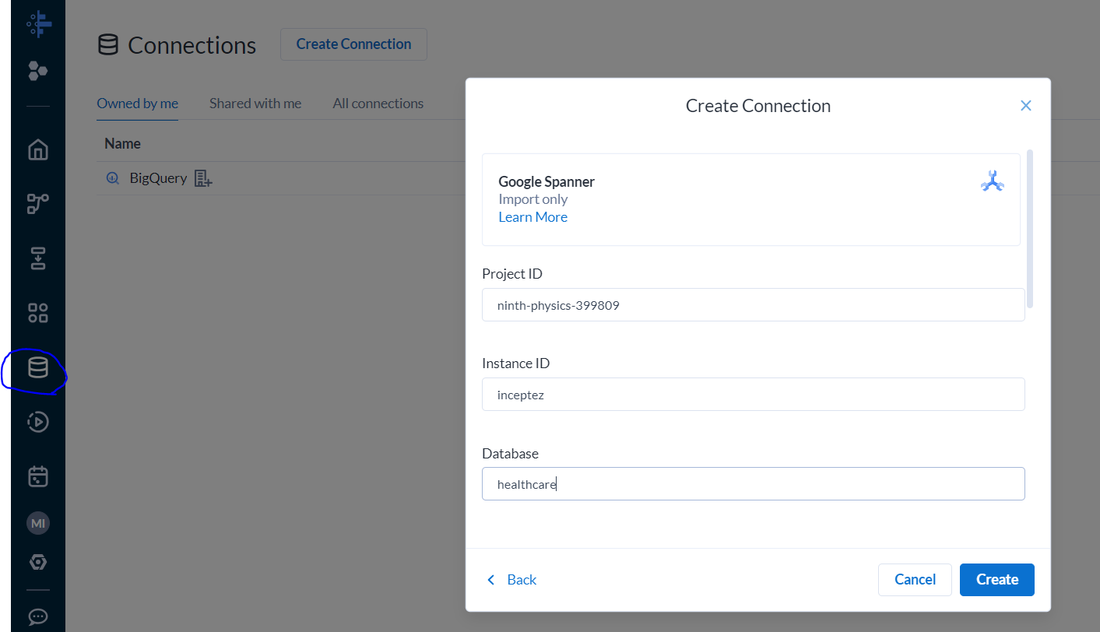

* 1. Create a flow in dataprep -> Choose connect to your dataset -> Choose cloud spanner -> Click public DB -> Click create dataset (drugs) -> Import and add to flow

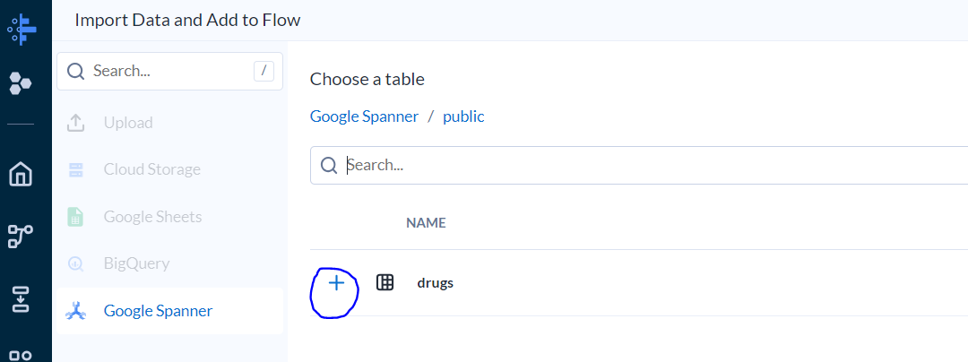

* 1. Apply some recipes to transform the data and load to BQ.

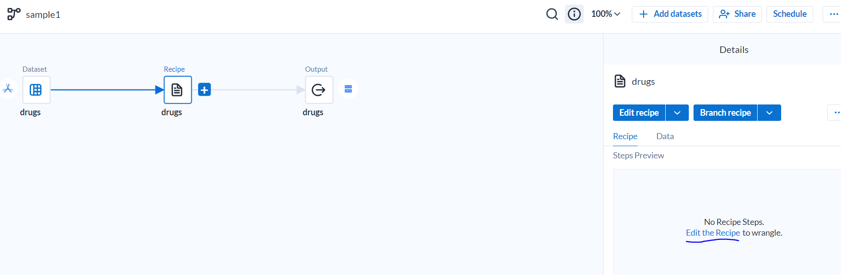

* 1. Run the pipeline and view the result in Bigquery layer.

**Scenario2:**

Some systems (clients) wanted the data from our BQ table as file extracts?

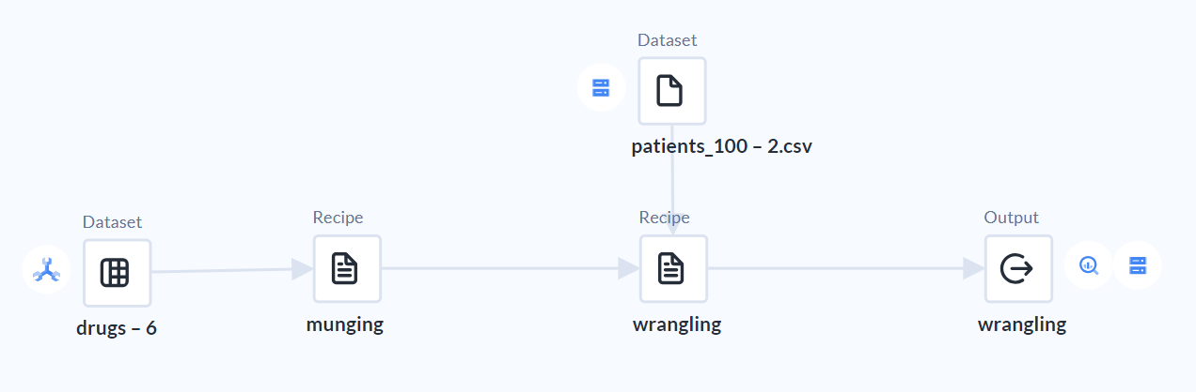

**BQ -> Wrangling/Data preparation activity -> GCS -> Egress (sent to others) -> AWS S3**

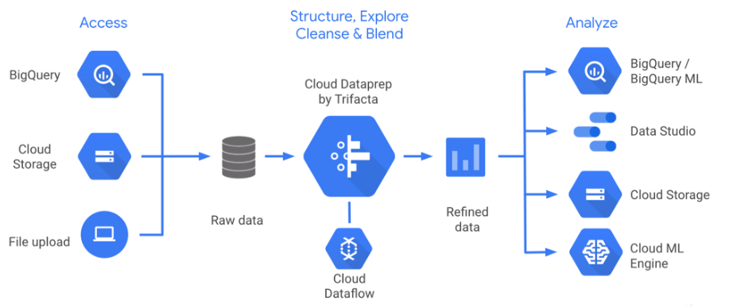



**BigQuery -> Dataprep (Dataflow (Beam engine)) -> Cloud Storage**

**Connection Creation to Cloud Spanner**

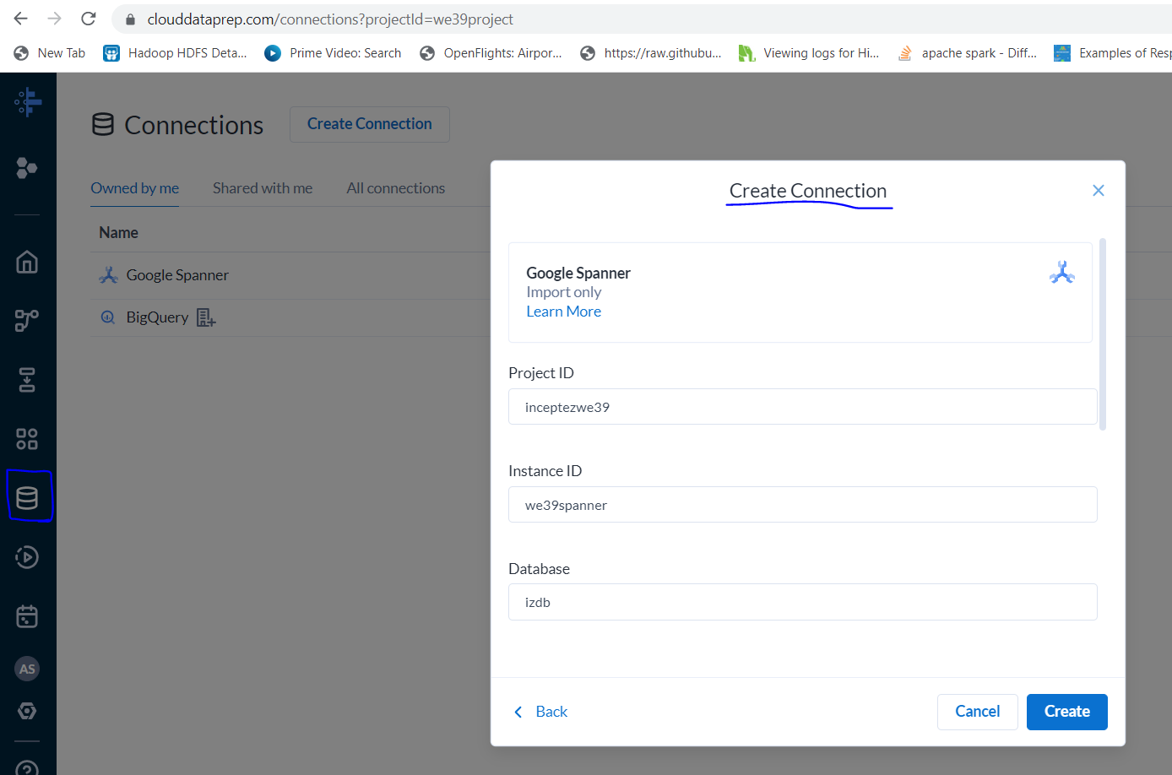

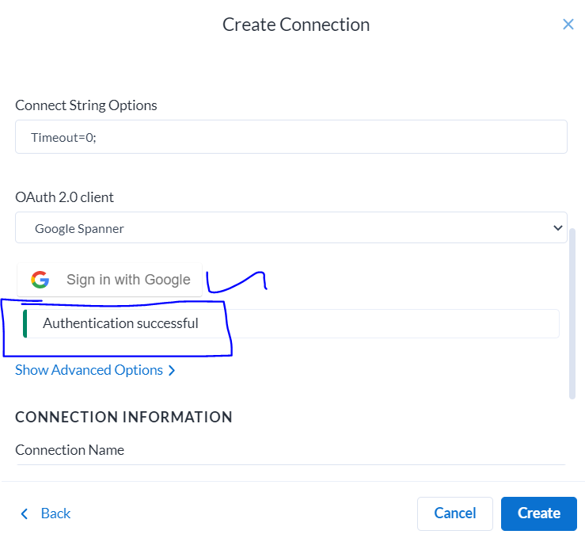

**RealTime Streaming:**

1. **PubSub:**

**(Brokerless/Serverless/Fully managed kafka of GCP, Equivalent of AWS (Kinesis/SQS) or event hub of MS Azure)**

***Create Topic*** (once for all) *eg. Hindu* -> ***Create Subscription*** (for the topic) *eg. Subscribe for e-paper*

Publish messages to Topic *eg. Reporters (source systems) publish some news/messages* -> Subscribe will ***Pull*** the message from the Topic using the subscription *eg. Pull the news and consume.*

If we want to create a Realtime pipeline-> Source will talk to pubsub admin -> get a topic created -> admin will create a Subscription also -> Source will publish some data -> subscriber will pull the data using the subscription created…

**Create a topic : Create a topic with the ID**

gcloud pubsub **topics** create **webeventswd30** --message-retention-duration=*3d*

**Create a subscription: Create a subscription and attach it to the above topic:**

gcloud pubsub **subscriptions** create subscriberwebevents --topic=**webeventswd30** --ack-deadline=10 --enable-exactly-once-delivery --enable-message-ordering --expiration-period=1d

**Publish messages: Publish a message to the topic:**

gcloud pubsub topics **publish** **webeventswd30** --message="hello how are you"  
gcloud pubsub topics **publish** **webeventswd30** --message="1,10,irfan"

**Receive messages: Receive the message from the subscription created above:**

gcloud pubsub subscriptions **pull** subscriberwebevents --auto-ack

**PubSub Schema: Create topics with schema.**

gcloud pubsub topics create clickstreamwe41

vi schema.yml

- column: event_id

description: Event id

mode: REQUIRED

type: INT64

- column: event_timestamp

description: Event timestamp

mode: REQUIRED

type: TIMESTAMP

- column: event

description: Type of event

mode: NULLABLE

type: STRING

- column: page

description: page visited

mode: NULLABLE

type: STRING

gcloud data-catalog entries update \

--lookup-entry='pubsub.topic.`ninth-physics-399809`.clickstreamwe41' \

--schema-from-file=/home/inceptezbigdatameet/schema.yml

create a message file and put some messages into it in json format..

msg1="{\"event_id\":\"1\",\"event_timestamp\":\"2023-01-01 00:01:01\",\"event\":\"click\",\"page\":\"product1\"}"

gcloud pubsub topics publish strct --message="$(echo $msg1)"

msg1="{\"event_id\":2,\"event_timestamp\":\"2023-01-01 00:01:02\",\"event\":\"click\",\"page\":\"pubsub_product2\"}"

gcloud pubsub topics publish strct --message="$(echo $msg1)"

Create a subscription and try pulling the messages

gcloud pubsub **subscriptions** create sub2 --topic=**strct**

gcloud pubsub subscriptions pull sub2

**Equivalent CLI Command**

gcloud dataflow sql query 'select * from pubsub.topic.`ninth-physics-399809`.topicname;' --job-name dfsql-job1 --region us-central1 --pubsub-topic projects/ninth-physics-399809/topics/inceptez-topic1 --staging-location inceptez-main-bucket/tmp/

1. **DataFlow: Realtime streaming pipeline using Dataflow**

**Equivalent to Onprem ..**

**Api -> KAFKA -> SPARK STRUCT STREAM -> NOSQL/HIVE -> KIBANA**

**Usecase1:**

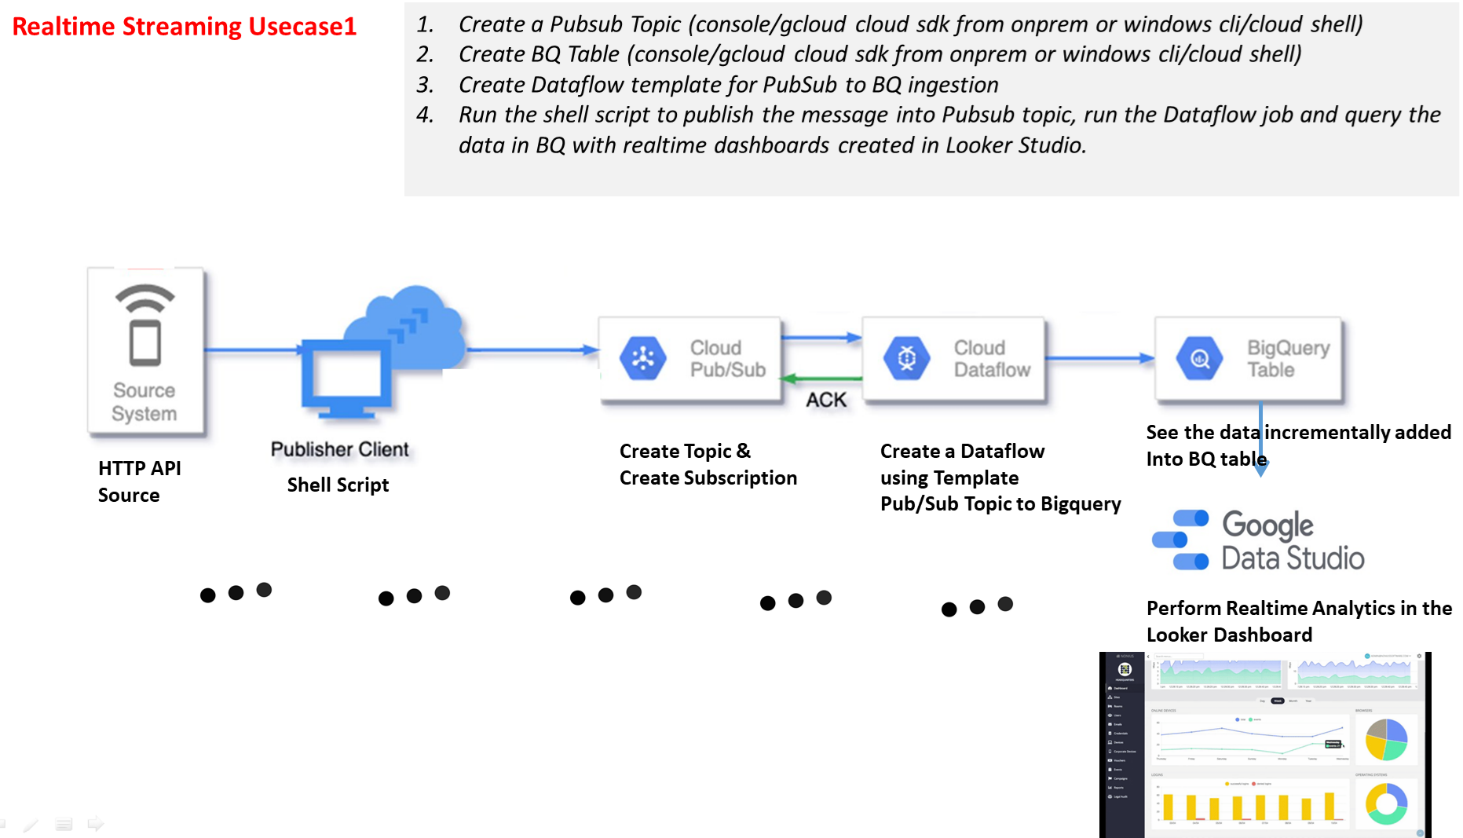

gcloud dataflow jobs run text-to-ps-inceptez-topic1 --gcs-location gs://dataflow-templates-us-central1/latest/GCS_Text_to_Cloud_PubSub --region us-central1 --max-workers 1 --num-workers 1 --worker-machine-type n1-standard-1 --staging-location gs://inceptez-main-bucket/tmp/ --enable-streaming-engine --additional-user-labels {} --parameters inputFilePattern=gs://inceptez-main-bucket/data,outputTopic=projects/ninth-physics-399809/topics/inceptez-topic1

1. Create a pubsub topic called webevents

gcloud pubsub **topics** create **webevents** --message-retention-duration=*15d*

1. Create a shell script to generate streaming data to the pubsub

**vi stream_api.sh**

while true

do

msg=`curl https://api.randomuser.me/?exc=login`

gcloud pubsub topics publish webevents --message="$msg"

sleep 3

done

1. Create a json file and place the above json data in the below gcs bucket location (just to create a table with the same structure of the json)

**Sample JSON**

{"results":[{"gender":"female","name":{"title":"Miss","first":"Michelle","last":"Garcia"},"location":{"street":{"number":237,"name":"Manchester Road"},"city":"Durham","state":"West Yorkshire","country":"United Kingdom","postcode":"ER97 9AX","coordinates":{"latitude":"-9.2577","longitude":"99.1204"},"timezone":{"offset":"+4:00","description":"Abu Dhabi, Muscat, Baku, Tbilisi"}},"email":"michelle.garcia@example.com","login":{"uuid":"b429064f-2c21-4b0a-b113-c123fb9c34a9","username":"bluesnake208","password":"babylon","salt":"WjeTbOUg","md5":"c79300cb2e83b14e6e14b3e2fc90ba27","sha1":"f6d47c3847a9e1a1da999fd67a8654d7563ded6b","sha256":"fa1b1a1f38f052caf3c74f31ef42c9c39df3ef0dcba7f6f703caa14e74da5251"},"dob":{"date":"1953-04-28T12:30:12.224Z","age":70},"registered":{"date":"2006-10-17T21:56:53.985Z","age":16},"phone":"017684 81692","cell":"07000 244564","id":{"name":"NINO","value":"AP 48 81 12 W"},"picture":{"large":"https://randomuser.me/api/portraits/women/93.jpg","medium":"https://randomuser.me/api/portraits/med/women/93.jpg","thumbnail":"https://randomuser.me/api/portraits/thumb/women/93.jpg"},"nat":"GB"}],"info":{"seed":"d799d748d20e8ecf","results":1,"page":1,"version":"1.4"}}

Create schema if not exists curatedds;

LOAD DATA OVERWRITE curatedds.webevents

  FROM FILES (format = 'JSON', uris = ['gs://inceptez-main-bucket/data/apidata.json']);

select * from curatedds.webevents;

1. Run the below shell script to publish the http data to pubsub topic.

bash stream_api.sh

1. Create a Dataflow job from template to load data from PubSub topic to Bigquery:

gcloud dataflow jobs run job9 --gcs-location gs://dataflow-templates-us-central1/latest/PubSub_to_BigQuery --region us-central1 --staging-location gs://inceptez-main-bucket/tmp/ --additional-user-labels {} --parameters inputTopic=projects/ninth-physics-399809/topics/webevents,outputTableSpec=ninth-physics-399809:curatedds.webevents

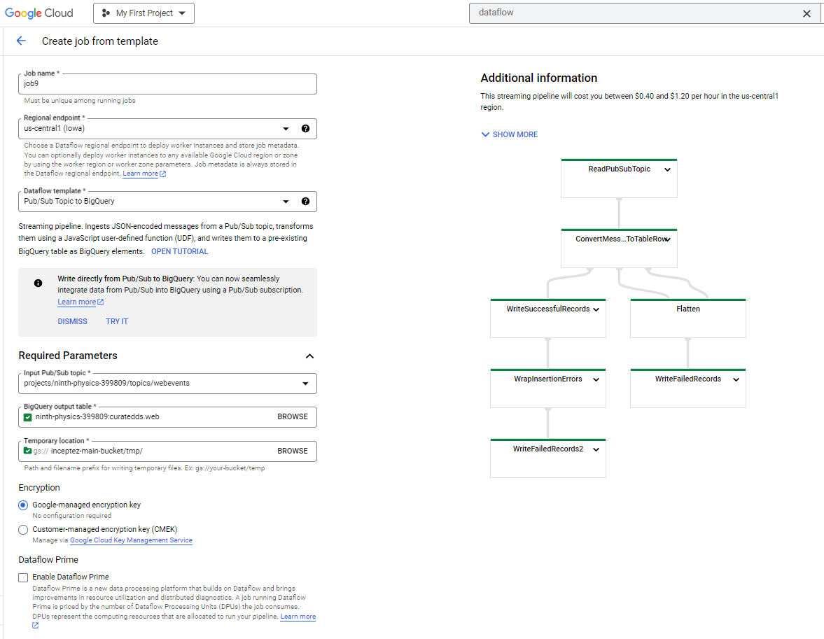

**Usecase2:**

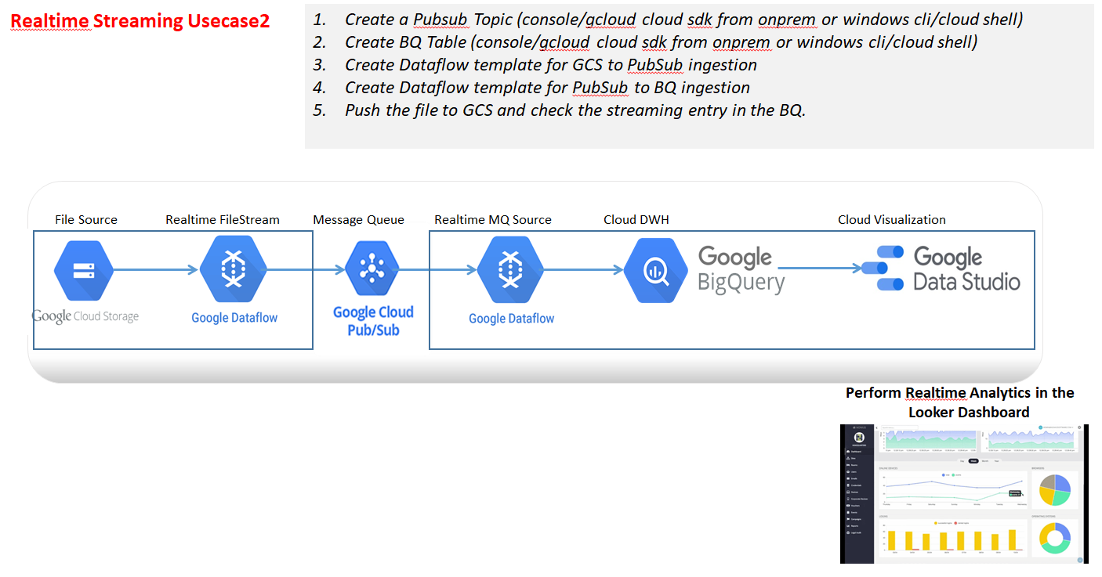

1. Create a shell script to generate streaming data to the gcs location

**vi stream_api.sh**

while true

do

**dt=`date +%Y%m%d%H%M%S`**

**curl https://api.randomuser.me/?exc=login > ./userapi$dt.json**

#msg=`curl https://api.randomuser.me/?exc=login`

#gcloud pubsub topics publish webevents --message="$msg"

echo $msg

sleep 1

gsutil cp ./userapi$dt.json gs://inceptez-main-bucket/data/

done

1. Create a json file and place the above json data in the below gcs bucket location (just to create a table with the same structure of the json)

create schema rawds;

LOAD DATA OVERWRITE rawds.apidata

  FROM FILES (format = 'JSON', uris = ['gs://inceptez-main-bucket/data/apidata.json']);

select * from rawds.apidata;

1. Create a Dataflow job from template to load data from GCS to PubSub:

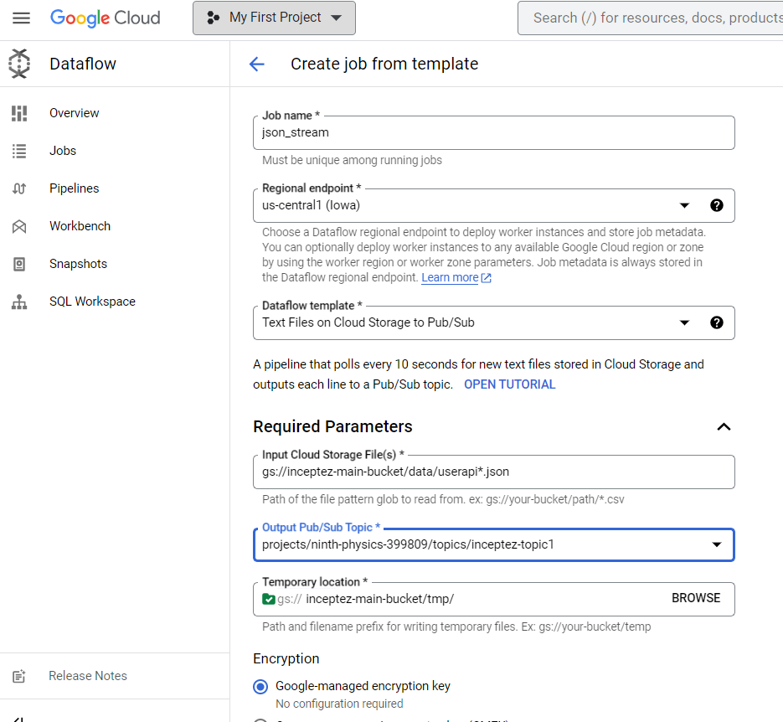

* 1. Create another Dataflow job from template to load data from pubsub to bigquery:

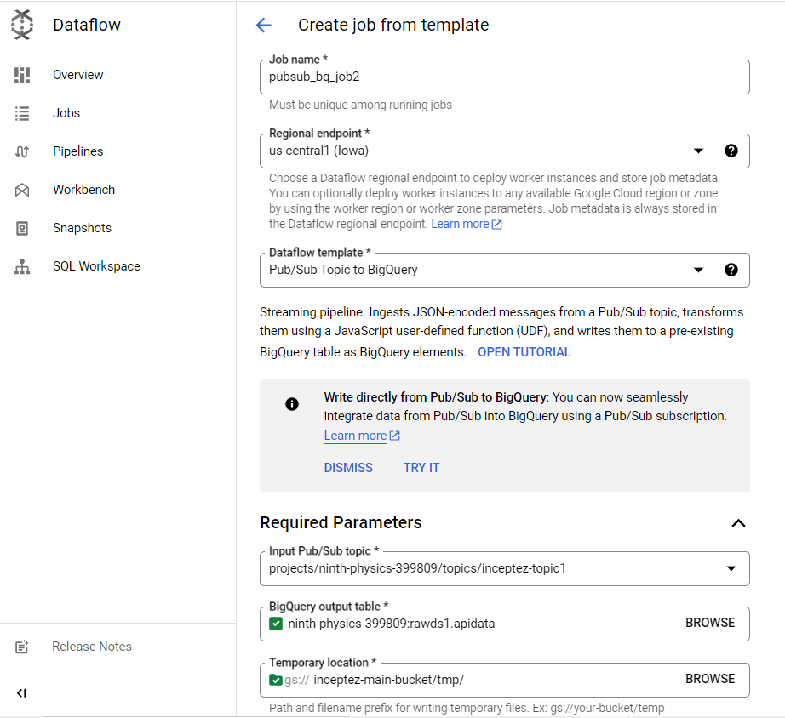

**Usecase3: Structured Streaming**

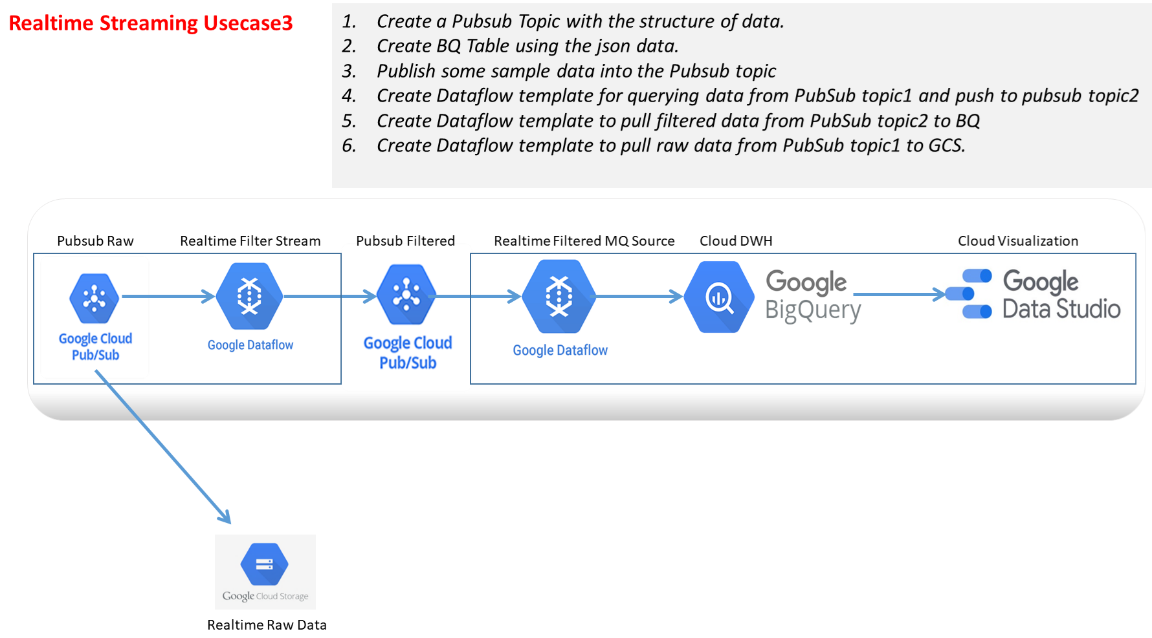

1. **PubSub Schema: Create topics with schema.**

gcloud pubsub topics create clickstreamanalysis_raw

gcloud pubsub topics create clickstreamanalysis_filtered

vi schema.yml

- column: event_id

description: Event id

mode: REQUIRED

type: INT64

- column: event_timestamp

description: Event timestamp

mode: REQUIRED

type: TIMESTAMP

- column: event

description: Type of event

mode: NULLABLE

type: STRING

- column: page

description: page visited

mode: NULLABLE

type: STRING

**#Pubsub schema registry update**

gcloud data-catalog entries update \

--lookup-entry='pubsub.topic.`ninth-physics-399809`.clickstreamanalysis' \

--schema-from-file=/home/inceptezbigdatameet/schema.yml

1. **Create a Data flow template to query the data from above pubsub topic and publish to another topic.** 
   1. **Click on the SQL Workspace**
   2. **Search for the current project and identify the topic name to consume the message from, copy the id to write the query as given below.**

**select event_id,upper(event) event,upper(page) page,event_timestamp from** pubsub.topic.`ninth-physics-399809`.clickstreamwe41 **where event_timestamp>'2023-10-05 00:00:01' and event='click';**

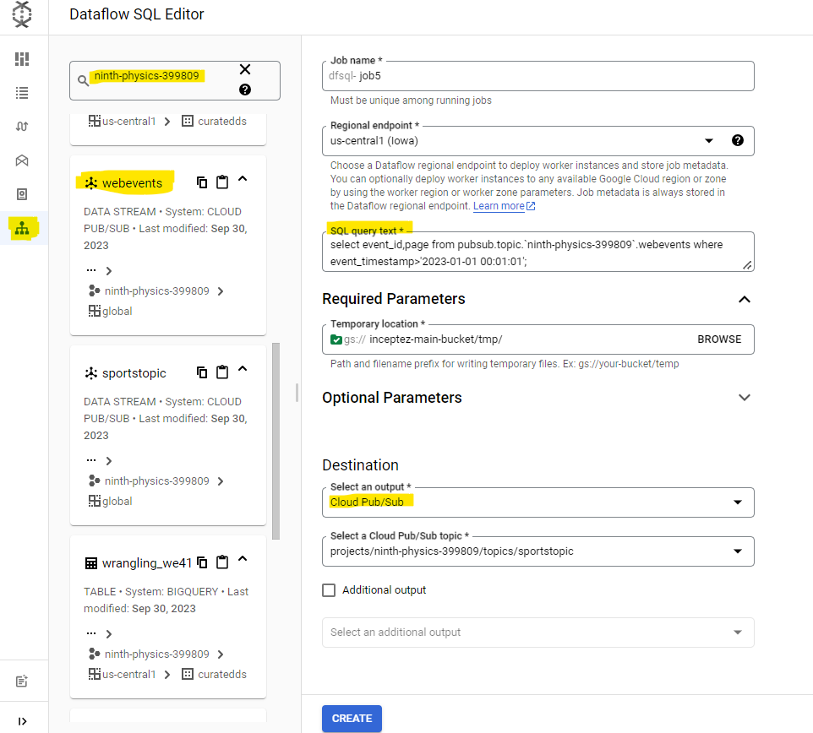

**Equivalent CLI Command**

gcloud dataflow sql query 'select * from pubsub.topic.`ninth-physics-399809`.topicname;' --job-name dfsql-job1 --region us-central1 --pubsub-topic projects/ninth-physics-399809/topics/inceptez-topic1 --staging-location inceptez-main-bucket/tmp/

1. **create a message file and put some messages into it in json format..**

msg1="{\"event_id\":1,\"event_timestamp\":\"2023-01-01 00:01:01\",\"event\":\"click\",\"page\":\"product1\"}"

msg1="{\"event_id\":2,\"event_timestamp\":\"2023-10-05 00:00:01\",\"event\":\"click\",\"page\":\"product3\"}"

msg1="{\"event_id\":3,\"event_timestamp\":\"2023-01-01 00:01:03\",\"event\":\"browse\",\"page\":\"product3\"}"

msg1="{\"event_id\":4,\"event_timestamp\":\"2023-01-01 00:01:04\",\"event\":\"download\",\"page\":\"product2\"}"

msg1="{\"event_id\":5,\"event_timestamp\":\"2023-01-01 00:01:05\",\"event\":\"click\",\"page\":\"product1\"}"

gcloud pubsub topics publish clickstreamwe41 --message="$(echo $msg1)"

1. **Create a BQ table as per the above sql output structure.**
2. **Create another Data flow template to consume the data from above pubsub topic and publish to anywhere else in a different pipeline.**

**Cloud Spanner Change stream to GCS Bucket (Change Data Capture):**

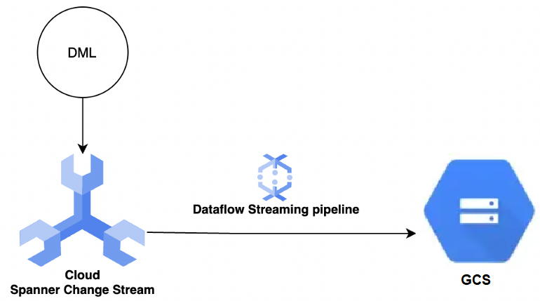

CREATE CHANGE STREAM drugs_stream FOR drugs;

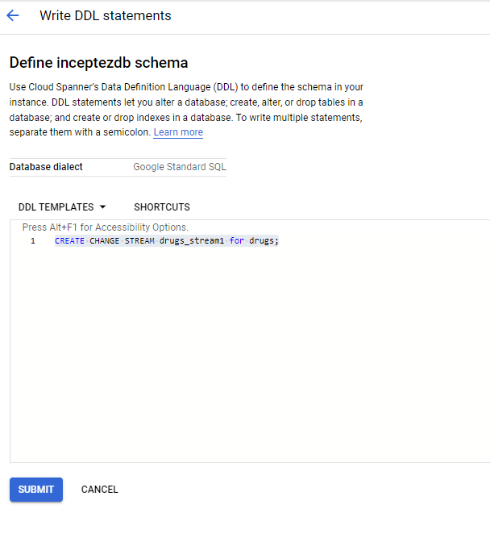

create table rawds.drugs_stream1 (uniqueid INT64, drugname STRING(100) , condition STRING(100),rating INT64,date STRING(10),usefulcount INT64)

1. **Big-Table:**

**(Google’s own Columnar NOSQL Datastore) – Managed Service - equivalent to HBase**

Linearly scalable, PB scale, Realtime random read write on a huge dataset, columnar datastore (equivalent to HBase)

Bigtable is a fully managed, wide-column NoSQL database that offers low latency and replication for high availability.